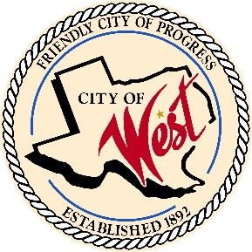
City of West
110 N. Reagan, West, Texas 76691 Phone (254) 826-5351 Fax (254) 826-5969
THE WEST CITY COUNCIL WILL MEET ON FRIDAY, DECEMBER 12, 2025, AT 6:00 PM FOR A SPECIAL CALLED MEETING AT THE WEST CITY HALL, 110 NORTH REAGAN TO DISCUSS ITEMS ON THE AGENDA.
- Call to order

- Roll Call

- Discussion, consideration, action, if any; Solid Waste Contract with Frontier Waste

- Discussion, consideration, action, if any; Wate Water Treatment Plant, liquidated damages

- Discussion, consideration, action, if any; Designating Mayor, Chris Nors as a signer on accounts with Point West Bank

- Discussion, consideration, action, if any; Designating Mayor, Chris Nors as a signer on accounts with Cadence Bank

- Discussion, consideration, action, if any; A resolution Designating Mayor, Chris Nors as a signer on accounts with LOGIC

- Discussion, consideration, action, if any; Designating City Secretary, Robin Wylie as a signer on accounts with Point West Bank

- Discussion, consideration, action, if any; Designating City Secretary, Robin Wylie as a signer on accounts with Cadence Bank

- Adjourn

I certify that the above notice of meeting was posted at West City Hall, 110 North Reagan, West, Texas, on the 8 ^{th} day of December 2025 at 1:00 p.m.

________________________________
Robin Wylie, City Secretary

