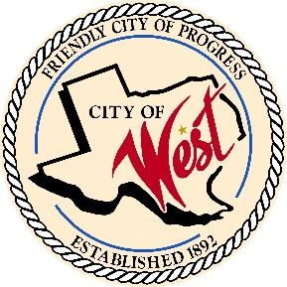
City of West
110 N. Reagan, West, Texas 76691 Phone (254) 826-5351 Fax (254) 826-5969
THE WEST CITY COUNCIL WILL MEET ON WEDNESDAY, NOVEMBER 12, 2025, AT 7:30 AM FOR A SPECIAL CALLED MEETING AT THE WEST CITY HALL, 110 NORTH REAGAN TO DISCUSS ITEMS ON THE AGENDA.
- Call to order

- Roll Call

- Discussion, consideration, action, if any; Canvass The City of West, November 4, 2025, General Election

- Discussion, consideration, action, if any; EDC Board Member appointment of David Pratka, and reappointment of EDC Board Members; John Hurtik, Laura Langford, and Mandy Kutscherosky

I certify that the above notice of meeting was posted at West City Hall, 110 North Reagan, West, Texas, on the 6 ^{th} day of November 2025 at 10:00 a.m.

________________________________
Robin Wylie, City Secretary

