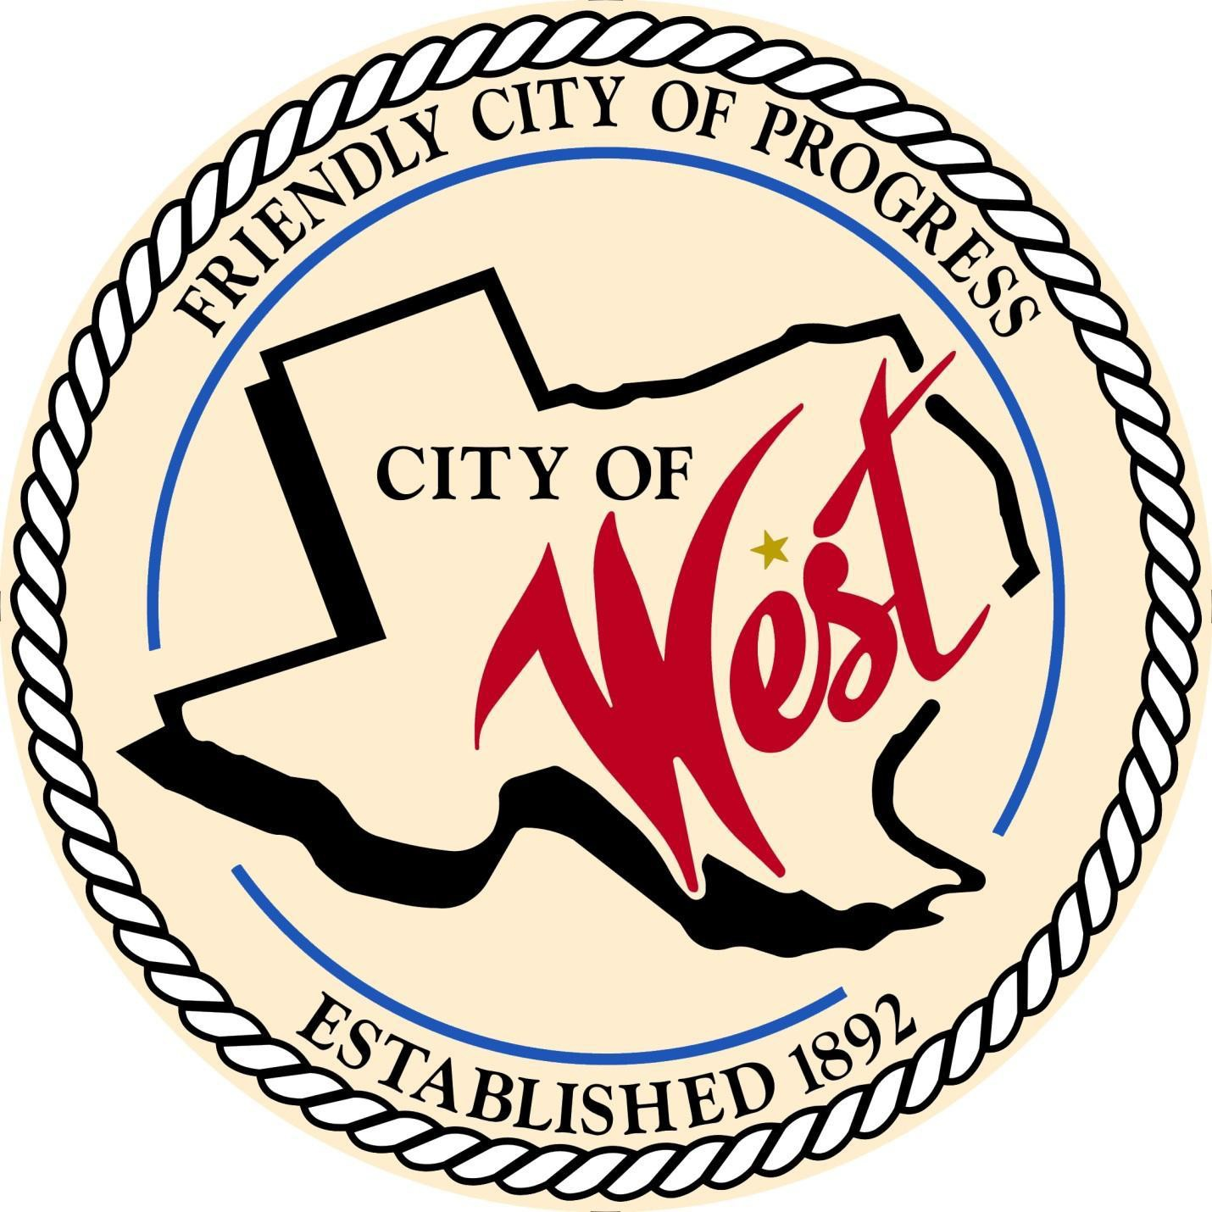

City Council Meeting September 03, 2024

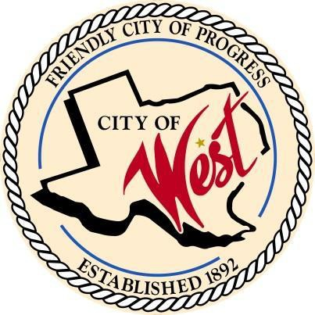City of West

110 N. Reagan, West, Texas 76691

Phone (254) 826-5351 Fax (254) 826-5969

THE WEST CITY COUNCIL WILL MEET ON TUESDAY, SEPTEMBER 3, 2024, AT 5:30 PM LOCATED AT THE WEST COMMUNITY CENTER AT 200 TOKIO ROAD FOR A PUBLIC HEARING REGARDING THE 2024-2025 FISCAL YEAR PROPOSED TAX RATE OF $0.630000 PER $100 VALUATION, WHICH IS EFFECTIVELY A 11.46 PERCENT INCREASE IN THE TAX RATE. THIS TAX RATE WILL RAISE MORE TAXES FOR MAINTENANCE AND OPERATIONS THAN LAST YEAR'S TAX RATE.  THE TAX RATE WILL EFFECTIVELY BE RAISED BY 62.98 PERCENT AND WILL RAISE TAXES FOR MAINTENANCE AND OPERATIONS ON A $100,000 HOME BY APPROXIMATELY $61.04.

ALSO TO DISCUSS ITEMS ON THE AGENDA.

THE REGULAR COUNCIL MEETING WILL START AT 6:00 PM.

1. Call to Order
2. Invocation and Pledge
3. Roll Call
4. Citizen Comments will be heard, but please note that speakers are strictly limited to 3 minutes. It is important to remember that the council will only discuss matters that are listed on an official agenda as required by law, and no discussion will be held on any other topics.
5. Consent Agenda:

The consent agenda includes all matters considered to be of a routine or noncontroversial nature. All items on the consent agenda are approved by a single motion and vote. Any item on the consent agenda can be removed at the request of any member of the Council or City staff. Any items removed are considered separately by the City Council after the consent agenda.

* 1. Approve Minutes: July 30, 2024, August 06, 2024, August 13, 2024, August 20, 2024, August 22, 2024
  2. Approve Bills: August 2024
  3. Monthly Departmental Reports:
     + Police Department Report
     + Public Works Report
     + Fire Marshal Report
     + Code/Permitting Report
     + Engineer Report
     + Mayor Report
     + Project expenditure report
     + Sales tax allocation/ EDC report

1. Discussion, consideration, action, if any, re: Adoption of the 2024 - 2025 fiscal year budget.
2. Discussion, consideration, action, if any, re: Approval of the property tax rate for the 2024 - 2025 budget by the adoption of a tax rate of $0.630000, which is effectively a 11.46 percent increase in the tax rate.
3. Discussion, consideration, action, if any, re: Request from Westfest and from West Rodeo Association for funding from EDC – John Hurtick.
4. Discussion, consideration, action, if any, re: Certifying unopposed candidate for November 05, 2024, City of West one-year special term election, and ordering the cancelation of the special term election.
5. Discussion, consideration, action, if any, re: TML Intergovernmental Risk Pool votes for board of trusty members, places 11 – 14. Only one vote per place (total of 4 nominations).
6. Discussion, consideration, action, if any, re: Nomination and approval for resolution of candidate nominations for the McLennan central appraisal district board of directors for the year 2025.  It could be an existing member or anyone of your governing body’s choosing, with up to five nominations.
7. Council member comments and requests for items to be placed on future agendas.
8. Adjourn

CERTIFICATION

I certify that the above notice of the meeting was posted on the bulletin board of the West City Hall in the City of West, Texas on the

29th day of August 2024 at 9:00 a.m.

City Secretary Robin Wylie