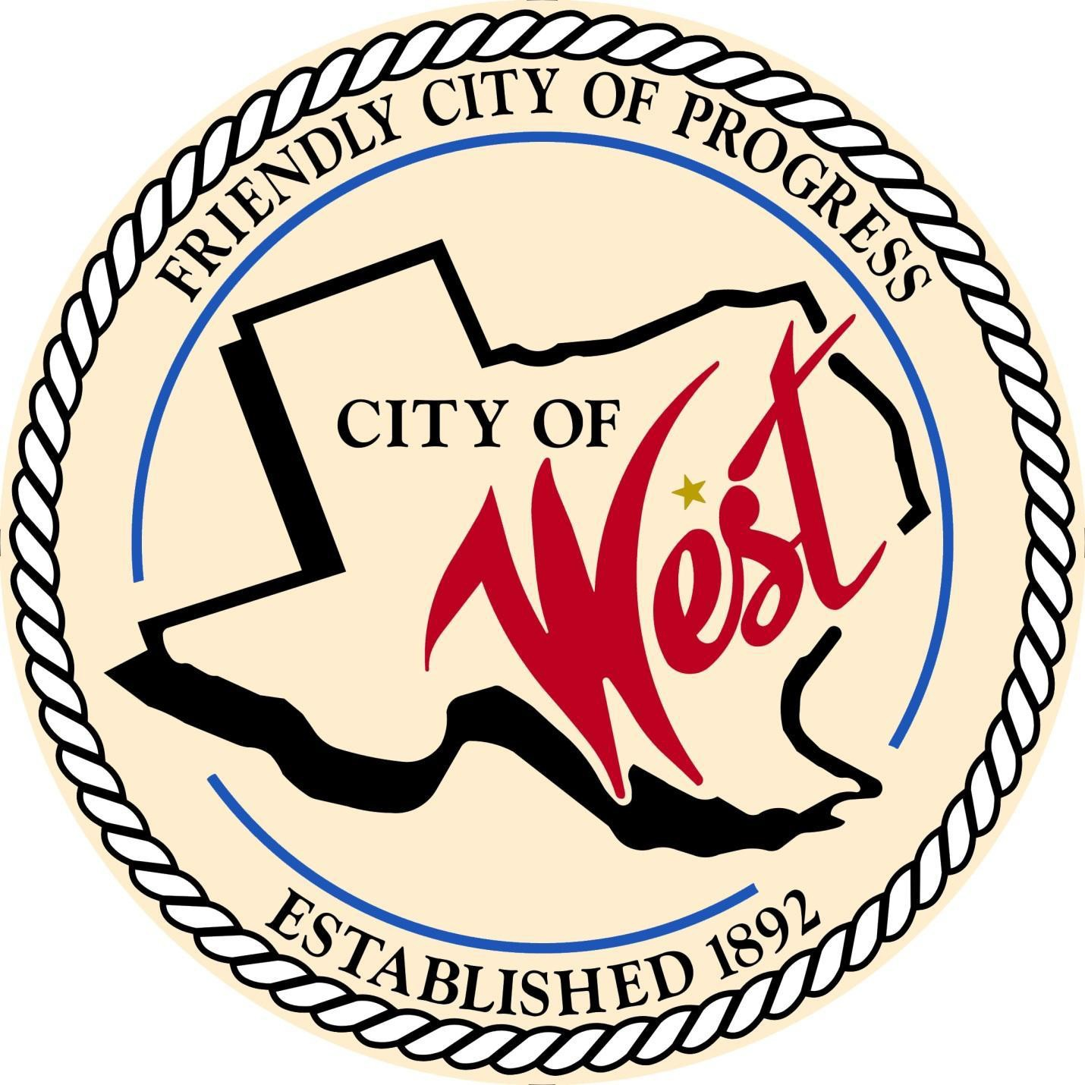

City Council Meeting August 6, 2024

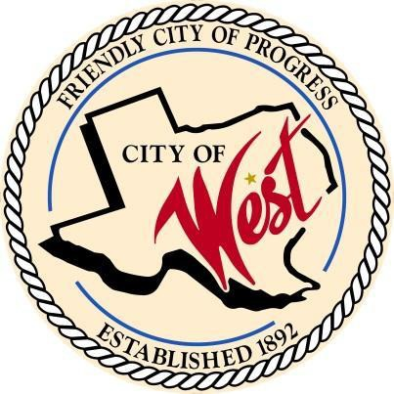City of West

110 N. Reagan, West, Texas 76691

Phone (254) 826-5351 Fax (254) 826-5969

THE WEST CITY COUNCIL WILL MEET ON TUESDAY, AUGUST 6, 2024, AT 5:30 PM IN WORKSHOP AT THE WEST COMMUNITY CENTER AT 200 TOKIO ROAD TO DISCUSS ITEMS ON THE AGENDA.

THE REGULAR COUNCIL MEETING WILL START AT 6:00 PM.

1. Call to Order
2. Invocation and Pledge
3. Roll Call
4. Citizen Comments will be heard, but please note that speakers are strictly limited to 3 minutes. It is important to remember that the council will only discuss matters that are listed on an official agenda as required by law, and no discussion will be held on any other topics.
5. Consent Agenda:

The consent agenda includes all matters considered to be of a routine or noncontroversial nature. All items on the consent agenda are approved by a single motion and vote. Any item on the consent agenda can be removed at the request of any member of the Council or City staff. Any items removed are considered separately by the City Council after the consent agenda.

* 1. Approve Minutes: June 4, 2024
  2. Approve Bills: June & July 2024
  3. Monthly Departmental Reports:
     + Police Department Report
     + Public Works Report
     + Fire Marshal Report
     + Code/Permitting Report
     + Engineer Report
     + Mayor Report
     + Project expenditure report

1. Discussion, consideration, action, if any, re: Sales tax allocation/ EDC report
2. Discussion, consideration, action, if any, re: Review of cost-of-living adjustments/retirement figures for 2024 – 2025 fiscal year - Anthony Mills, TMRS Representative.
3. Discussion, consideration, action, if any, re: Boy Scott project for retired flags, change of drop-off location – Brody Buchanan & Joe Pustejovsky.
4. Discussion, consideration, action, if any, re: Approve notice for joint general election, November 5, 2024.
5. Discussion, consideration, action, if any, re: Water rates for inside and outside city limits-Natalie Kelinske
6. Discussion, consideration, action, if any, re: Request from Westfest and from West Rodeo Association for funding from EDC – John Hurtick
7. Discussion, consideration, action, if any, re: Resolution to formally dedicate a portion of city owned property as a public right of way and designate it as W. Mynarcik Road.
8. Discussion, consideration, action, if any, re: Mill & overlay of North Davis – Joe Pustejovsky.
9. Discussion, consideration, action, if any, re: West Rodeo Parade request – Chief White.
10. Council member comments and requests for items to be placed on future agendas.
11. Adjourn

CERTIFICATION

I certify that the above notice of the meeting was posted on the bulletin board of the West City Hall in the City of West, Texas on the

2nd day of August 2024 at 9:00 a.m.

City Administrator Shelly Gillaspie