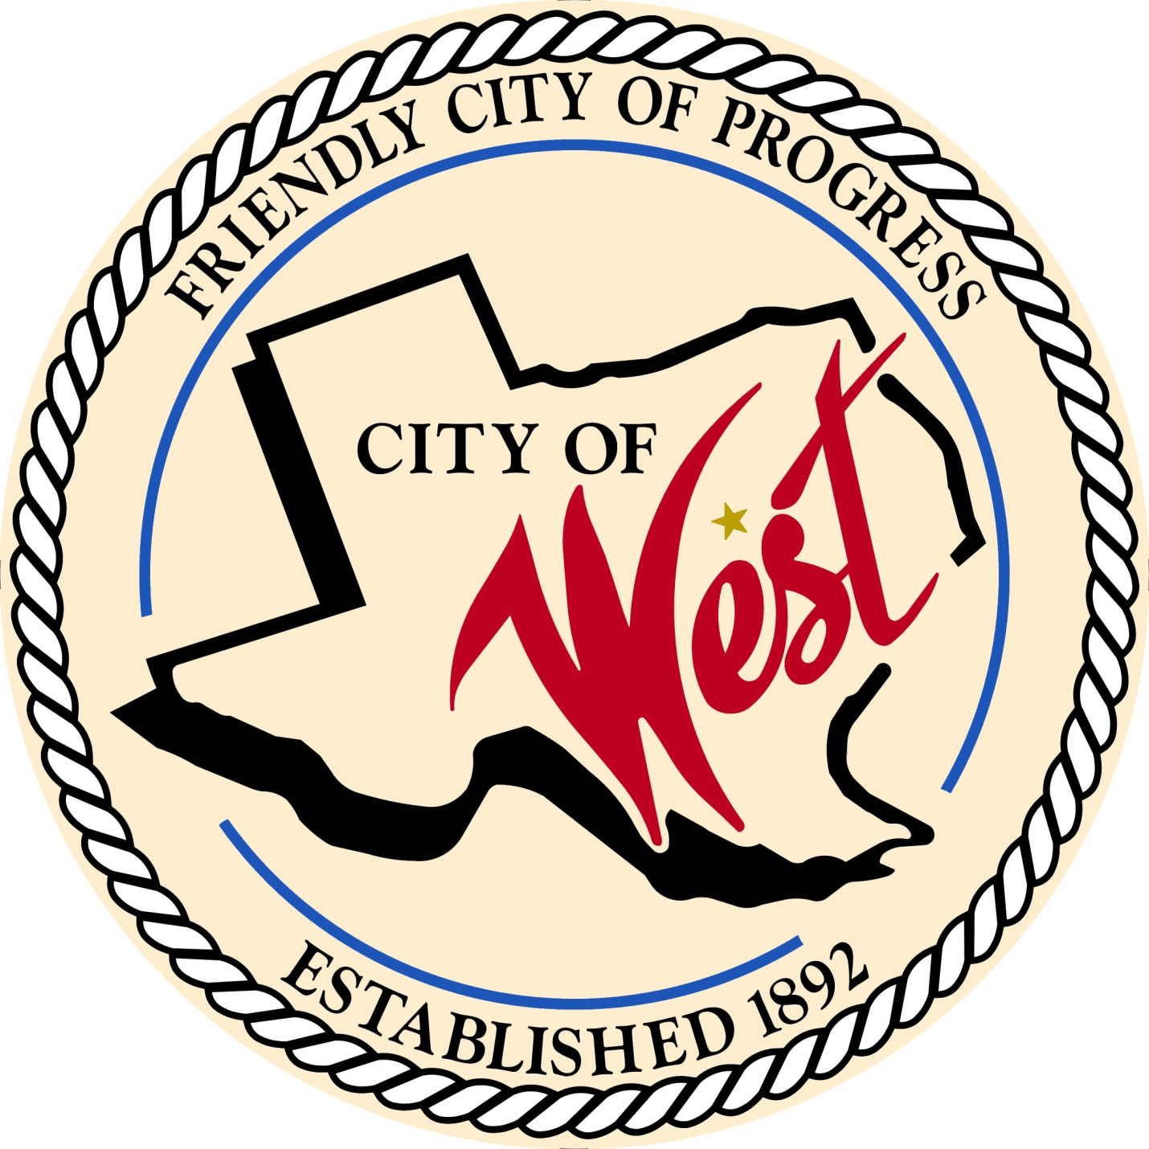

City Council Meeting
NOVEMBER 7, 2023

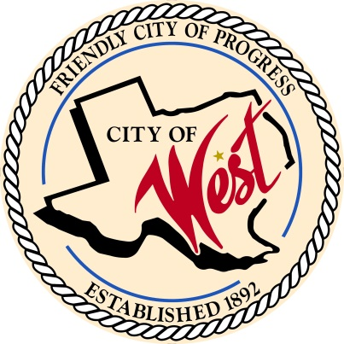
City of West
110 N. Reagan, West, Texas 76691
Phone (254) 826-5351 Fax (254) 826-5969

THE WEST CITY COUNCIL WILL MEET ON TUESDAY, NOVEMBER 7, 2023, AT 5:30 PM LOCATED AT THE WEST FIRE STATION AT 111 S. REAGAN TO DISCUSS ITEMS ON THE AGENDA.

THE REGULAR COUNCIL MEETING WILL START AT 6:00 PM.

- Call to Order

- Invocation and Pledge

- Roll Call

- Approve Minutes: October 3, 2023

- Approve Bills: October 2023.

- Discussion, consideration, action, if any, re:
Monthly Departmental Reports
Finance Report
Police Department Report
Public Works Report
Fire Marshal Report
Code/Permitting Report
Engineer Report
West EMS

- Citizen Comments: Citizens may be heard on any subject, but no discussion by or with Council will be held on any matter not listed on an official agenda as required by law.
- Discussion, consideration, action, if any, re: Eagle Scout recognition – Johnathon Nors.
- Discussion, consideration, action, if any, re: Frontier Waste price increase, effective January 1, 2024 – Sabrina Norton.
- Discussion, consideration, action, if any, re: Easement for Liberty Rest Cemetery on John Nors Rd.

- Discussion, consideration, action, if any, re: Street lights for Long Subdivision.

- Discussion, consideration, action, if any, re: City of West facility lease agreement with West League Booster Club (ballfields).

- Discussion, consideration, action, if any, re: Amending moving building non-refundable deposit – Bill Hunt.
14. Discussion, consideration, action, if any, re: Approve hiring RM Construction for the Home Program.
15. Discussion, consideration, action, if any, re: Bids for renovating City Hall.
16. Executive Session: Under the provisions of Government Code 551, the Council will meet in Executive Session to discuss:
1). Executive Session: A closed meeting will be held pursuant to Section 551.074 of the Government Code (V.C.T.A.) to address the addition of an employee for public works.

17. Discussion, consideration, action, if any, re: Amending the 2023 – 2024 fiscal year budget addition of an employee for public works.
18. Discussion, consideration, action, if any, re: Amending the 2023 – 2024 fiscal year budget, two used patrol vehicles.
19. Discussion, consideration, action, if any, re: Water/Wastewater Study – Town Hall meeting on November 13, 2023, at 6:00 pm.
20. Council member comments and requests for items to be placed on future agendas.

21. Adjourn.

CERTIFICATION
I certify that the above notice of meeting was posted on the bulletin board of the West City Hall in the City of West, Texas on the 3rd day of November 2023 at 10:00 o’clock a.m.

____________________________
City Secretary Shelly Gillaspie

