PUBLIC NOTICE OF MEETING
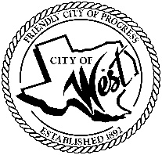
CITY OF WEST
November 20, 2023
TAKE NOTICE THAT A SPECIAL MEETING OF THE WEST CITY COUNCIL WILL BE HELD AT THE WEST COMMUNITY CENTER, 200 TOKIO ROAD, WEST, TEXAS, COMMENCING AT 5:30 P.M. ON MONDAY, NOVEMBER 20, 2023.

AGENDA
CALL MEETING TO ORDER
- Canvass results of the November 7, 2023, general municipal election
- Executive Session: Under the provisions of Government Code 551, the Council will meet in Executive Session to discuss:
1). Executive Session: A closed meeting will be held pursuant to Section 551.074 of the Government Code (V.C.T.A.) to address city administration salary.
- Discussion, consideration, action, if any, re: Revision of 2023-2024 fiscal year budget for city administration salary.
- Adjournment

I certify that the above notice of meeting was posted at West City Hall, 110 North Reagan, West, Texas, on the 17th day of November 2023 at 10:00 a.m.

________________________________
Vanessa Perez, City Secretary

