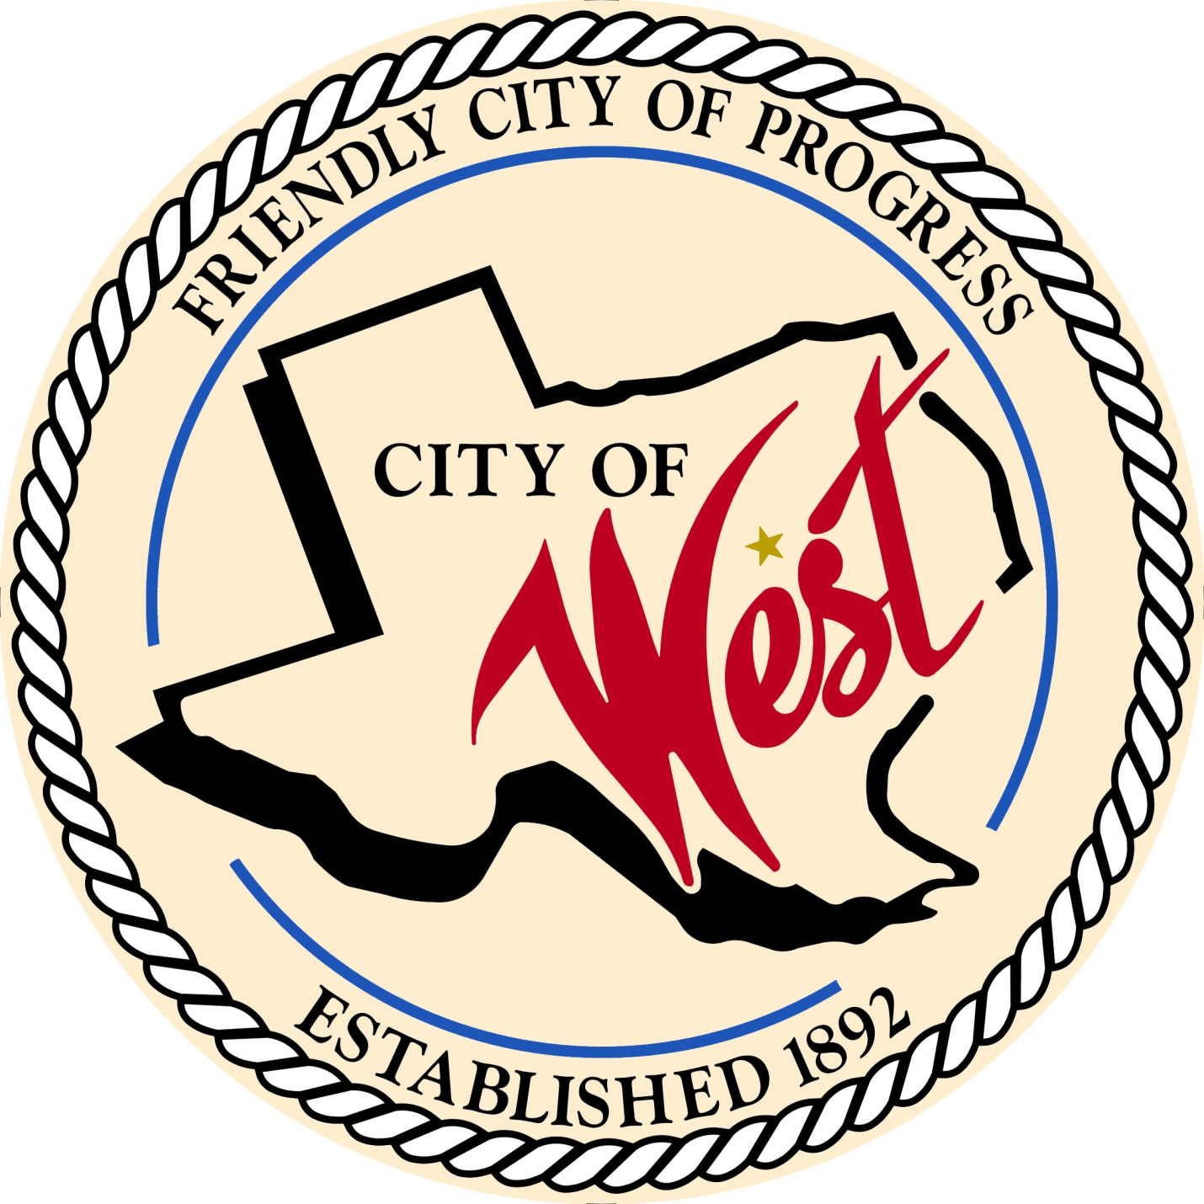

City Council Meeting
OCTOBER 3, 2023

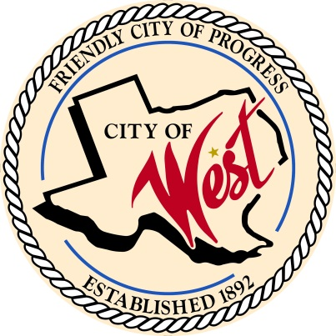
City of West
110 N. Reagan, West, Texas 76691
Phone (254) 826-5351 Fax (254) 826-5969

THE WEST CITY COUNCIL WILL MEET ON TUESDAY, OCTOBER 3, 2023, AT 5:30 PM LOCATED AT THE WEST COMMUNITY CENTER AT 200 TOKIO ROAD TO DISCUSS ITEMS ON THE AGENDA.

THE REGULAR COUNCIL MEETING WILL START AT 6:00 PM.

- Call to Order

- Invocation and Pledge

- Roll Call

- Approve Minutes: September 5, 2023

- Approve Bills: September 2023.

- Discussion, consideration, action, if any, re:
Monthly Departmental Reports
Finance Report
Police Department Report
Public Works Report
Fire Marshal Report
Code/Permitting Report
Engineer Report
West EMS

- Citizen Comments: Citizens may be heard on any subject, but no discussion by or with Council will be held on any matter not listed on an official agenda as required by law.
8. Discussion, consideration, action, if any, re: Water/Wastewater rate study findings – Nelisa Heddin.
- Discussion, consideration, action, if any, re: Food truck permit cost – Matt Nemec.

- Discussion, consideration, action, if any, re: West Chamber of Commerce Trunk or Treat, Saturday October 28th, 2023, with Main Street shutdown from 5:00 pm to 8:00 pm – Nicole Nemec.

- Discussion, consideration, action, if any, re: Tipsy Lion Halloween Karaoke Bash event on October 31, 2023, from 6:00 pm – 11:00 pm, blocking parking spaces in front of restaurant – Nicole Nemec.

- Discussion, consideration, action, if any, re: Application for a replat with a variance Zoning Ordinance Section 20 minimum front yard 25 ft. for Shook Addition Lots 6 7 Block 22 (MCAD 199887).
- Discussion, consideration, action, if any, re: Application for a replat with a variance Zoning Ordinance Section 20 minimum lot depth 100 ft. for Davis Extension Lots 12 13C 13D Block 5, Lots 13B 14B Block 5, Lots 13A 14A Block 5 (MCAD 199099, 199098, 199100).

- Discussion, consideration, action, if any, re: Application for a replat with a variance Zoning Ordinance Section 21 Supplementary District C (4) carport or canopy minimum 5 feet from any side lot line for Davis and Marable Addition Lots A5 A6 A7 Block 8, Lots B5 B6 B7 Block 8 (MCAD 199384, 199385).

- Discussion, consideration, action, if any, re: Approve Resolution #231003, of the West City Council, to adopt the Home Program application along with the affirmative action policy and waitlist policy.

- Discussion, consideration, action, if any, re: Railroad crossing and potential grants – Natalie Kelinske.

- Discussion, consideration, action, if any, re: Tank issue (debris) from drainage problems that occurred during the reconstruction of Davis Street – Gary Vrba.

- Discussion, consideration, action, if any, re: City of West facility lease agreement with West League Booster Club (ballfields).

- Discussion, consideration, action, if any, re: Change of location for November 7, 2023, city council meeting to West Fire Department located at 110 S. Reagan due to elections.

- Council member comments and requests for items to be placed on future agendas.

- Adjourn
CERTIFICATION
I certify that the above notice of meeting was posted on the bulletin board of the West City Hall in the City of West, Texas on the 29th day of September 2023 at 11:45 o’clock a.m.

____________________________
City Secretary Shelly Gillaspie

