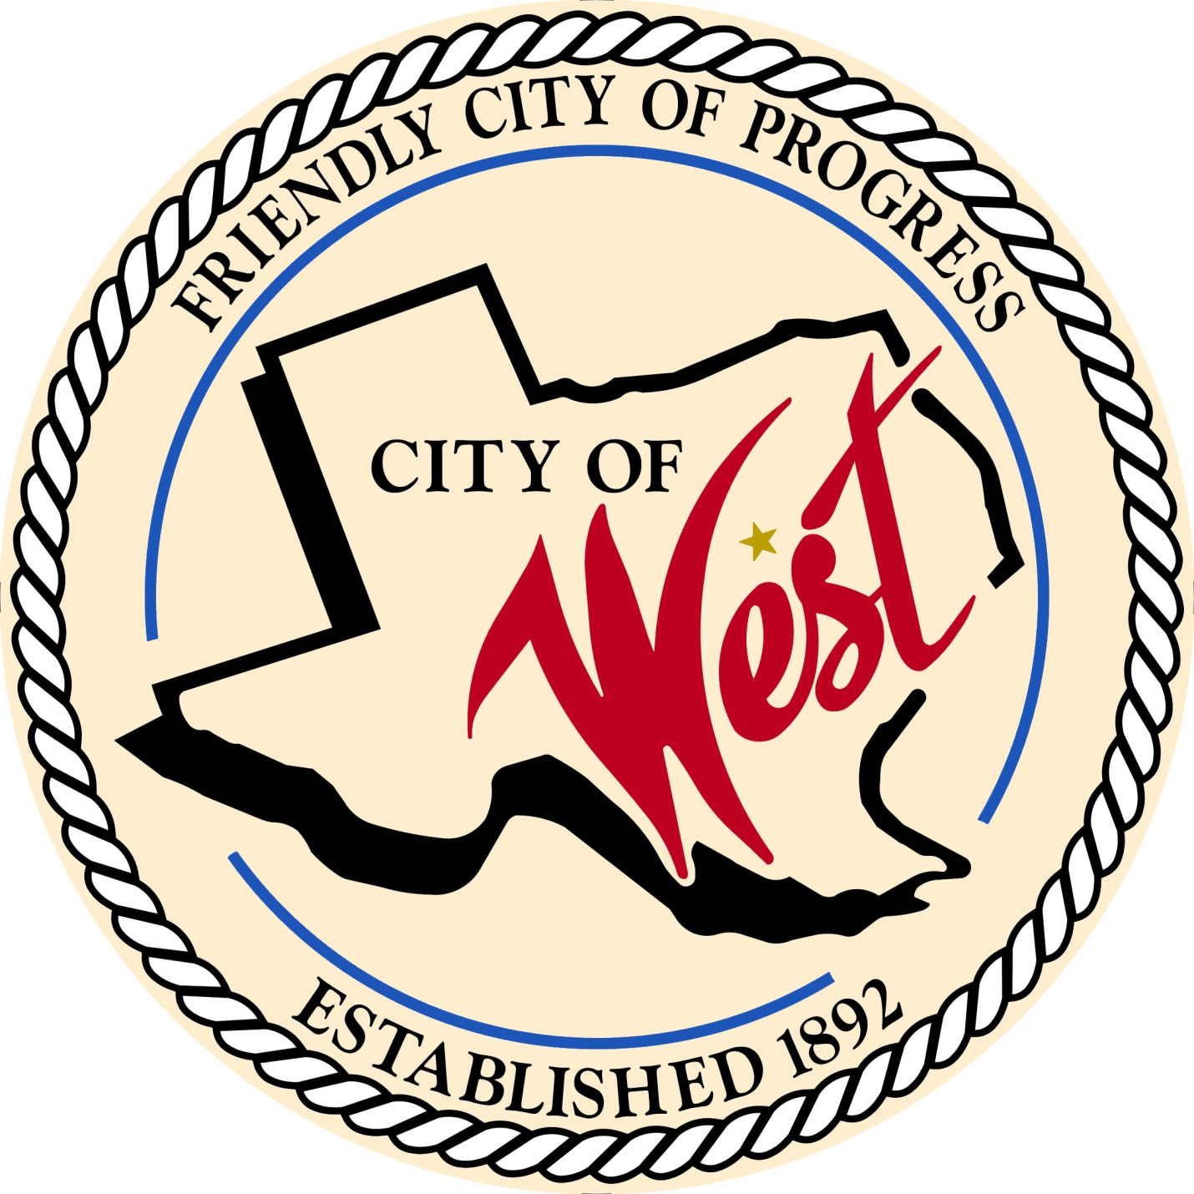

City Council Meeting
SEPTEMBER 5, 2023

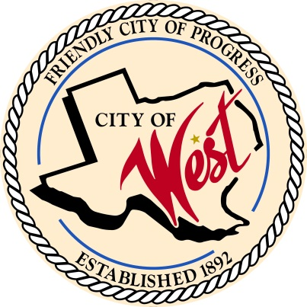
City of West
110 N. Reagan, West, Texas 76691
Phone (254) 826-5351 Fax (254) 826-5969

THE WEST CITY COUNCIL WILL MEET ON TUESDAY, SEPTEMBER 5, 2023, AT 5:30 PM LOCATED AT THE WEST COMMUNITY CENTER AT 200 TOKIO ROAD FOR A PUBLIC HEARING REGARDING THE 2023-2024 FISCAL YEAR PROPOSED TAX RATE OF $0.600000 PER $100 VALUATION. THE PROPOSED TAX RATE IS NOT GREATER THAN THE VOTER-APPROVAL TAX RATE, THE CITY IS NOT REQUIRED TO HOLD AN ELECTION.

THE REGULAR COUNCIL MEETING WILL START AT 6:00 PM.

- Call to Order

- Invocation and Pledge

- Roll Call

- Approve Minutes: August 1, August 3, August 8, and August 24, 2023.

- Approve Bills: August 2023.

- Discussion, consideration, action, if any, re:
Monthly Departmental Reports
Finance Report
Police Department Report
Public Works Report
Fire Marshal Report
Code/Permitting Report
Engineer Report
West EMS

- Citizen Comments: Citizens may be heard on any subject, but no discussion by or with Council will be held on any matter not listed on an official agenda as required by law.
8. Discussion, consideration, action, if any, re: Adoption of the 2023 – 2024 fiscal year budget.
- Discussion, consideration, action, if any, re: Approve the property tax rate for the 2023 – 2024 budget by the adoption of a tax rate of $0.600000.

- Discussion, consideration, action, if any, re: Conner Lathern – Eagle Scout project.

- Discussion, consideration, action, if any, re: Matt Nemec – street dance and food truck permits.

- Discussion, consideration, action, if any, re: Gary Vrba – tank project.

- Discussion, consideration, action, if any, re: Upgrading Facebook live streaming capabilities and approving quote from Brazos Media Technologies for $3,757.83 – Matt Miller.

- Discussion, consideration, action, if any, re: Request to rezone residential property to commercial at 613 West Spruce West, TX, legal description CASEY FM lot 12, block 3, acres 0.376.

- Discussion, consideration, action, if any, re: Request to rezone residential property to commercial at East Elm Street West, TX, legal description West OT lot 12, block 16.

- Discussion, consideration, action, if any, re: Planning & Zoning, addition of rezoning fees to fee schedule – Bill Hunt.

- Discussion, consideration, action, if any, re: Approval of replat for 600 W. Broadway St. West, Texas, Legal Description SHOOK Lot 6 7 Block 22 Acres 0.3215 LAND ACCT, MH ONLY ON PID: 19910.

- Discussion, consideration, action, if any, re: Approval of replat for 406 N. Harrison St. West, Texas, Legal Description DAVIS EXT LOT 11 12 13C 13D Block 5 Acres 0.4602.

- Discussion, consideration, action, if any, re: Approval of replat for 410 W. Columbus Ave West, Texas, Legal Description D & M Lot A5 A6 A7 Block 8 Acres 0.3409 and 408 W. Columbus Ave West, Texas, Legal Description D & M Lot B6 B7 B5 Block 8 Acres 0.1705.

- Discussion, consideration, action, if any, re: Approval of replat for 301 S. Main St., Legal Description West OT Lot 2 THRU 8A (0.009 AC ROW), B (0.088 Ac. OF ALLEY) Block 16 Acres 0.785 125’ X 250’.

- Discussion, consideration, action, if any, re: Kapavik parking lot variance.

- Council member comments and requests for items to be placed on future agendas.

- Adjourn
CERTIFICATION
I certify that the above notice of meeting was posted on the bulletin board of the West City Hall in the City of West, Texas on the 30th day of August 2023 at 4:20 o’clock a.m.

____________________________
City Secretary Shelly Gillaspie

