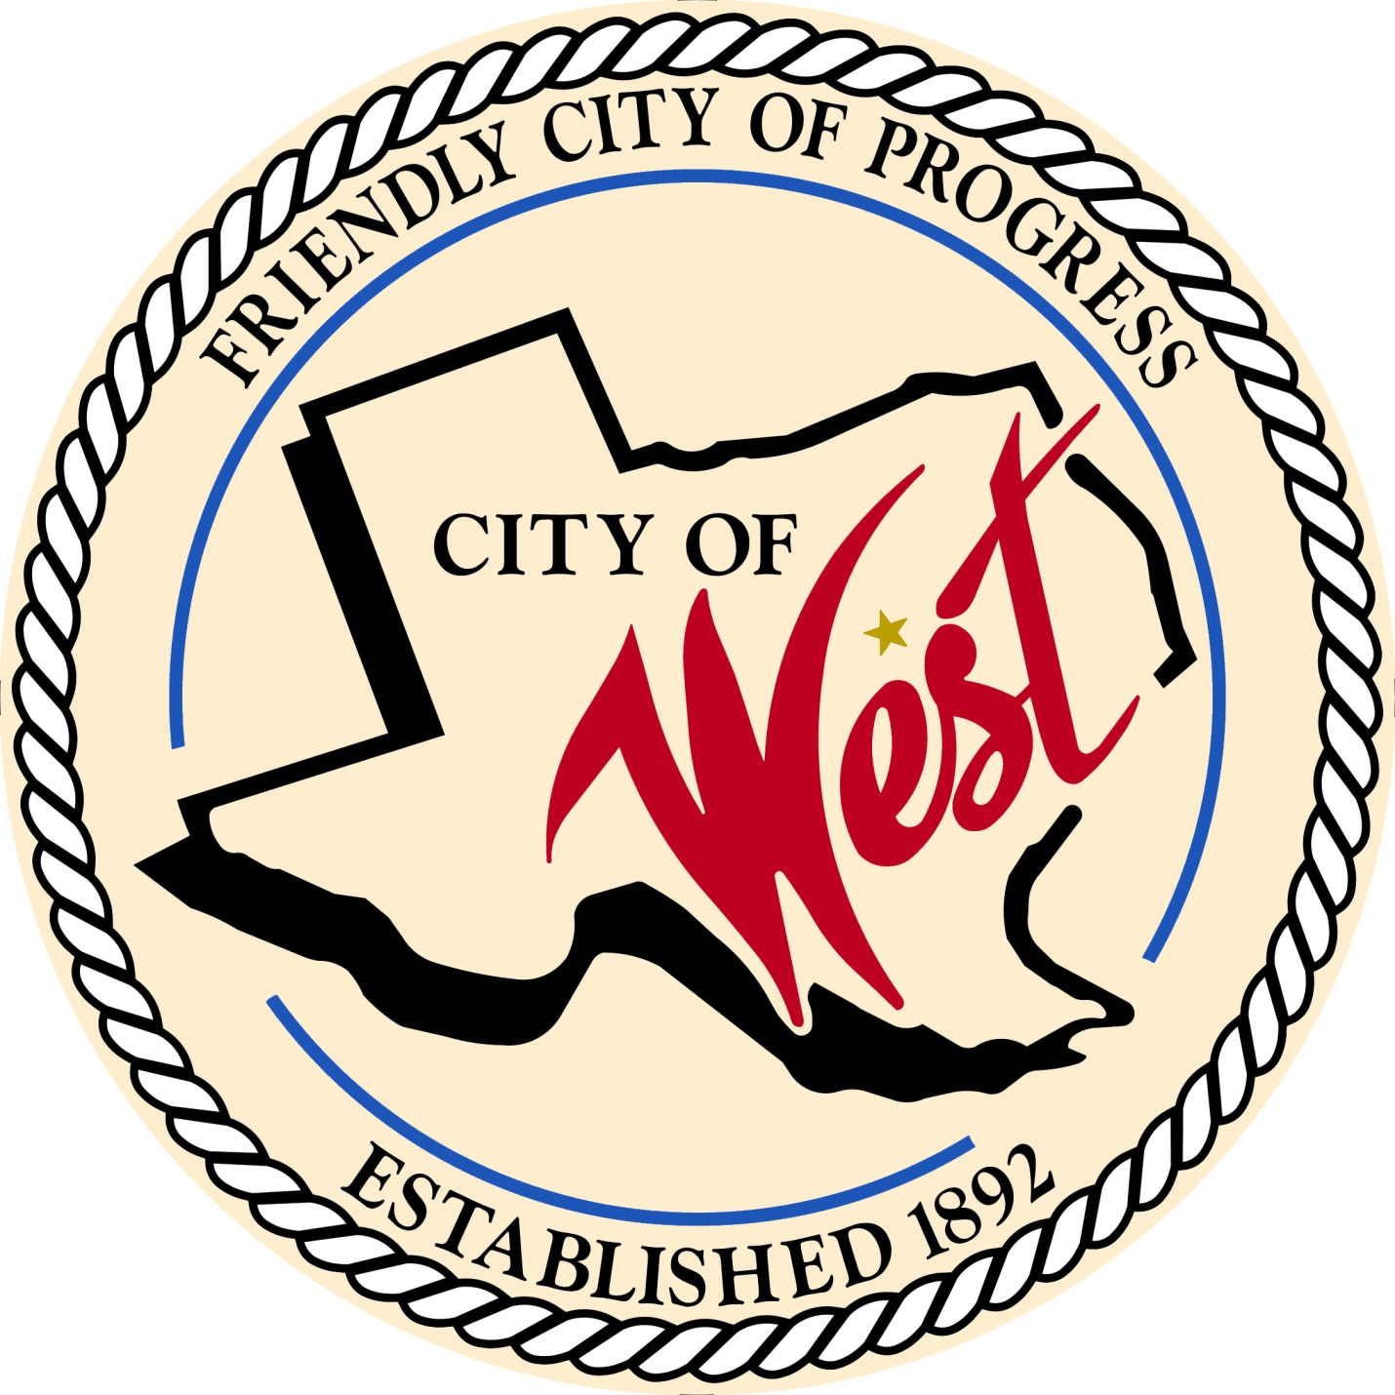

City Council Meeting

August 24, 2023

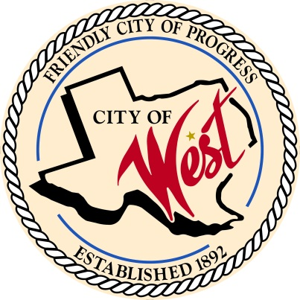 City of West

110 N. Reagan, West, Texas 76691

Phone (254) 826-5351 Fax (254) 826-5969

THE WEST CITY COUNCIL WILL MEET ON TUESDAY, AUGUST 24, 2023, AT 5:30 PM AT THE WEST COMMUNITY CENTER LOCATED AT 200 TOKIO ROAD TO CONSIDER AND ACT ON THE ITEMS ON THE FOLLOWING AGENDA AND TO REVIEW PROPOSED 2023 – 2024 FISCAL YEAR BUDGET.

1. Call to Order
2. Roll Call
3. Discussion, consideration, action, if any, re: 2023 – 2024 fiscal year budget.
4. Discussion, consideration, action, if any, re: Proposing tax rate of $0.60 for the 2023 - 2024 fiscal year.
5. Adjourn

CERTIFICATION

I certify that the above notice of meeting was posted on the bulletin board of the West City Hall in the City of West, Texas on the 21st day of August 2022 at 2:30 o’clock p.m.

____________________________

City Secretary Shelly Gillaspie