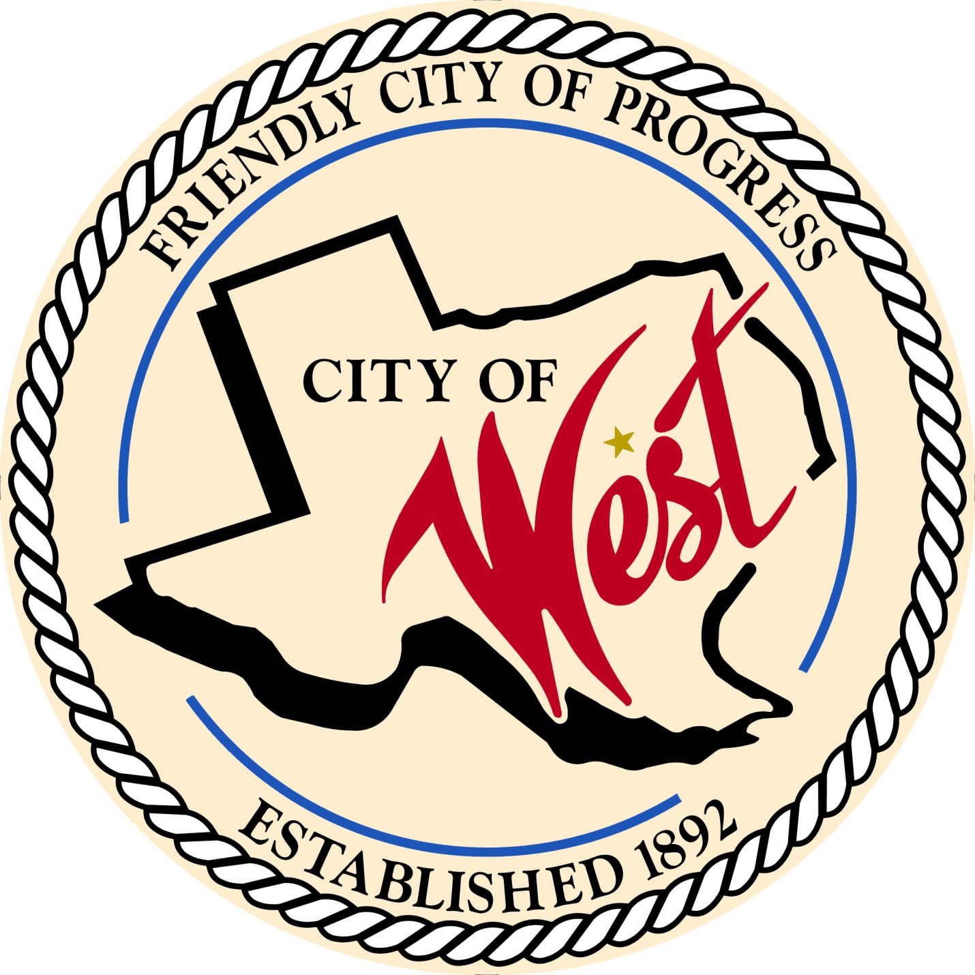

City Council Budget Workshops
JULY 2023

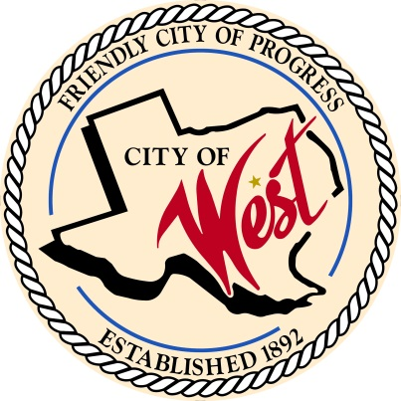
City of West
110 N. Reagan, West, Texas 76691
Phone (254) 826-5351 Fax (254) 826-5969

THE WEST CITY COUNCIL WILL MEET EVERY TUESDAY AND THURSDAY IN JULY AS NEEDED ON THE FOLLOWING DATES AT 5:30 PM AT THE WEST COMMUNITY CENTER AT 200 TOKIO RD. TO DISCUSS ITEMS ON THE AGENDA.
JULY 11, 2023
JULY 13, 2023
JULY 18, 2023
JULY 20, 2023
JULY 25, 2023
JULY 27, 2023

- Call to Order

- Roll Call

- Discussion, consideration, action, if any, re: City of West 2023 – 2024 fiscal year budget.

- Adjourn
CERTIFICATION
I certify that the above notice of meeting was posted on the bulletin board of the West City Hall in the City of West, Texas on the 7th day of July 2023 at 10:00 o’clock a.m.
____________________________
City Secretary Shelly Gillaspie

