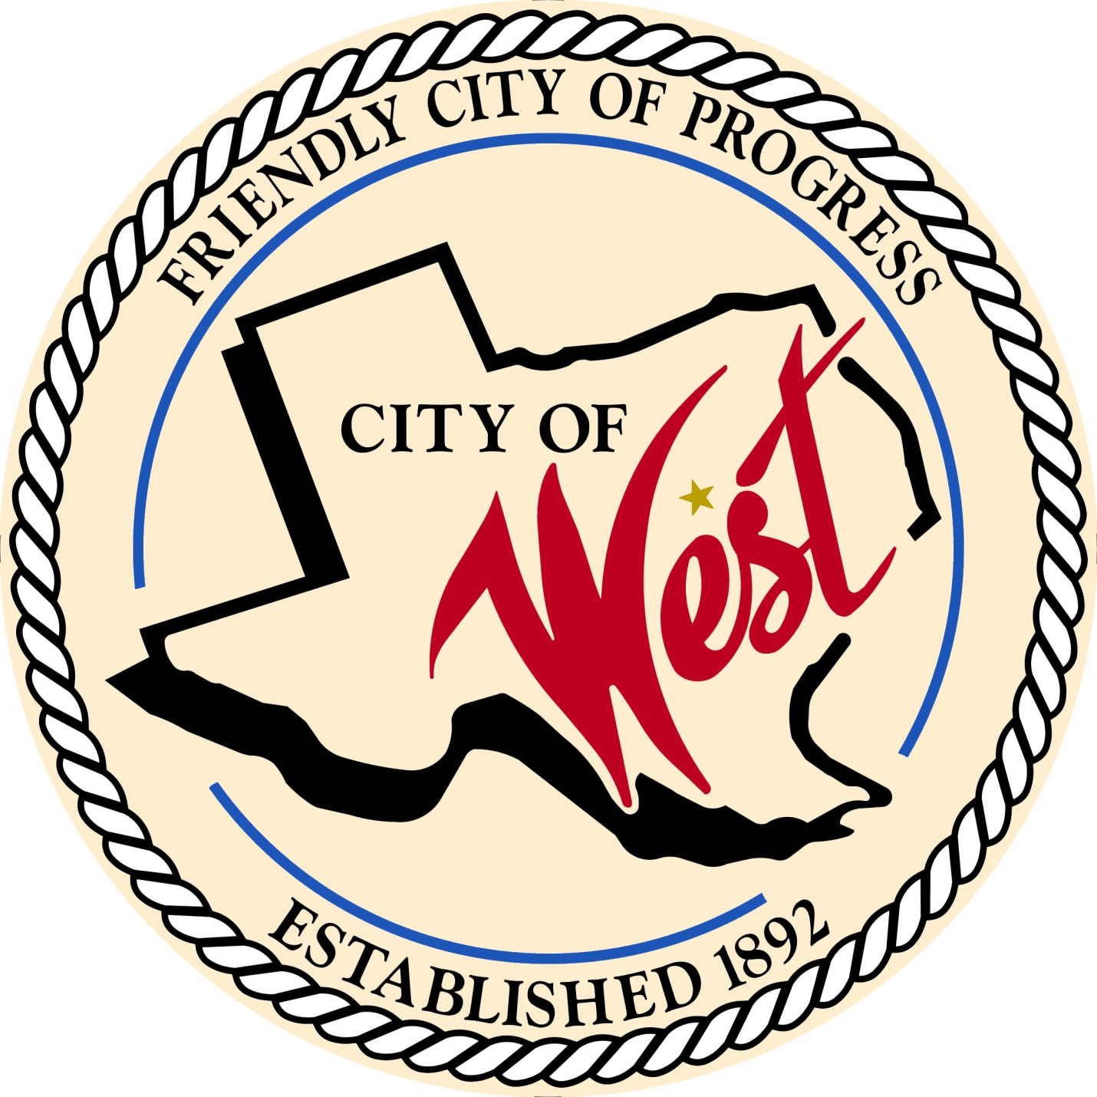

City Council Budget Workshops

AUGUST 2023

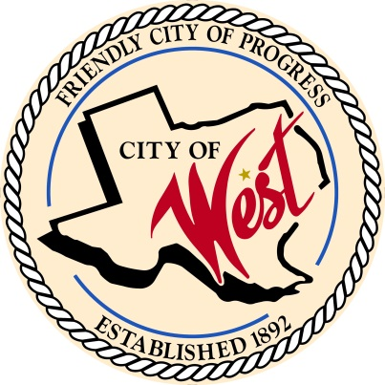 City of West

110 N. Reagan, West, Texas 76691

Phone (254) 826-5351 Fax (254) 826-5969

THE WEST CITY COUNCIL WILL MEET EVERY TUESDAY AND THURSDAY IN AUGUST AS NEEDED ON THE FOLLOWING DATES AT 5:30 PM AT THE WEST COMMUNITY CENTER AT 200 TOKIO RD. TO DISCUSS ITEMS ON THE AGENDA.

AUGUST 3, 2023

AUGUST 8, 2023

AUGUST 10, 2023

AUGUST 15, 2023

AUGUST 17, 2023

AUGUST 22, 2023

AUGUST 24, 2023

AUGUST 29, 2023

AUGUST 31, 2023

1. Call to Order
2. Roll Call
3. Discussion, consideration, action, if any, re: City of West 2023 – 2024 fiscal year budget.
4. Adjourn

CERTIFICATION

I certify that the above notice of meeting was posted on the bulletin board of the West City Hall in the City of West, Texas on the 28th day of July 2023 at 12:00 o’clock p.m.

____________________________

City Secretary Shelly Gillaspie