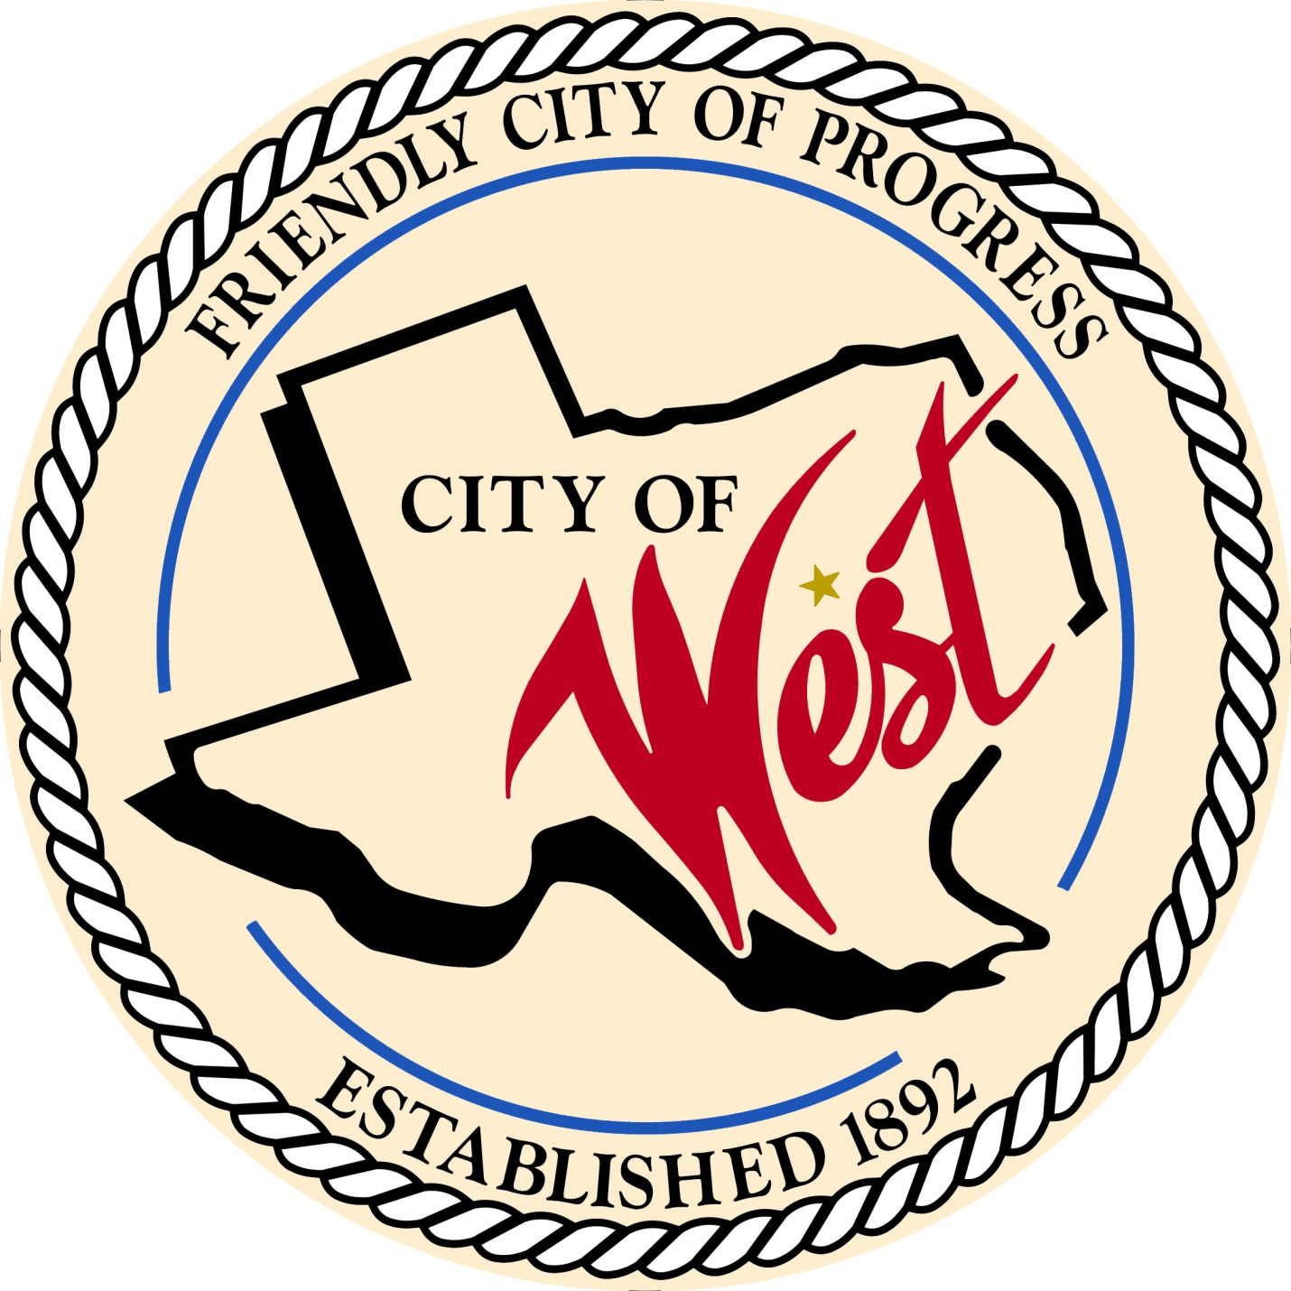

City Council Meeting
AUGUST 1, 2023

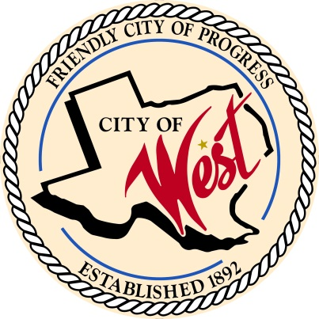
City of West
110 N. Reagan, West, Texas 76691
Phone (254) 826-5351 Fax (254) 826-5969

THE WEST CITY COUNCIL WILL MEET ON TUESDAY, AUGUST 1, 2023, AT 5:30 PM IN WORKSHOP LOCATED AT THE WEST COMMUNITY CENTER AT 200 TOKIO ROAD TO DISCUSS ITEMS ON THE AGENDA AND TO DISCUSS THE 2023-2024 FISCAL YEAR FINANCIAL BUDGET .
THE REGULAR COUNCIL MEETING WILL START AT 6:00 PM.

- Call to Order

- Invocation and Pledge

- Roll Call

- Approve Minutes: June 6, July 13, July 20, July 25, July 27, 2023.

- Approve Bills: June & July 2023.

- Discussion, consideration, action, if any, re:
Monthly Departmental Reports
Finance Report
Police Department Report
Public Works Report
Fire Marshal Report
Code/Permitting Report
Engineer Report
West EMS

- Citizen Comments: Citizens may be heard on any subject, but no discussion by or with Council will be held on any matter not listed on an official agenda as required by law.
8. Discussion, consideration, action, if any, re: Approve notice for joint general election, November 7, 2023.
- Discussion, consideration, action, if any, re: Street dance and food truck permits – Matt Nemec.

- Discussion, consideration, action, if any, re: Approval of Signors on Pointwest and Citizens State Bank Accounts.

- Discussion, consideration, action, if any, re: EDC recommendation for Westfest.

- Discussion, consideration, action, if any, re: EDC recommendation for fire hydrant at The Historic.

- Discussion, consideration, action, if any, re: Request to rezone residential property to commercial at 613 West Spruce West, TX, legal description CASEY FM lot 12, block 3, acres 0.376.

- Discussion, consideration, action, if any, re: Request to rezone residential property to commercial at East Elm Street West, TX, legal description West OT lot 12, block 16.

- Council member comments and requests for items to be placed on future agendas.

- Adjourn
CERTIFICATION
I certify that the above notice of meeting was posted on the bulletin board of the West City Hall in the City of West, Texas on the 28th day of July 2023 at 12:00 o’clock p.m.

____________________________
City Secretary Shelly Gillaspie

