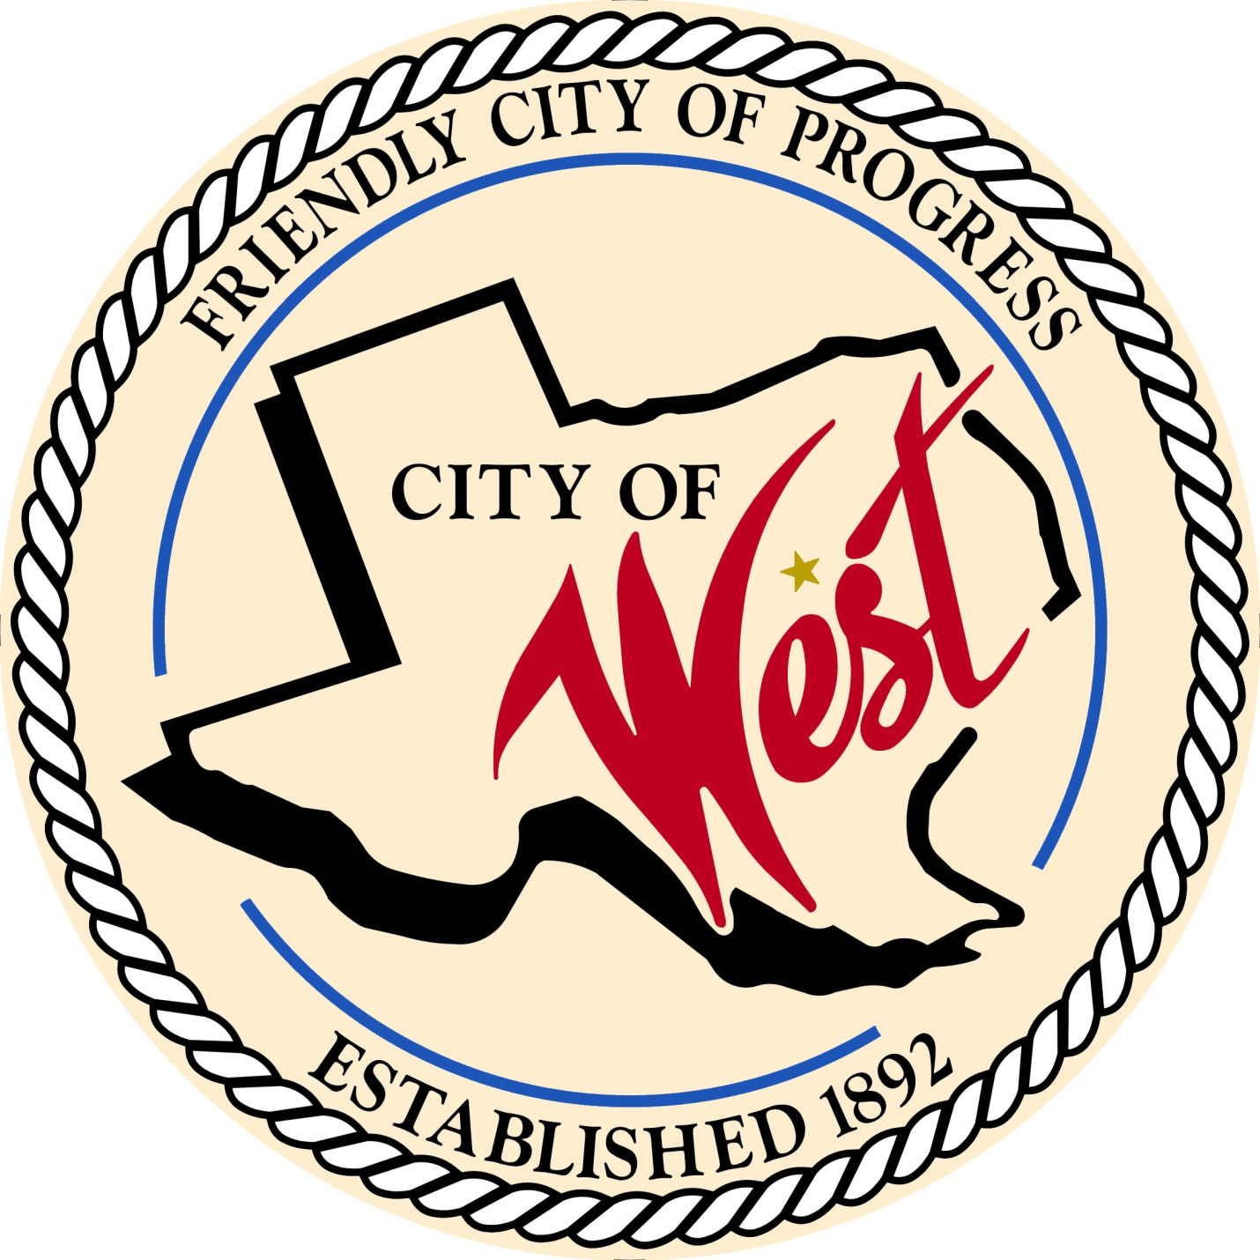

City Council Meeting

JUNE 6, 2023

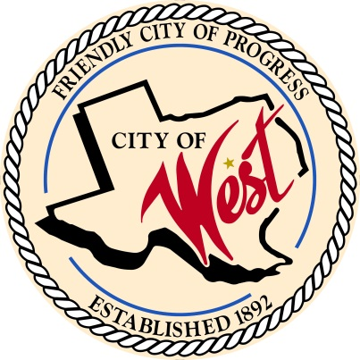 City of West

110 N. Reagan, West, Texas 76691

Phone (254) 826-5351 Fax (254) 826-5969

THE WEST CITY COUNCIL WILL MEET ON TUESDAY, JUNE 6, 2023, AT 5:00 PM IN WORKSHOP LOCATED AT THE WEST COMMUNITY CENTER AT 200 TOKIO ROAD TO DISCUSS ITEMS ON THE AGENDA.

THE REGULAR COUNCIL MEETING WILL START AT 6:00 PM.

1. Call to Order
2. Invocation and Pledge
3. Roll Call
4. Approve Minutes: April 28, 2023, and May 2, 2023.
5. Approve Bills: May 2023.
6. Discussion, consideration, action, if any, re:

Monthly Departmental Reports

Finance Report

Police Department Report

Public Works Report

Fire Marshal Report

Code/Permitting Report

Engineer Report

1. Citizen Comments: Citizens may be heard on any subject, but no discussion by or with Council will be held on any matter not listed on an official agenda as required by law.

8**.** Discussion, consideration, action, if any, re: Approving a professional services agreement with Walker Partners, LLC for Construction Phase Services including Construction Administration and Resident Project Representative Services in connection with the Wastewater Treatment Plant Expansion Project, and authorizing the Mayor to execute all documents necessary to complete this transaction.

1. Discussion, consideration, action, if any, re: Awarding a professional services agreement with Langerman Foster Engineering Company, LLC for construction materials testing in connection with the Wastewater Treatment Plant Expansion Project, and authorizing the Mayor to execute all documents necessary to complete this transaction.
2. Discussion, consideration, action, if any, re: Awarding a professional services agreement with Langerman Foster Engineering Company, LLC for construction materials testing in connection with the Reagan/Marable/Davis Street Improvements Project, and authorizing the Mayor to execute all documents necessary to complete this transaction.
3. Discussion, consideration, action, if any, re: Grady Calvery North Lot 7 and 8 plat and zoning.
4. Discussion, consideration, action, if any, re: Amending ordinance Sec. 6.04.009 Mobile Food Establishments to include Mobile Food Establishment Park-Jacob Polansky, Bill Hunt.
5. Discussion, consideration, action, if any, re: Request to rezone property, legal description: Webre Addition, Lot 1 Block 1, Acres .24 from commercial to residential –Patricia Webre, Bill Hunt.
6. Discussion, consideration, action, if any, re: Request zoning variance for 6 foot privacy fence in front yard, 700 S Harrison St., Parcel 199736, legal description: K&H, Lot 15, 16 Block 8 Acres .4057 –Dan Webre, Bill Hunt.
7. Discussion, consideration, action, if any, re: Cancellation of July 4th city council meeting due to holiday.
8. Executive Session:  Pursuant to the Texas Open Meetings Act, codified as Chapter 551 of the Texas Government Code, the City Council reserves the right to adjourn into Executive Session at any time during the course of this meeting and conduct a closed meeting to discuss or deliberate regarding any of the following:

*(1)*     *to receive legal advice and discuss pending or contemplated litigation, or a settlement offer, as permitted by Section 551.071.*

-The City Council may also meet in open meeting to take action on matters considered in the closed meeting as required by Section 551.102.

1. Discussion, consideration, action, if any, re: Consider and take appropriate action concerning an agreement with West Ambulance Association
2. Hear presentation by the West Ambulance Association in response to City’s allegations.
3. Council member comments and requests for items to be placed on future agendas.
4. Adjourn

CERTIFICATION

I certify that the above notice of meeting was posted on the bulletin board of the West City Hall in the City of West, Texas on the 2nd day of June 2023 at 12:00 o’clock p.m.

____________________________

Assistant City Secretary Shannon Cox