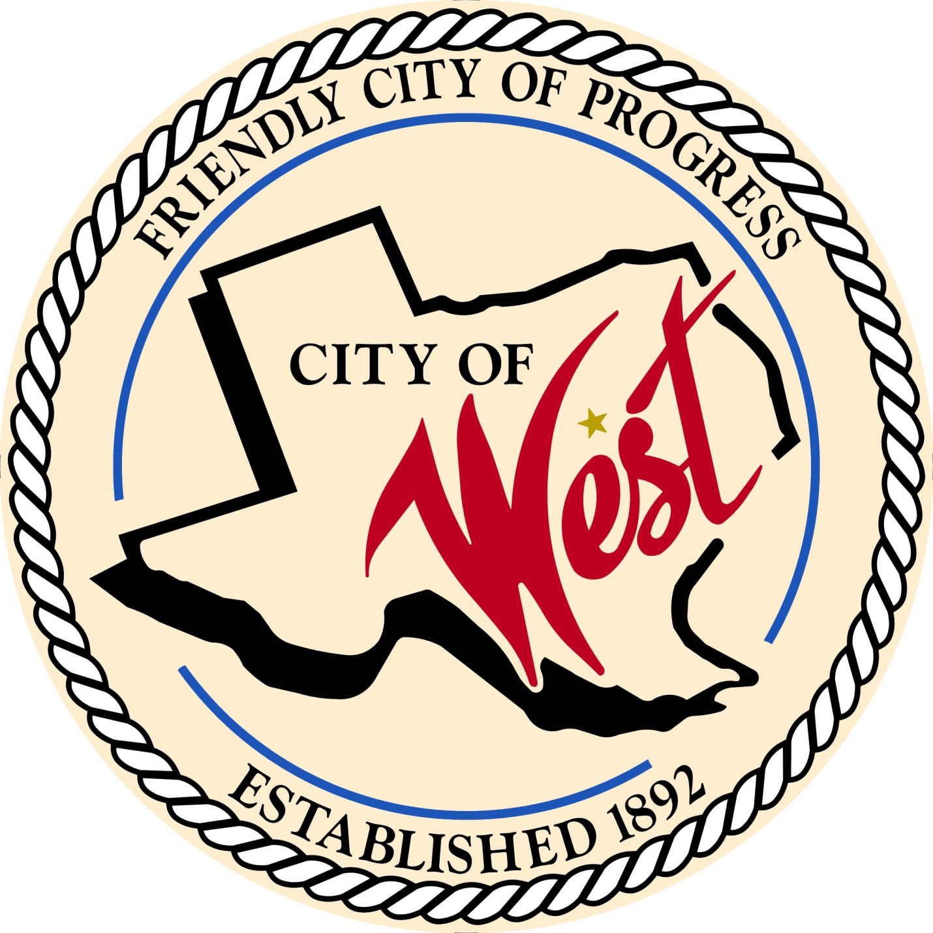

City Council Meeting
MAY 2, 2023

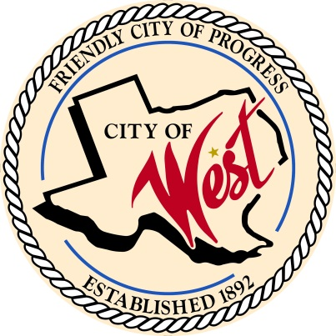
City of West
110 N. Reagan, West, Texas 76691
Phone (254) 826-5351 Fax (254) 826-5969

THE WEST CITY COUNCIL WILL MEET ON TUESDAY, MAY 2, 2023, AT 5:30 PM IN WORKSHOP LOCATED AT THE WEST COMMUNITY CENTER AT 200 TOKIO ROAD TO DISCUSS ITEMS ON THE AGENDA.
THE REGULAR COUNCIL MEETING WILL START AT 6:00 PM.

- Call to Order

- Invocation and Pledge

- Roll Call

- Approve Minutes: April 4, 2023.

- Approve Bills: April 2023.

- Discussion, consideration, action, if any, re:
Monthly Departmental Reports
Finance Report
Police Department Report
Public Works Report
Fire Marshal Report
Code/Permitting Report
EMS Report
Engineer Report

- Citizen Comments: Citizens may be heard on any subject, but no discussion by or with Council will be held on any matter not listed on an official agenda as required by law.

- Discussion, consideration, action, if any, re: Overview and explanation of QIPP Program – Trent Krienke.

- Discussion, consideration, action, if any, re: Take action to operate West Rest Haven and St. Anthony’s Care Center and participate in QIPP.

- Discussion, consideration, action, if any, re: Take action to engage third-party consultant to assist City with QIPP.

- Discussion, consideration, action, if any, re: Awarding a construction contract for the Reagan/Marable/Davis Street Improvements Project, as recommended by the City Engineer, Walker Partners, LLC, and authorizing the mayor to execute all documents necessary to complete this transaction.

- Discussion, consideration, action, if any, re: Amending ordinance Sec. 6.04.009 Mobile Food Establishments to include Mobile Food Establishment Park-Jacob Polansky, Bill Hunt.

- Discussion, consideration, action, if any, re: Rezoning 501 N College Street, legal description Shook Lot 1 Block 25 Acres .1894, 503 N College Street, legal description Shook Lot 2 Block 25 Acres .1894, and 505 N College Street, legal description Shook Lot 3 Block 25 Acres .1894 to Commercial (C2).

- Discussion, consideration, action, if any, re: Fire truck temporary replacement – Hank Pfleiderer.

- Discussion, consideration, action, if any, re: Briefing and discussion concerning emergency medical and ambulance services – Matt Miller

- Executive Session: Pursuant to the Texas Open Meetings Act, codified as Chapter 551 of the Texas Government Code, the City Council may adjourn into Executive Session and conduct a closed meeting to discuss or deliberate regarding any of the following:
(1) an offer of a financial or other incentive to a business prospect related to economic development negotiations as permitted by Section 551.087.
(2) to receive legal advice and discuss pending or contemplated litigation, or a settlement offer, as permitted by Section 551.071.
(3) the purchase, exchange, lease, or value of real property, as permitted by Section 551.072.
The City Council may also meet in open meeting to take action on matters considered in the closed meeting as required by Section 551.102.

- Council member comments and requests for items to be placed on future agendas.

- Adjourn
CERTIFICATION
I certify that the above notice of meeting was posted on the bulletin board of the West City Hall in the City of West, Texas on the 28th day of April 2023 at 11:20 o’clock a.m.

____________________________
City Secretary Shelly Nors

