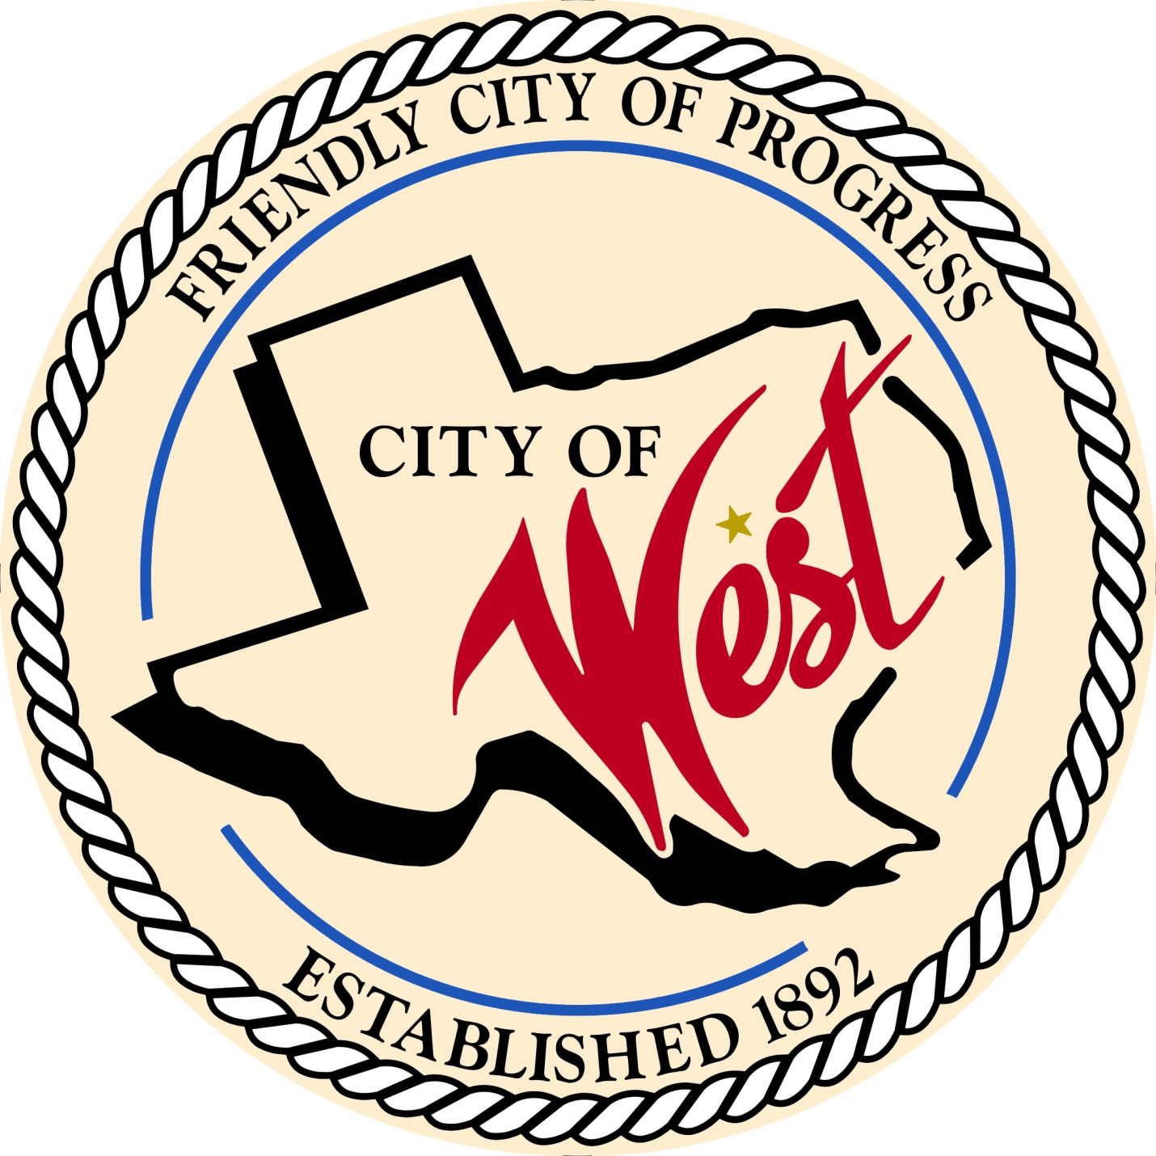

City Council Meeting
APRIL 28, 2023

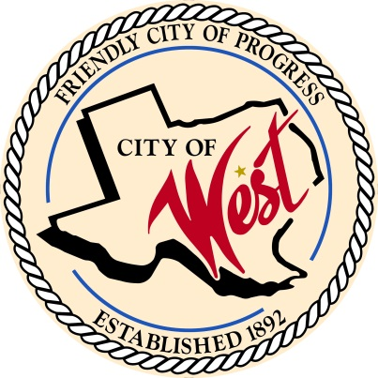
City of West
110 N. Reagan, West, Texas 76691
Phone (254) 826-5351 Fax (254) 826-5969

THE WEST CITY COUNCIL WILL MEET ON FRIDAY, APRIL 28, 2023, AT 8:00 AM IN SPECIAL SESSION LOCATED AT THE WEST COMMUNITY CENTER AT 200 TOKIO ROAD TO DISCUSS ITEMS ON THE AGENDA.

- Call to Order

- Roll Call

- Executive Session: Under the provisions of Government Code 551, the Council will meet in Executive Session to discuss:
- Executive Session: A closed meeting will be held pursuant to Section 551.071 of the Government Code (V.C.T.A.) to consult with an attorney regarding pending or contemplated litigation, as permitted by Section 551.071, of the Texas Open Meetings Act, codified as Chapter 551 of the Texas Government Code. The City Council may also meet in open meeting to take action on matters considered in the closed meeting as required by Section 551.102 of the Open Meetings Act, Chapter 551 of the Texas Government Code.

- Adjourn
CERTIFICATION
I certify that the above notice of meeting was posted on the bulletin board of the West City Hall in the City of West, Texas on the 25th day of April 2023 at 8:40 o’clock a.m.

____________________________
City Secretary Shelly Nors

