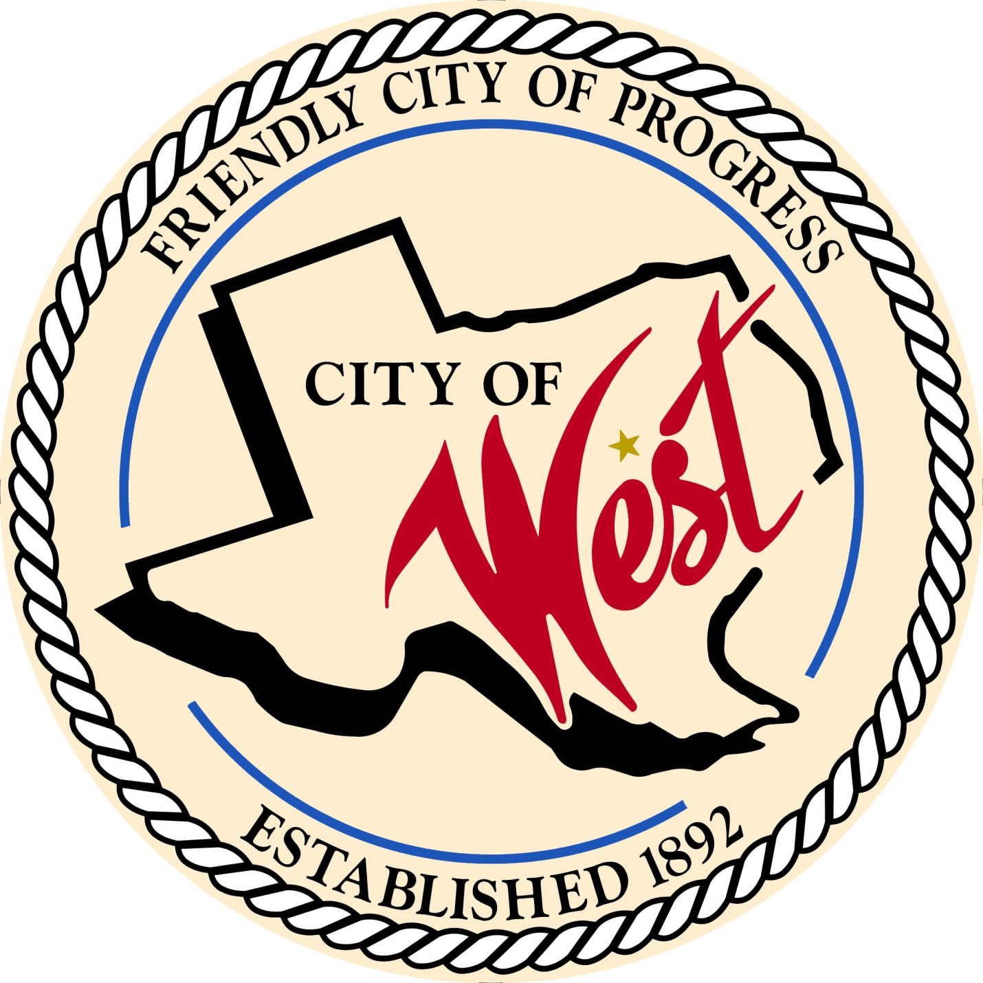

City Council Meeting
MARCH 7, 2023

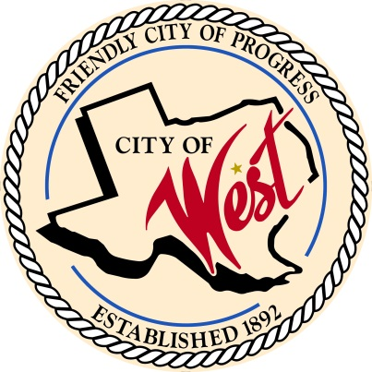
City of West
110 N. Reagan, West, Texas 76691
Phone (254) 826-5351 Fax (254) 826-5969

THE WEST CITY COUNCIL WILL MEET ON TUESDAY, MARCH 7, 2023, AT 5:30 PM IN WORKSHOP LOCATED AT THE WEST COMMUNITY CENTER AT 200 TOKIO ROAD TO DISCUSS ITEMS ON THE AGENDA.

A PUBLIC HEARING WILL START AT 6:00 PM.
The City of West, Texas proposes to enlarge and extend its boundary limits to include the following described territory:
Being 14.22 acres of land located on Grady Calvery Drive, out of the R. Mitchell Survey, Abstract Number 1038, in McLennan County, being a part of the remainder of that called 77.61 acre tract described in a deed to Long & Brock INC., recorded under instrument Number
2022006351 of the Official Public Records of McLennan County, Texas, as requested by Leslie Long.

The City of West, Texas proposes to enlarge and extend its boundary limits to include the following described territory:
Being a 5.356 acre tract of land, located in the Hannibal Callen Jr. survey, abstract no. 1025, McLennan County, Texas, said 5.356 acre tract, being a portion of that called 9.996 acre tract of land recorded in document no. 2017034818, official public records, McLennan County, Texas,
as requested by David Holy.

THE REGULAR COUNCIL MEETING WILL START AFTER THE PUBLIC HEARING.

- Call to Order

- Invocation and Pledge

- Roll Call

- Approve Minutes: February 7 and February 21, 2023.

- Approve Bills: February 2023.

- Discussion, consideration, action, if any, re:
Monthly Departmental Reports
Finance Report
Police Department Report
Public Works Report
Fire Marshal Report
Code/Permitting Report
EMS Report
Engineer Report

- Citizen Comments: Citizens may be heard on any subject, but no discussion by or with Council will be held on any matter not listed on an official agenda as required by law.

- Discussion, consideration, action, if any, re: Approval of Ordinance No. 230307A annexing, for full purposes, approximately 14.22 acres of land and the abutting Grady Calvery Drive right-of-way, in McLennan County, Texas; providing for initial zoning; ratifying a municipal services agreement with the owner (Long & Brock, INC.), providing an effective date.

- Discussion, consideration, action, if any, re: Approval of Ordinance No. 230307B annexing, for full purposes, approximately 5.356 acres of land and the abutting Playdium Drive right-of-way, in McLennan County, Texas; providing for initial zoning; ratifying a municipal services agreement with the owner (David Holy), providing an effective date.

- Discussion, consideration, action, if any, re: Stephanie Gray requesting permission to block N. Roberts Street on Sunday, April 23, 2023, for the Cole Simmons Memorial Scholarship Fundraiser.

- Discussion, consideration, action, if any, re: Overview and explanation of QIPP Program.

- Discussion, consideration, action, if any, re: Approval of Water/Wastewater Rate Study.

- Discussion, consideration, action, if any, re: Overview of bid and approval of Reagan Street project.

- Discussion, consideration, action, if any, re: Rescinding of Ordinance No. 230207C, Overnight parking ordinance – Natalie Kelinske.

- Discussion, consideration, action, if any, re: Approval of Ordinance No. 230307C, parade parking – Natalie Kelinske.

- Discussion, consideration, action, if any, re: Approval/updating of Ordinance No. 230307D regarding Chapter 13, solid waste – Bill Hunt.

- Discussion, consideration, action, if any, re: Amendment of Golf Cart regulations, replacement of the language currently found in the Code of Ordinances Sec 12.06 – Chief White.

- Discussion, consideration, action, if any, re: Enforcement and/or any updates/amendments to City Ordinance relating to sex offender residency which is listed in Chapter 8 of the Code – Chief White.

- Discussion, consideration, action, if any, re: West Police Department policy in reference to “Take Home Car” rules/guidelines – Chief White.

- Discussion, consideration, action, if any, re: Approve resolution regarding Jag Grant No. 4754301 and appointing the mayor as the authorized official – Chief White.

- Discussion, consideration, action, if any, re: Approve resolution regarding Homeland Security Grant No. 4838501 and appointing the mayor as the authorized official – Chief White.

- Discussion, consideration, action, if any, re: City contract processes – Natalie Kelinske.

- Discussion, consideration, action, if any, re: Changing a portion of Stillmeadow Drive to Memorial Drive – Joe Pustejovsky.

- Discussion, consideration, action, if any, re: Review holiday lighting and installation under the hotel tax budget.

- Discussion, consideration, action, if any, re: Approval of final plat Playdium Estates Phase II – David Holy.

- Discussion, consideration, action, if any, re: Approval of final plat for Grady Calvery North – Long & Brock.

- Council member comments and requests for items to be placed on future agendas.

- Adjourn
CERTIFICATION
I certify that the above notice of meeting was posted on the bulletin board of the West City Hall in the City of West, Texas on the 3rd day of March 2023 at 9:30 o’clock a.m.

____________________________
City Secretary Shelly Nors

