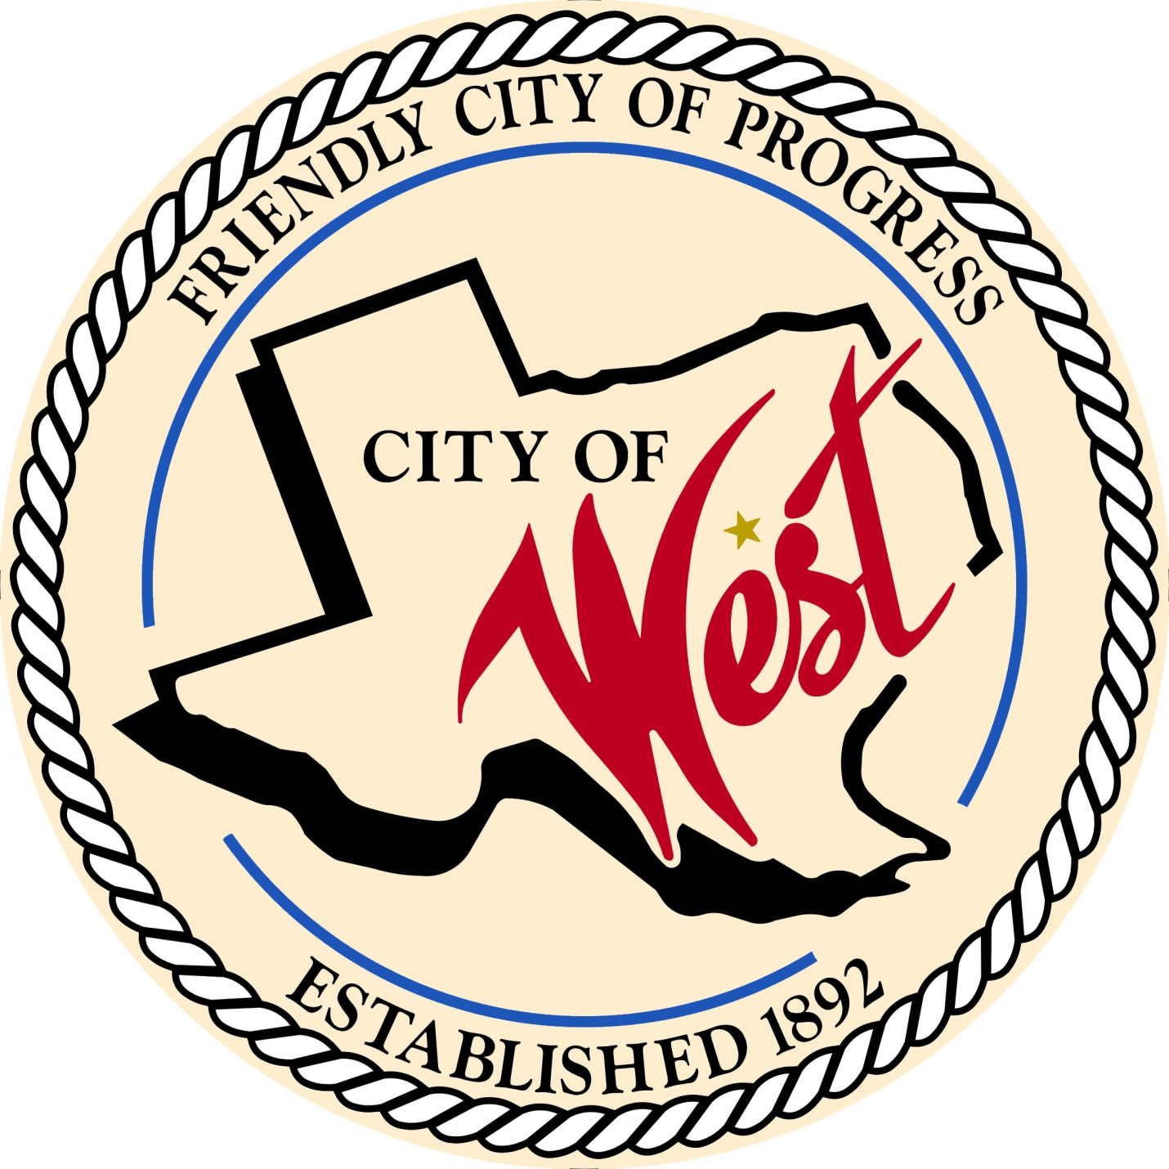

City Council Workshop
MARCH 28, 2023

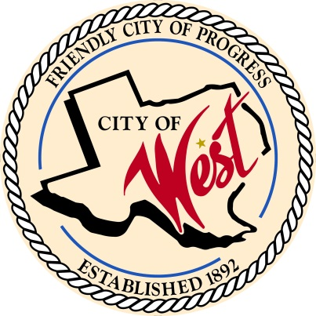
City of West
110 N. Reagan, West, Texas 76691
Phone (254) 826-5351 Fax (254) 826-5969

THE WEST CITY COUNCIL WILL MEET ON TUESDAY, MARCH 28, 2023, AT 5:30 PM IN WORKSHOP LOCATED AT THE WEST COMMUNITY CENTER AT 200 TOKIO ROAD TO DISCUSS THE FOLLOWING ITEMS:

- Call to Order

- Roll Call

- Discussion, consideration, action, if any, re: Water, street, and infrastructure projects for the city.

- Adjourn
CERTIFICATION
I certify that the above notice of meeting was posted on the bulletin board of the West City Hall in the City of West, Texas on the 24th day of March 2023 at 2:25 o’clock p.m.
____________________________
City Secretary Shelly Nors

