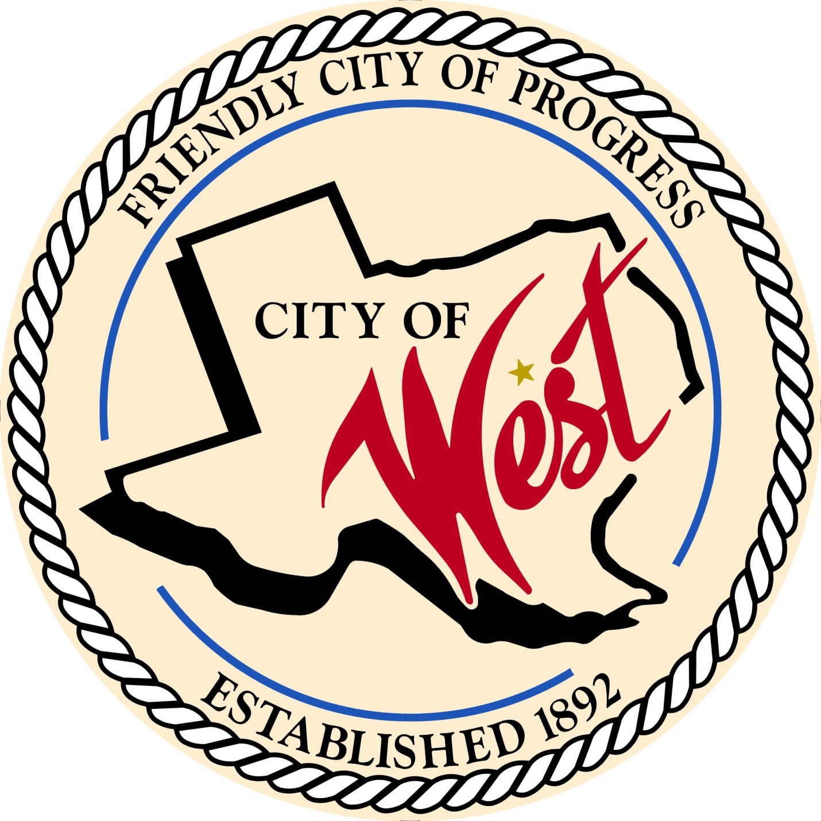

City Council Meeting
APRIL 4, 2023

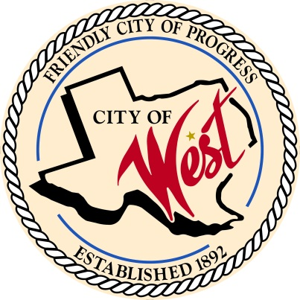
City of West
110 N. Reagan, West, Texas 76691
Phone (254) 826-5351 Fax (254) 826-5969

THE WEST CITY COUNCIL WILL MEET ON TUESDAY, APRIL 4, 2023, AT 5:00 PM IN WORKSHOP LOCATED AT THE WEST COMMUNITY CENTER AT 200 TOKIO ROAD TO DISCUSS ITEMS ON THE AGENDA.
THE REGULAR COUNCIL MEETING WILL START AT 6:00 PM.

- Call to Order

- Invocation and Pledge

- Roll Call

- Approve Minutes: March 7, 2023.

- Approve Bills: March 2023.

- Discussion, consideration, action, if any, re:
Monthly Departmental Reports
Finance Report
Police Department Report
Public Works Report
Fire Marshal Report
Code/Permitting Report
EMS Report
Engineer Report

- Citizen Comments: Citizens may be heard on any subject, but no discussion by or with Council will be held on any matter not listed on an official agenda as required by law.

- Discussion, consideration, action, if any, re: Sabrina Norton – explanation of Frontier Waste contract.

- Discussion, consideration, action, if any, re: Approval/updating of Ordinance No. 230404 regarding Chapter 13, solid waste – Bill Hunt.

- Discussion, consideration, action, if any, re: Consider and approve an Ordinance authorizing the issuance of “City of West, Texas, Combination Tax and Revenue Certificates of Obligation, Series 2023”; specifying the terms and features of such certificates; providing for the payment of such certificates by the levy of an ad valorem tax upon all taxable property within the City and a limited pledge of the net revenues from the operation of the City’s Waterworks and Sewer System; and resolving other matters incident and related thereto.

- Discussion, consideration, action, if any, re: Greater Waco Sports Commission.

- Discussion, consideration, action, if any, re: Overview and explanation of QIPP Program.

- Discussion, consideration, action, if any, re: Closing part of Main Street on June 10, 2023, for street dance – Matt Nemec.

- Discussion, consideration, action, if any, re: Approval of Water/Wastewater Rate Study.

- Discussion, consideration, action, if any, re: Awarding a construction contract for the Wastewater Treatment Plant Expansion Project, as recommended by the City Engineer, Walker Partners, LLC, and authorizing the mayor to execute all documents necessary to complete this transaction.

- Discussion, consideration, action, if any, re: Awarding a construction contract for the Reagan/Marable/Davis Street Improvements Project, as recommended by the City Engineer, Walker Partners, LLC, and authorizing the mayor to execute all documents necessary to complete this transaction.

- Discussion, consideration, action, if any, re: West ISD Senior Class parade, Saturday, May 20, 2023, at 10:00 AM.

- Discussion, consideration, action, if any, re: Memorial Drive – Joe Pustejovsky.

- Discussion, consideration, action, if any, re: Seeking authorization to contract with Tyler Technologies to replace records management system from COPsync’s RMS – Chief White.

- Discussion, consideration, action, if any, re: Police department budget adjustments from previous police administration mistakes and corrective measures concerning patrol car camera systems/body camera systems – Chief White.

- Executive Session: Under the provisions of Government Code 551, the Council will meet in Executive Session to discuss:
1). Executive Session: A closed meeting will be held pursuant to Section 551.071 of the Government Code (V.C.T.A.) to receive legal advice and discuss pending or contemplated litigation, or a settlement offer, as permitted by Section 551.071, of the Texas Open Meetings Act, codified as Chapter 551 of the Texas Government Code. The City Council may also meet in open meeting to take action on matters considered in the closed meeting as required by Section 551.102 of the Open Meetings Act, Chapter 551 of the Texas Government Code.

- Council member comments and requests for items to be placed on future agendas.

- Adjourn
CERTIFICATION
I certify that the above notice of meeting was posted on the bulletin board of the West City Hall in the City of West, Texas on the 31st day of March 2023 at 12:00 o’clock p.m.

____________________________
City Secretary Shelly Nors

