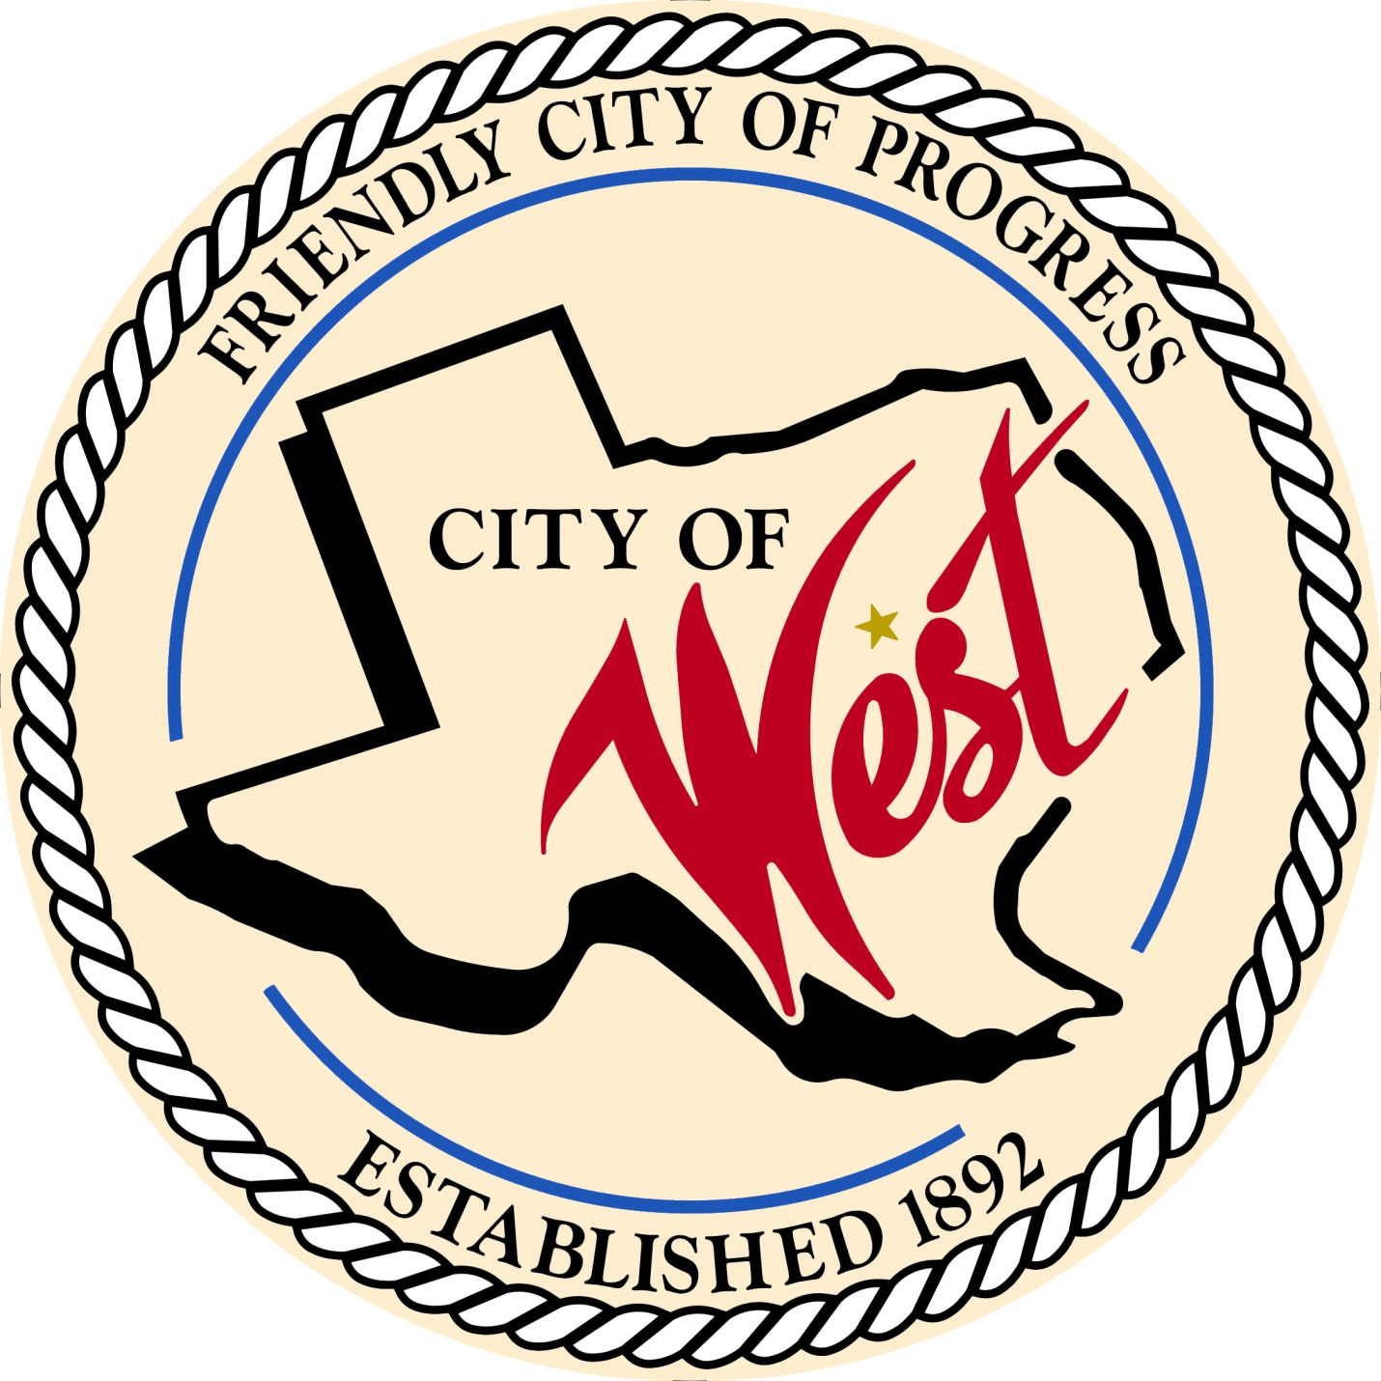

City Council Meeting
FEBRUARY 7, 2023

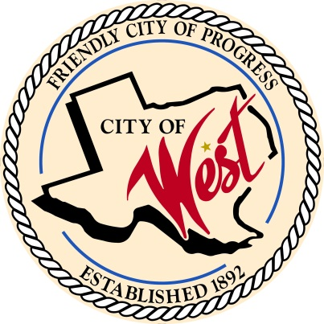
City of West
110 N. Reagan, West, Texas 76691
Phone (254) 826-5351 Fax (254) 826-5969

THE WEST CITY COUNCIL WILL MEET ON TUESDAY, FEBRUARY 7, 2023, AT 5:30 PM IN WORKSHOP LOCATED AT THE WEST COMMUNITY CENTER AT 200 TOKIO ROAD TO DISCUSS ITEMS ON THE AGENDA.

A PUBLIC HEARING WILL START AT 6:00 PM.
The City of West, Texas proposes to enlarge and extend its boundary limits to include the following described territory:
Approximately 30.0 acres of land located at 825 Cottonwood Road (site of new West Elementary School) and 1.84 acres, more or less, of FM 2114 public right of way, located in the Hannibal D. Callen Survey, Abstract No, 260, McLennan County, Texas.

THE REGULAR COUNCIL MEETING WILL START AFTER THE PUBLIC HEARING.

- Call to Order

- Invocation and Pledge

- Roll Call

- Approve Minutes: January 3, January 9, January 19, and January 27, 2023.

- Approve Bills: January 2023.

- Discussion, consideration, action, if any, re:
Monthly Departmental Reports
Finance Report
Police Department Report
Public Works Report
Fire Marshal Report
Code/Permitting Report
EMS Report
Engineer Report

- Citizen Comments: Citizens may be heard on any subject, but no discussion by or with Council will be held on any matter not listed on an official agenda as required by law.

- Discussion, consideration, action, if any, re: Approval of Ordinance No. 230207A annexing, for full purposes, approximately 30.00 acres of land, located at 825 Cottonwood Rd., and 1.84 acres, more or less, of FM 2114 public right-of-way, (FM 2114), in McLennan County, Texas; and ratifying a municipal services agreement with the owner, West ISD, providing an effective date.

- Discussion, consideration, action, if any, re: Approval of Ordinance No. 230207B establishing speed limits on specified public roadways within the city limits of the City of West, pursuant to section 545.356 of the Texas transportation code; providing penalties, providing an effective date, repealer, severability, and proper notice and hearing.

- Discussion, consideration, action, if any, re: Awarding a construction contract for the CDBG CDV21-0430 Playdium Drive Wastewater Improvements, Phase 2 Project, as recommended by the City Engineer, Walker Partners, LLC, and authorizing the Mayor to execute all documents necessary to complete this transaction.

- Discussion, consideration, action, if any, re: Golf cart licensing – Nicole Nemec.

- Discussion, consideration, action, if any, re: Junior Girl Scout Troop 7074 recycling project - Abigayle Melton.

- Discussion, consideration, action, if any, re: Rise Up Fitness, requesting water south of their current location – Jonathan Morris.

- Discussion, consideration, action, if any, re: Request to waive fire suppression for downtown historic theater building – Austin Brock.

- Discussion, consideration, action, if any, re: Approval of a resolution of support from the West City Council for The West Apartments located at 625 E Tokio Rd., West, TX to receive funding from the Texas Department of Housing and Community Affairs for renovations.

- Discussion, consideration, action, if any, re: Overnight parking ordinance – Natalie Kelinske.

- Discussion, consideration, action, if any, re: Parade parking ordinance – Natalie Kelinske.

- Discussion, consideration, action, if any, re: Event/parade permit – Natalie Kelinske.

- Discussion, consideration, action, if any, re: Fronter Waste exclusive commercial roll off agreement – Bill Hunt.

- Discussion, consideration, action, if any, re: Updating employee handbook regarding notice of resignation of employment.

- Council member comments and requests for items to be placed on future agendas.

- Adjourn
CERTIFICATION
I certify that the above notice of meeting was posted on the bulletin board of the West City Hall in the City of West, Texas on the 3rd day of February 2023 at 9:30 o’clock a.m.

____________________________
City Secretary Shelly Nors

