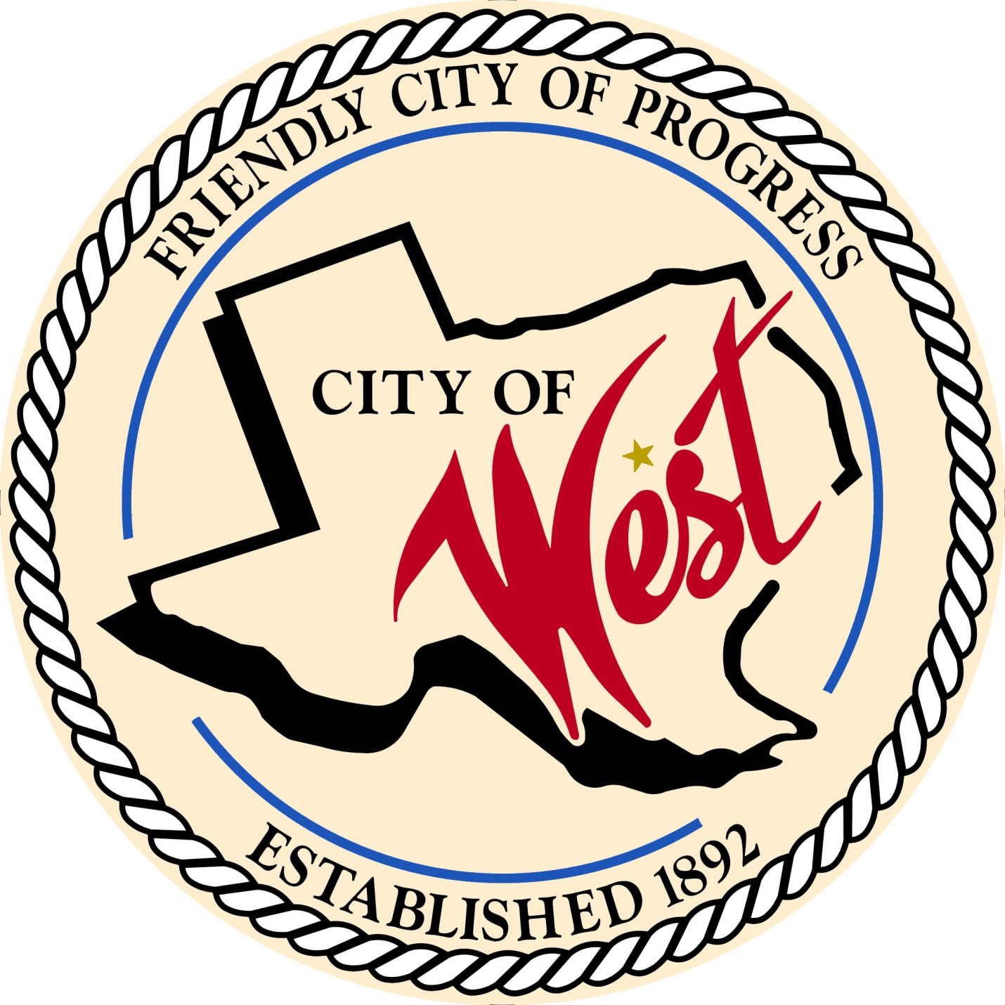

City Council Meeting
February 21, 2023

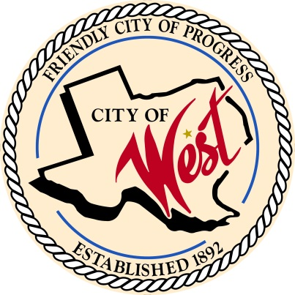
City of West
110 N. Reagan, West, Texas 76691
Phone (254) 826-5351 Fax (254) 826-5969

THE WEST CITY COUNCIL WILL MEET ON TUESDAY, FEBRUARY 21, 2023, AT 8:00 AM AT WEST CITY HALL AT 110 NORTH REAGAN TO DISCUSS ITEMS ON THE AGENDA.

- Call to Order

- Roll Call

- Discussion, consideration, action, if any, re: Overview of bid and approval of Reagan Street project.

- Adjourn
CERTIFICATION
I certify that the above notice of meeting was posted on the bulletin board of the West City Hall in the City of West, Texas on the 16th day of February 2023 at 2:25 o’clock p.m.
____________________________
City Secretary Shelly Nors

