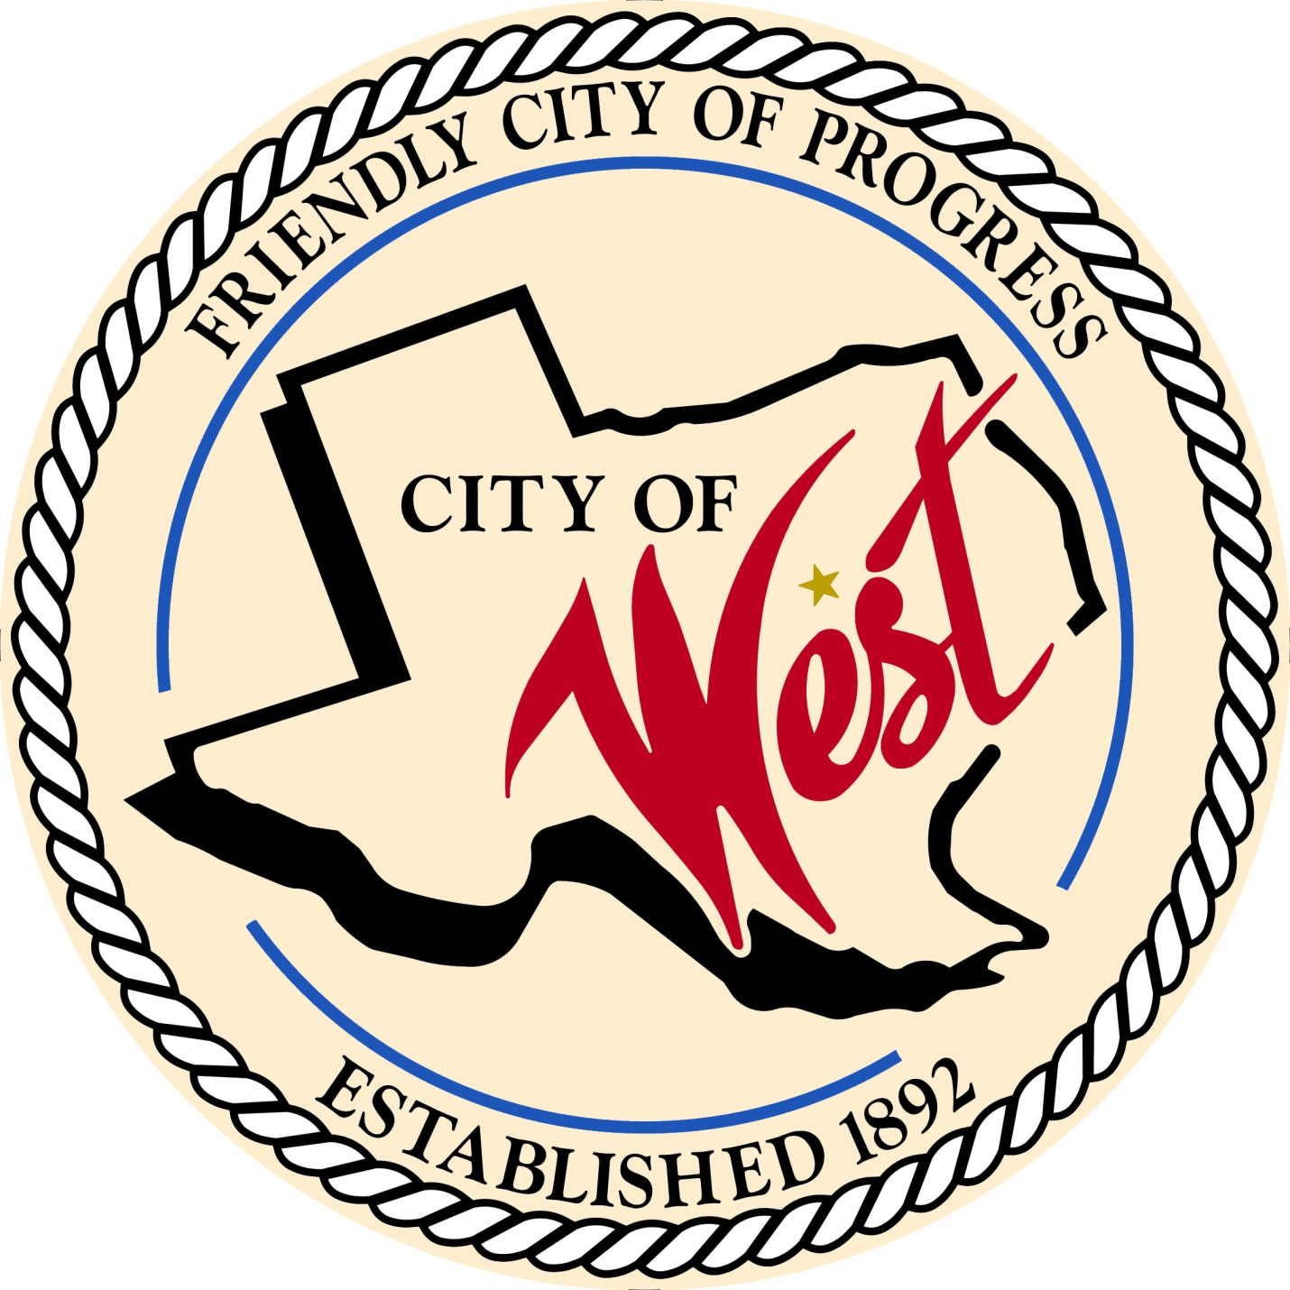

City Council Meeting
January 27, 2023

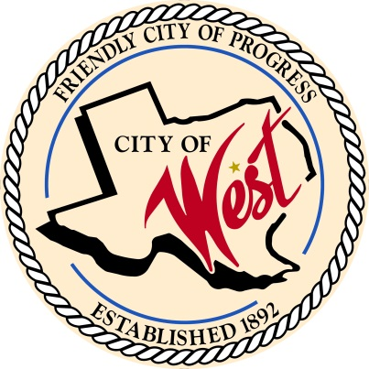
City of West
110 N. Reagan, West, Texas 76691
Phone (254) 826-5351 Fax (254) 826-5969

THE WEST CITY COUNCIL WILL MEET ON FRIDAY JANUARY 27, 2023, AT 7:30 AM AT CITY HALL AT 110 N REAGAN TO DISCUSS ITEMS ON THE AGENDA.

- Call to Order

- Roll Call

- Discussion, consideration, action, if any, re: Proceed with one year commitment to enter QIPP agreement.

- Adjourn
CERTIFICATION
I certify that the above notice of meeting was posted on the bulletin board of the West City Hall in the City of West, Texas on the 23rd day of January 2023 at 4:00 o’clock p.m.
____________________________
City Secretary Shelly Nors

