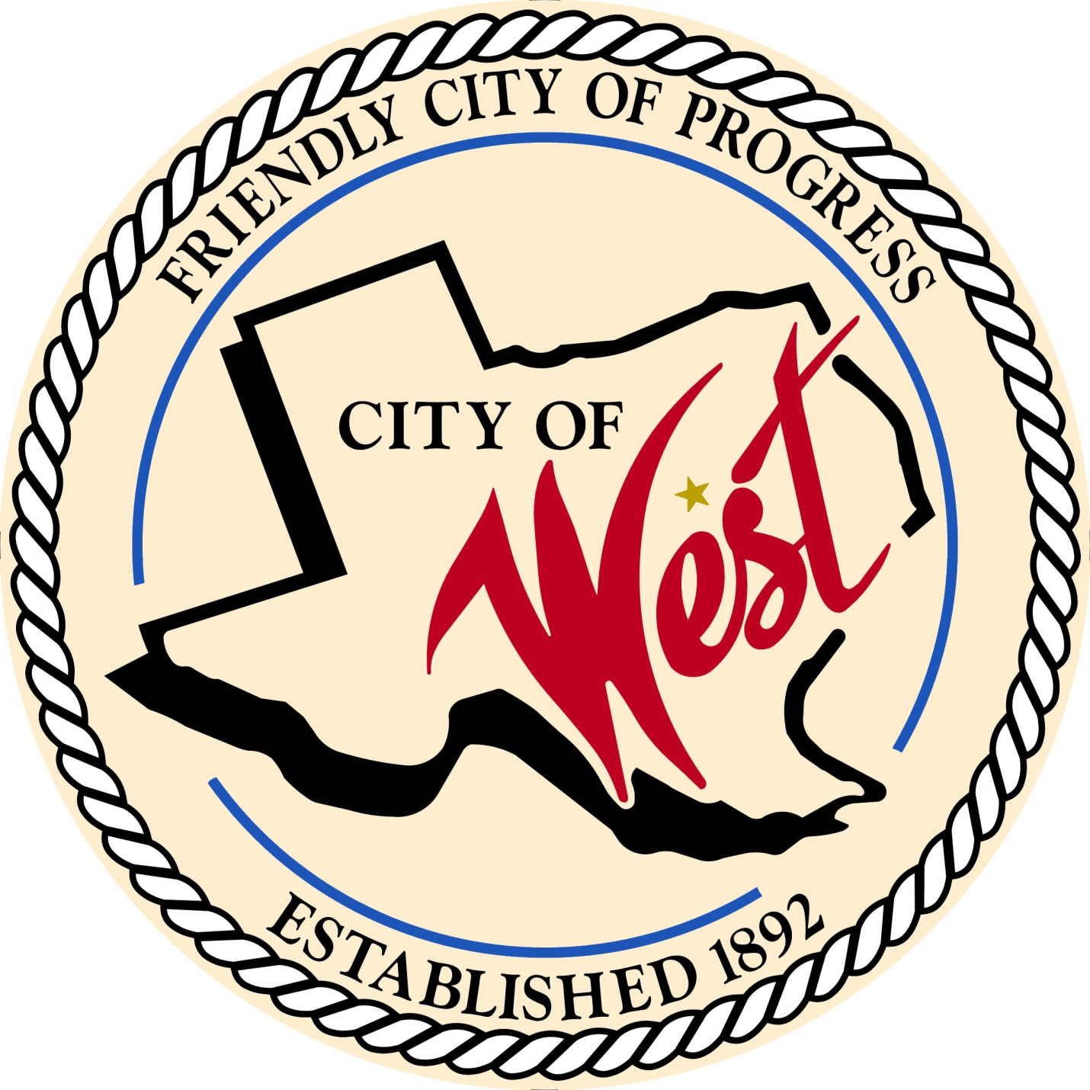

City Council Meeting
JANUARY 3, 2023

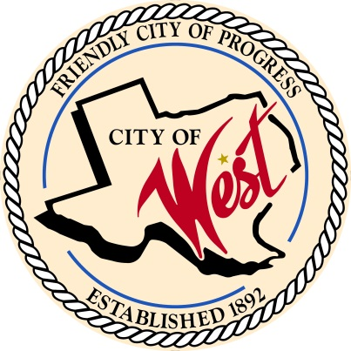
City of West
110 N. Reagan, West, Texas 76691
Phone (254) 826-5351 Fax (254) 826-5969

THE WEST CITY COUNCIL WILL MEET ON TUESDAY, JANUARY 3, 2023, AT 5:30 PM IN WORKSHOP LOCATED AT THE WEST COMMUNITY CENTER AT 200 TOKIO ROAD TO DISCUSS ITEMS ON THE AGENDA.

THE REGULAR COUNCIL MEETING WILL START AT 6:00 PM.

- Call to Order

- Invocation and Pledge

- Roll Call

- Approve Minutes: December 6 and December 12, 2022.

- Approve Bills: December 2022.

- Discussion, consideration, action, if any, re:

Monthly Departmental Reports
Finance Report
Police Department Report
Public Works Report
Fire Marshal Report
Code/Permitting Report
EMS Report
Engineer Report

- Citizen Comments: Citizens may be heard on any subject, but no discussion by or with Council will be held on any matter not listed on an official agenda as required by law.

- Discussion, consideration, action, if any, re: Approval of 2021 – 2022 financial audit.

- Discussion, consideration, action, if any, re: Resolution directing publication of notice of intention to issue Combination Tax and Revenue Certificates of Obligation; and resolving other matters relating to the subject.

- Discussion, consideration, action, if any, re: Installation of slow curve sign or speed bump at Holt/Davis St. – Donna Davis/Chief Chris White.

- Discussion, consideration, action, if any, re: Golf Carts and Off-Highway vehicles use ordinance – Chief Chris White.

- Discussion, consideration, action, if any, re: Basketball court repairs for City Park – Mayor Muska.

- Discussion, consideration, action, if any, re: Approval of quote for rubber mulch for city park playground from Child’s Play, Inc. for $4,482.00 – Mayor Muska.

- Discussion, consideration, action, if any, re: Approval of landscaping quotes for Community Center and Welcome to West sign from GreenLife Nursery and Landscaping – Mayor Muska.

- Discussion, consideration, action, if any, re: Frontier Waste Solutions price increase on city trash services effective February 1, 2023.

- Discussion, consideration, action, if any, re: Enforcement of water service fees - $50.00

- Executive Session: Under the provisions of Government Code 551, the Council will meet in Executive Session to discuss:
1). Executive Session: A closed meeting will be held pursuant to Section 551.074 of the Government Code (V.C.T.A.) to address legal enforcement of city ordinances.

- Discussion, consideration, action, if any, re: Address legal enforcement of city ordinances.

- Council member comments and requests for items to be placed on future agendas.

- Adjourn
CERTIFICATION
I certify that the above notice of meeting was posted on the bulletin board of the West City Hall in the City of West, Texas on the 30th day of December 2022 at 9:30 o’clock a.m.

____________________________
City Secretary Shelly Nors

