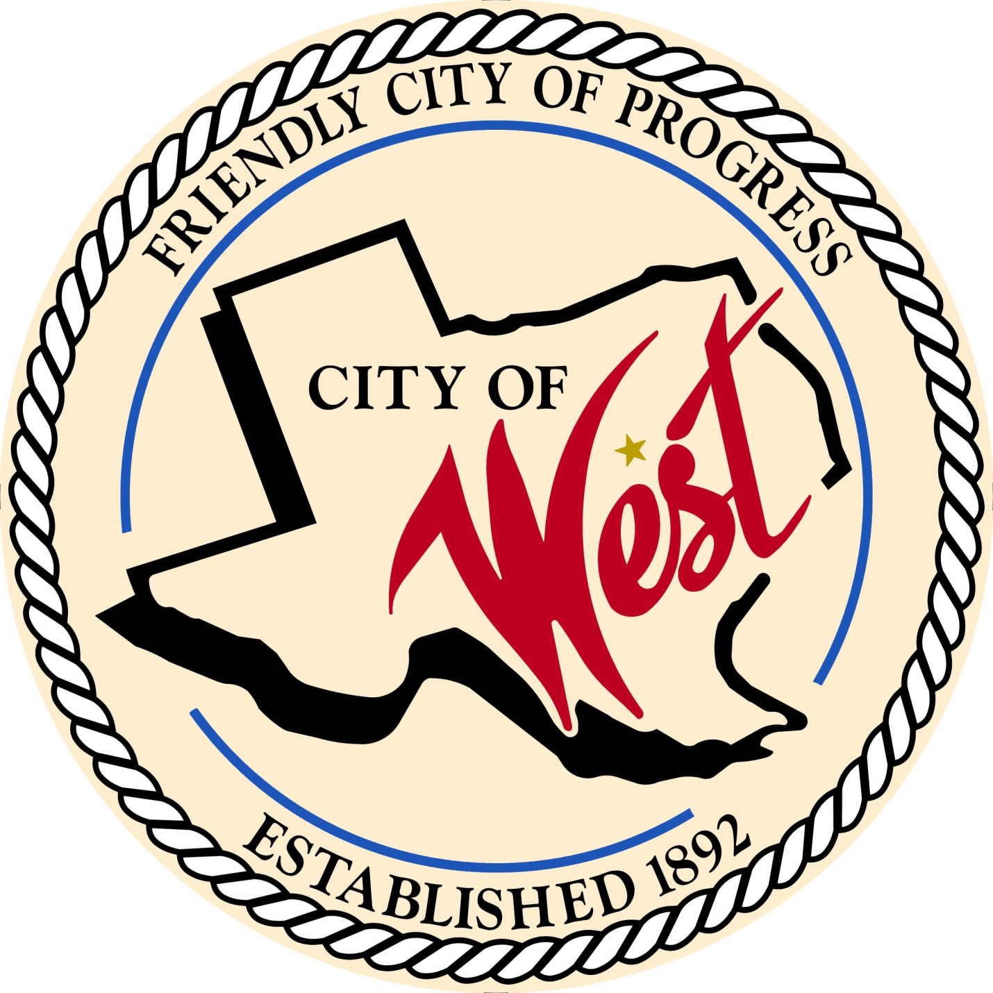

City Council Meeting
DECEMBER 6, 2022

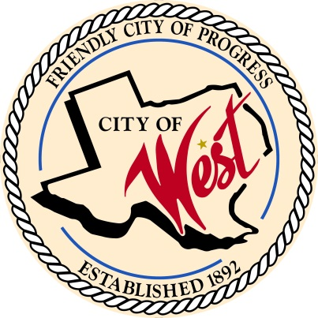
City of West
110 N. Reagan, West, Texas 76691
Phone (254) 826-5351 Fax (254) 826-5969

THE WEST CITY COUNCIL WILL MEET ON TUESDAY, DECEMBER 6, 2022, AT 5:30 PM IN WORKSHOP LOCATED AT THE WEST COMMUNITY CENTER AT 200 TOKIO ROAD TO DISCUSS ITEMS ON THE AGENDA.

THE REGULAR COUNCIL MEETING WILL START AT 6:00 PM.

- Call to Order

- Invocation and Pledge

- Roll Call

- Discussion, consideration, action, if any, re: Oath of Office – swearing in of newly elected council members.

- Discussion, consideration, action, if any, re: Appointment of City Judge.

- Discussion, consideration, action, if any, re: Appointment of Associate City Judge.

- Discussion, consideration, action, if any, re: Appointment of City Attorney.

- Discussion, consideration, action, if any, re: Appointment of City Fire Marshal.

- Discussion, consideration, action, if any, re: Appointment of Mayor Pro-Tem

- Approve Minutes: November 1, November 15, and November 21, 2022.

- Approve Bills: November 2022.

- Recognition and appreciation of former City Council Member, Steve Vanek.

- Discussion, consideration, action, if any, re:

Monthly Departmental Reports
Finance Report
Police Department Report
Public Works Report
Fire Marshal Report
Code/Permitting Report
EMS Report
Engineer Report

- Citizen Comments: Citizens may be heard on any subject, but no discussion by or with Council will be held on any matter not listed on an official agenda as required by law.

- Discussion, consideration, action, if any, re: Installation of slow curve sign or speed bump at Holt/Davis St. – Donna Davis.

- Discussion, consideration, action, if any, re: Alley abandonment – Trevor Beuerlein

- Discussion, consideration, action, if any, re: Approval of annexation of Grady Calvery North Addition. – Leslie Long.

- Discussion, consideration, action, if any, re: Guerrero annexation request – David Pratka.

- Discussion, consideration, action, if any, re: Approval of 2022/2023 Hotel-Motel budget.

- Discussion, consideration, action, if any, re: Use of ATVs by public and private schools.

- Executive Session: Under the provisions of Government Code 551, the Council will meet in Executive Session to discuss:
1). Executive Session: A closed meeting will be held pursuant to Section 551.074 of the Government Code (V.C.T.A.) to address the pay scale for the West Police Department.
2).Executive Session: A closed meeting will be held pursuant to Section 551.074 of the Government Code (V.C.T.A.) to address reporting access/requirements between West EMS and City of West EMC/Fire Marshal.

- Discussion, consideration, action, if any, re: Approve the pay scale for the West Police Department.

- Council member comments and requests for items to be placed on future agendas.

- Adjourn
CERTIFICATION
I certify that the above notice of meeting was posted on the bulletin board of the West City Hall in the City of West, Texas on the 1st day of December 2022 at 4:30 o’clock p.m.

____________________________
City Secretary Shelly Nors

