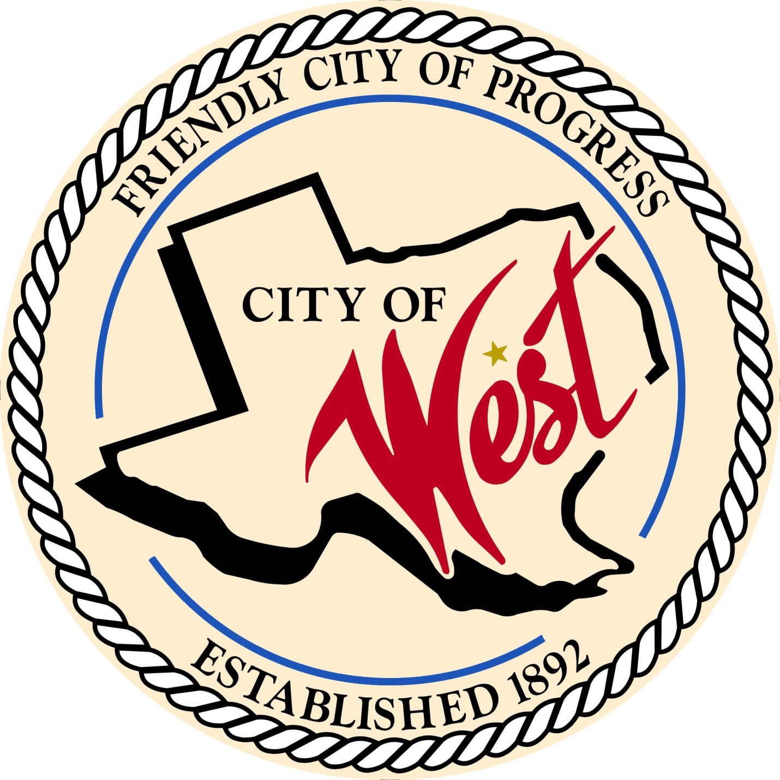

City Council Meeting
DECEMBER 12, 2022

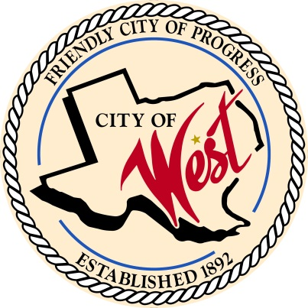
City of West
110 N. Reagan, West, Texas 76691
Phone (254) 826-5351 Fax (254) 826-5969

THE WEST CITY COUNCIL WILL MEET ON MONDAY, DECEMBER 12, 2022, AT 7:45 AM AT WEST CITY HALL AT 110 N. REAGAN TO DISCUSS ITEMS ON THE AGENDA.

- Call to Order

- Roll Call

- Executive Session: Under the provisions of Government Code 551, the Council will meet in Executive Session to discuss:
1). Executive Session: A closed meeting will be held pursuant to Section 551.074 of the Government Code (V.C.T.A.) to address the pay scale for the West Police Department.

- Discussion, consideration, action, if any, re: Approve the pay scale for the West Police Department.

- Discussion, consideration, action, if any, re: Patrol vehicles for police department 2022-2023 fiscal year budget.

- Adjourn
CERTIFICATION
I certify that the above notice of meeting was posted on the bulletin board of the West City Hall in the City of West, Texas on the 7th day of December 2022 at 11:10 o’clock a.m.

____________________________
City Secretary Shelly Nors

