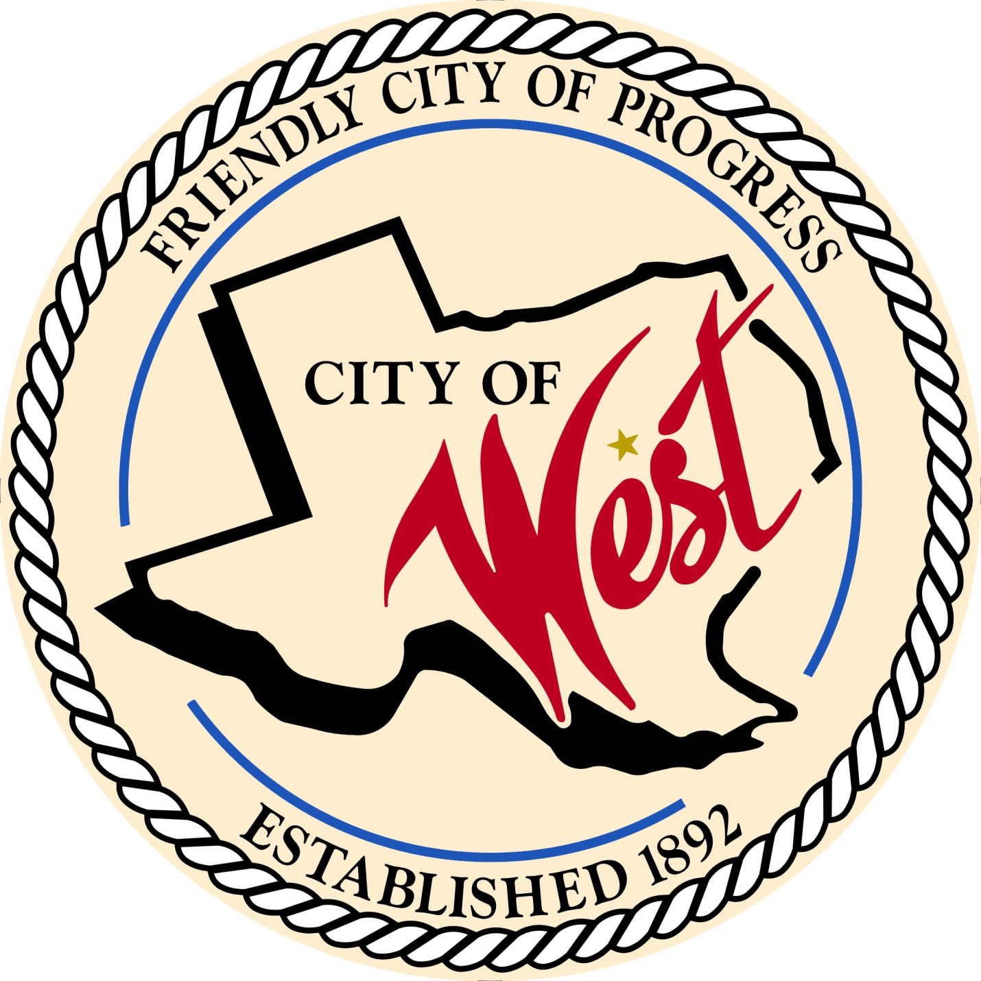

City Council Meeting
NOVEMBER 15, 2022

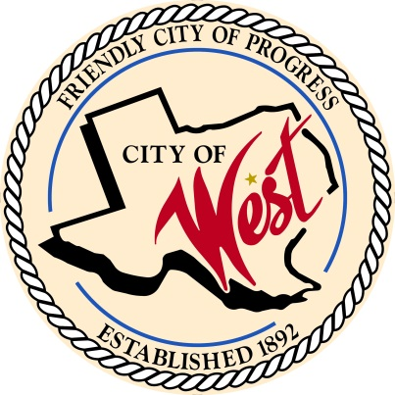
City of West
110 N. Reagan, West, Texas 76691
Phone (254) 826-5351 Fax (254) 826-5969

THE WEST CITY COUNCIL WILL MEET ON TUESDAY, NOVEMBER 15, 2022, AT 5:30 PM AT THE WEST COMMUNITY CENTER AT 200 TOKIO ROAD TO DISCUSS ITEMS ON THE AGENDA.

- Call to Order

- Roll Call

- Executive Session: Under the provisions of Government Code 551, the Council will meet in Executive Session to discuss:
1). Executive Session: A closed meeting will be held pursuant to Section 551.074 of the Government Code (V.C.T.A.) to conduct Police Chief interviews.

- Discussion, consideration, action, if any, re: Hiring of City of West Police Chief.

- Adjourn
CERTIFICATION
I certify that the above notice of meeting was posted on the bulletin board of the West City Hall in the City of West, Texas on the 10th day of November 2022 at 5:00 o’clock p.m.
____________________________
City Secretary Shelly Nors

