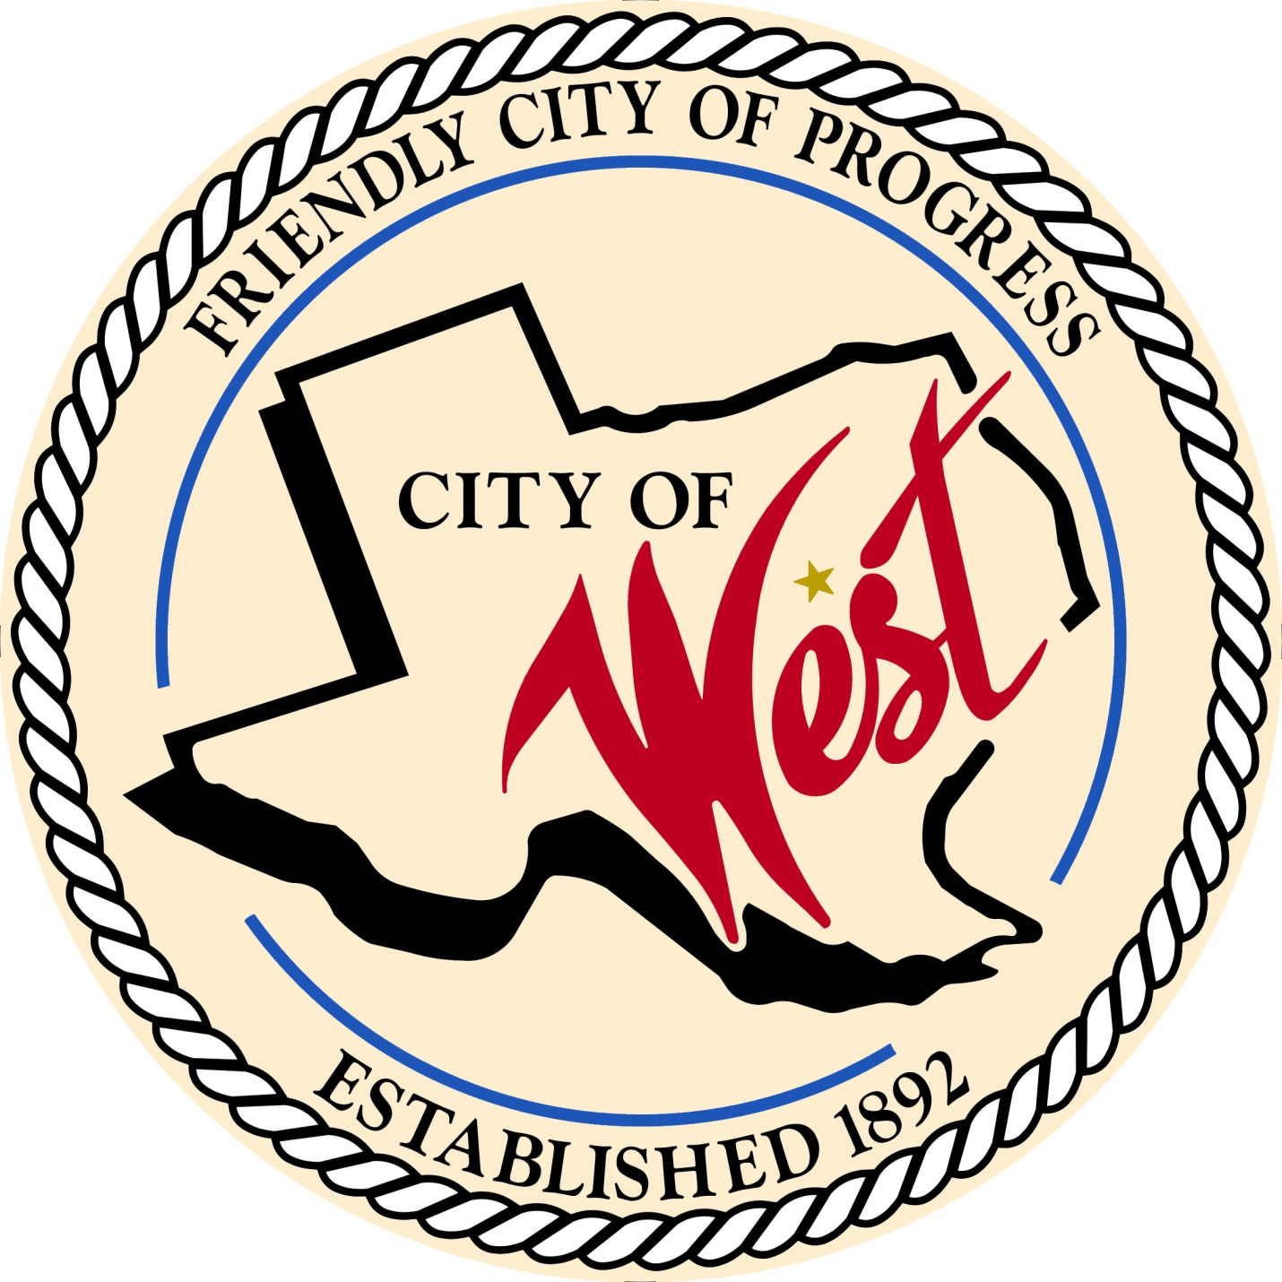

City Council Meeting
NOVEMBER 1, 2022

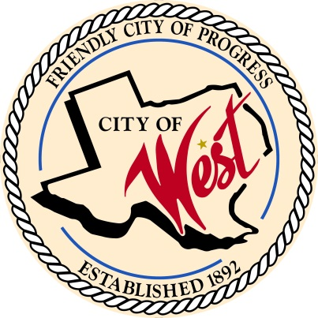
City of West
110 N. Reagan, West, Texas 76691
Phone (254) 826-5351 Fax (254) 826-5969

THE WEST CITY COUNCIL WILL MEET ON TUESDAY, NOVEMBER 1, 2022, AT 5:30 PM IN WORKSHOP LOCATED AT THE WEST COMMUNITY CENTER AT 200 TOKIO ROAD TO DISCUSS ITEMS ON THE AGENDA.

THE REGULAR COUNCIL MEETING WILL START AT 6:00 PM.

- Call to Order

- Invocation and Pledge

- Roll Call

- Approve Minutes: October 4, 2022.

- Approve Bills: October 2022.

- Discussion, consideration, action, if any, re: Monthly Departmental Reports
Finance Report
Police Department Report
Public Works Report
Fire Marshal Report
Code/Permitting Report
Engineer Report
EMS Report

- Citizen Comments: Citizens may be heard on any subject, but no discussion by or with Council will be held on any matter not listed on an official agenda as required by law.

- Discussion, consideration, action, if any, re: Update on police department construction and approve Steve Vanek as building consultant until complete.

- Discussion, consideration, action, if any, re: Welcome to West sign.

- Discussion, consideration, action, if any, re: Amend and review ordinance regarding dogs at large.

- Executive Session: Under the provisions of Government Code 551, the Council will meet in Executive Session to discuss:
1). Executive Session: A closed meeting will be held pursuant to Section 551.087 of the Government Code (V.C.T.A.) to address a potential economic development, project 1-A.

- Council member comments and requests for items to be placed on future agendas.

- Adjourn
CERTIFICATION
I certify that the above notice of meeting was posted on the bulletin board of the West City Hall in the City of West, Texas on the 28th day of October 2022 at 2:30 o’clock p.m.
____________________________
City Secretary Shelly Nors

