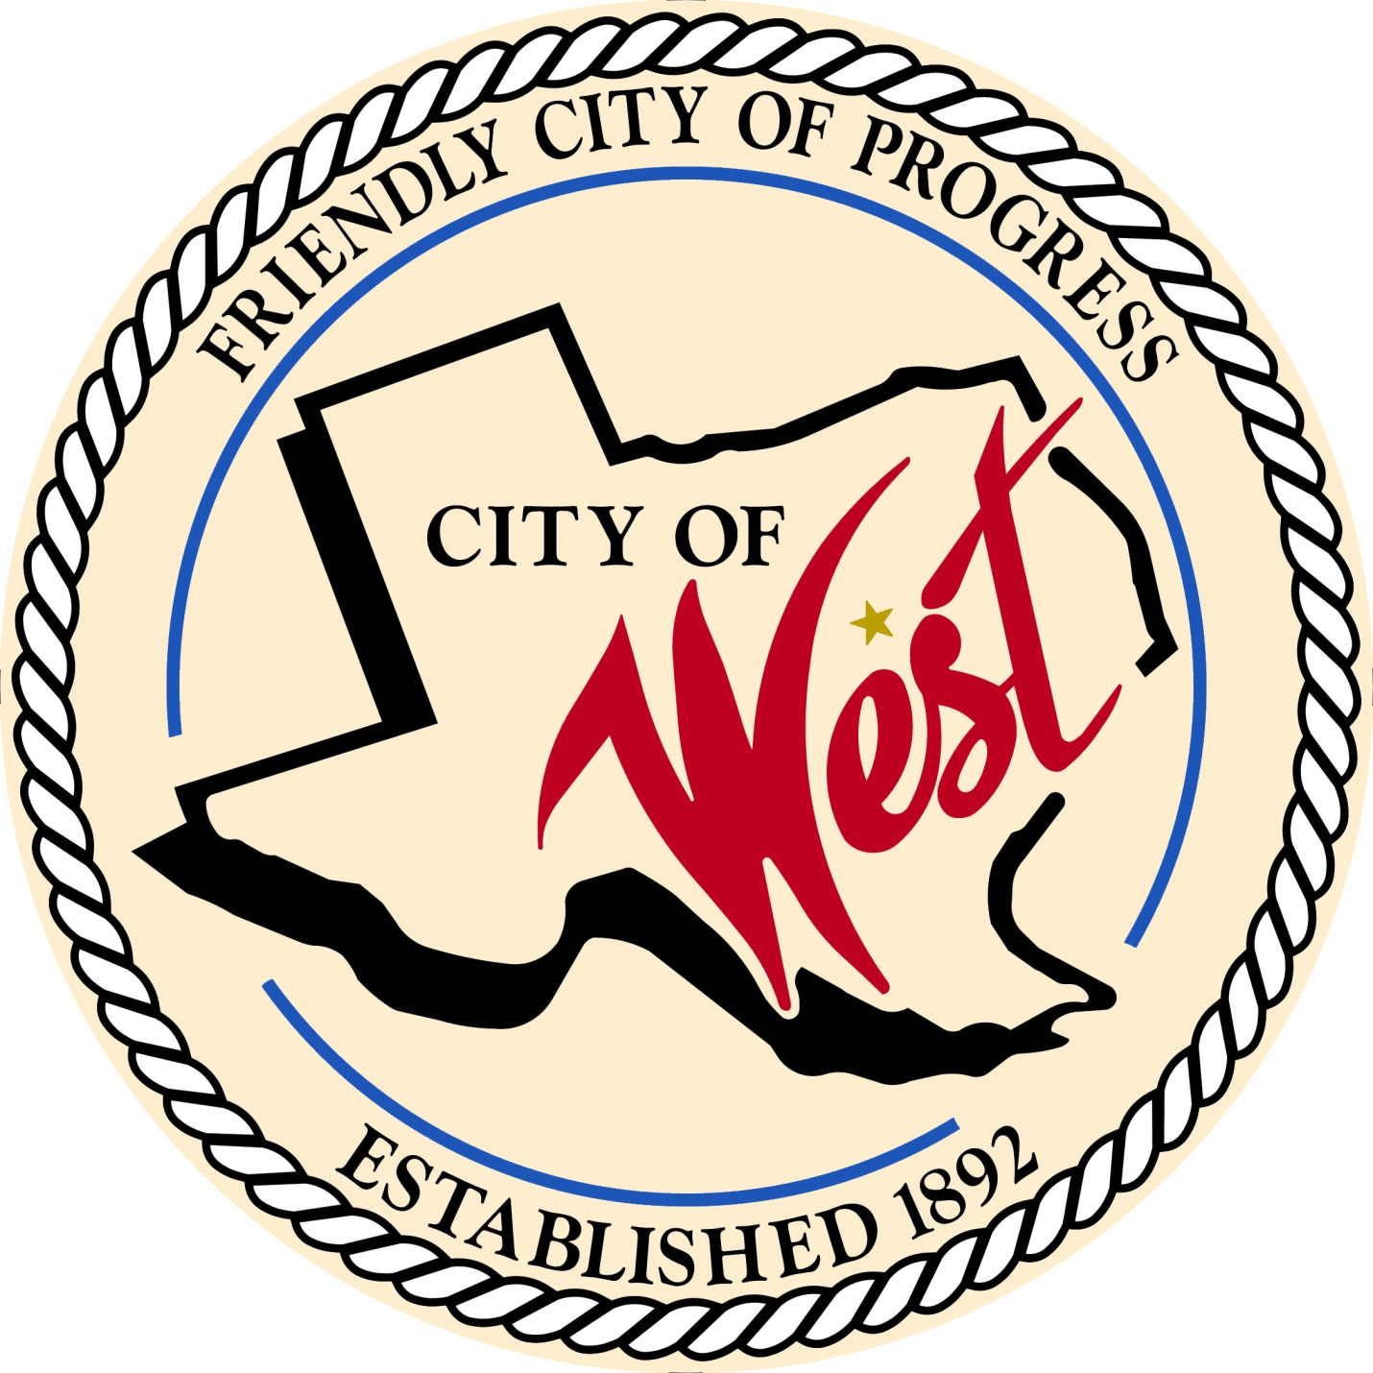

City Council Meeting
MAY 7, 2022

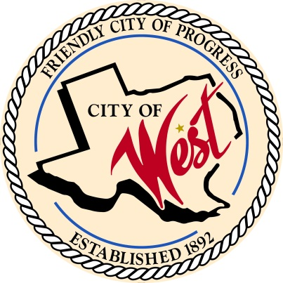
City of West
110 N. Reagan, West, Texas 76691
Phone (254) 826-5351 Fax (254) 826-5969

THE WEST CITY COUNCIL WILL MEET ON SATURDAY, MAY 7, 2022, AT 8:30 AM AT WEST CITY HALL AT 110 NORTH REAGAN TO DISCUSS ITEMS ON THE AGENDA.

- Call to Order

- Roll Call

- Executive Session: Under the provisions of Government Code 551, the Council will meet in Executive Session to discuss:
1). Executive Session: A closed meeting will be held pursuant to Section 551.074 of the Government Code (V.C.T.A.) to address the resignation/retirement, and severance pay for the Police Lieutenant and Chief of Police; and to discuss police department personnel.

- Discussion, consideration, action, if any, re: Resignation of the Police Lieutenant.

- Discussion, consideration, action, if any, re: Retirement of the Chief of Police.

- Discussion, consideration, action, if any, re: Severance package for the Police Lieutenant.

- Discussion, consideration, action, if any, re: Severance package for the Chief of Police.

- Discussion, consideration, action, if any, re: Appointment of interim Chief of Police.

- Adjourn
CERTIFICATION
I certify that the above notice of meeting was posted on the bulletin board of the West City Hall in the City of West, Texas on the 4th day of May 2022 at 8:00 o’clock a.m.
____________________________
City Secretary Shelly Nors

