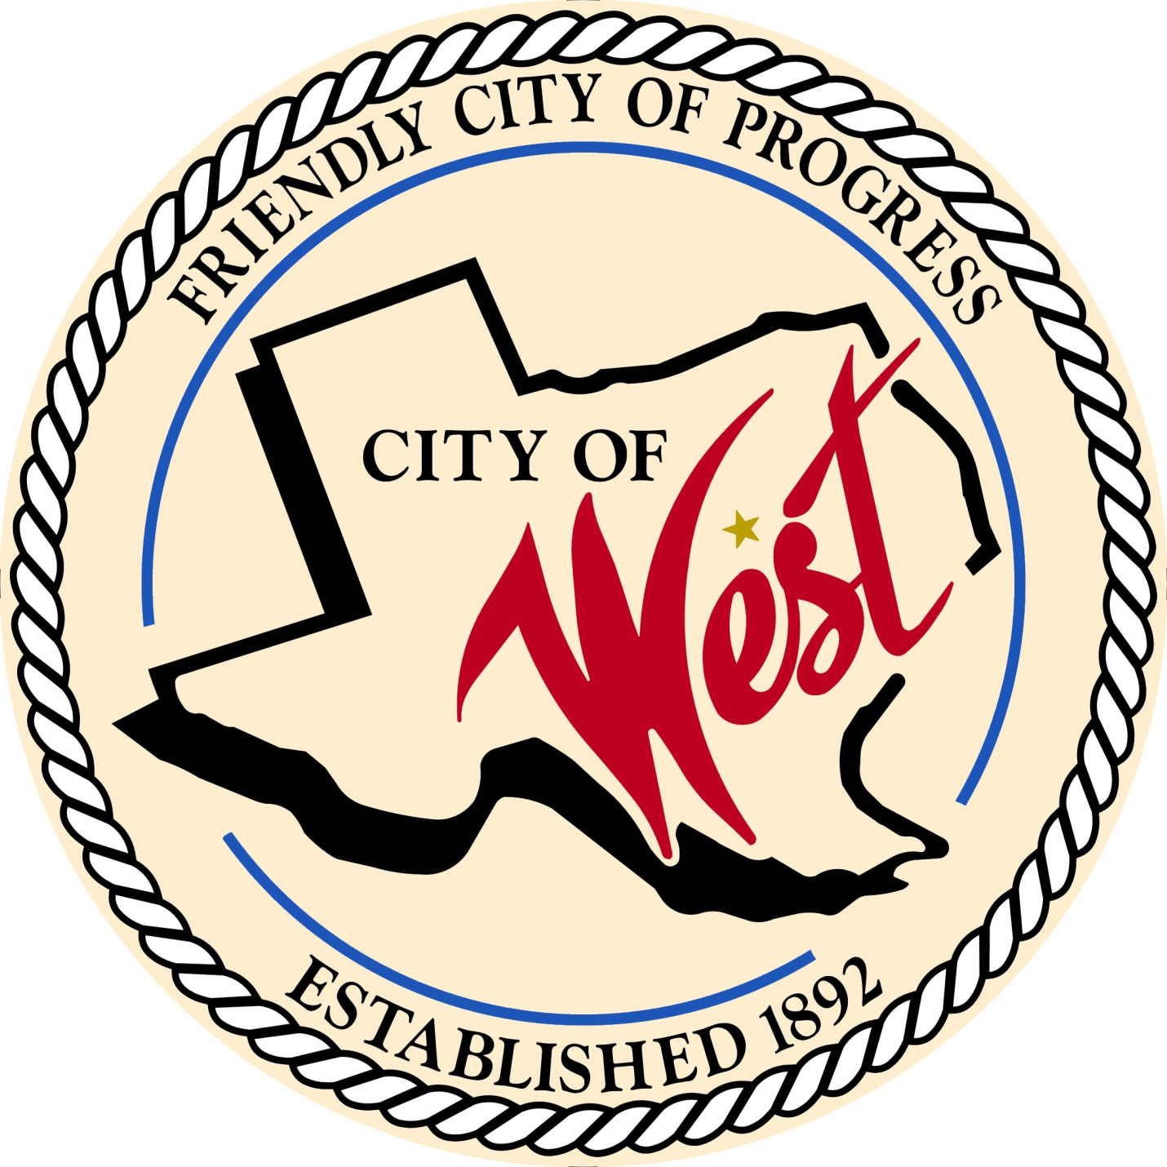

City Council Meeting
MAY 3, 2022

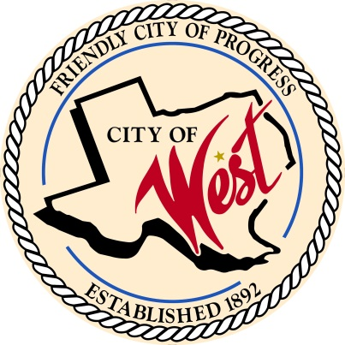
City of West
110 N. Reagan, West, Texas 76691
Phone (254) 826-5351 Fax (254) 826-5969

THE WEST CITY COUNCIL WILL MEET ON TUESDAY, MAY 3, 2022, AT 5:30 PM IN WORKSHOP LOCATED AT THE WEST COMMUNITY CENTER AT 200 TOKIO ROAD TO DISCUSS ITEMS ON THE AGENDA.

THE REGULAR COUNCIL MEETING WILL START AT 6:00 PM.

- Call to Order

- Invocation and Pledge

- Roll Call

- Approve Minutes: April 5, 2022.

- Approve Bills: April 2022.

- Discussion, consideration, action, if any, re: Monthly Departmental Reports
Finance Report
Police Department Report
Public Works Report
Fire Marshal Report
Engineer Report

- Citizen Comments: Citizens may be heard on any subject, but no discussion by or with Council will be held on any matter not listed on an official agenda as required by law.

- Discussion, consideration, action, if any, re: Water pressure – Kyle Schulze with Walker Partners.

- Discussion, consideration, action, if any, re: Water meters – CJ Gillaspie.

- Discussion, consideration, action, if any, re: Grady Calvery Estates septic tank contract for Leslie Long.

- Discussion, consideration, action, if any, re: Zoning - Grady Calvery Estates annexation of lots 1-8 with lots 1 - 6 being zoned as single family residential, and lots 7 and 8 being zoned M1 with restrictions outlined in proposal, and contingent on approval of final plat.

- Discussion, consideration, action, if any, re: Leslie Long request for utility easement along and beside railroad track on Well #7 property for Grady Calvery Estates.

- Discussion, consideration, action, if any, re: Fillin’ Station – abandon street (side alley for kitchen).

- Discussion, consideration, action, if any, re: College Street reimbursement – Robbie Mayse.

- Discussion, consideration, action, if any, re: Wrecker rotation with police department – Gary Hoffman (Steve Vanek).

- Discussion, consideration, action, if any, re: West ISD – land annexation East of school.

- Discussion, consideration, action, if any, re: West ISD – sidewalks.

- Discussion, consideration, action, if any, re: West ISD – graduation parade.

- Discussion, consideration, action, if any, re: Allowing West ISD tennis players exclusive use of the City Park tennis courts from 4:00 pm to 5:30 pm during tennis season.

- Discussion, consideration, action, if any, re: West Little League facilities.

- Discussion, consideration, action, if any, re: Edward Klish - address the Pareya Drive Street issue between his house (310 Northridge Circle) and Robert Payne’s house (402 Northridge Circle).

- Discussion, consideration, action, if any, re: Procurement of an engineering firm for pre-award and post award engineering; to help prepare Scope of work, estimated budget, and Benefit Cost Analysis for FEMA Hazard Mitigation Grant Application DR 4485 for a hazard mitigation project (pre-award) and upon funding of a state awarded contract (post award) the engineering firm will be responsible for the development of preliminary and final design plans, bidding process, construction compliance and necessary interim and final inspections as required by the City for its proposed project.

- Discussion, consideration, action, if any, re: Procurement of a grant manager/administrative firm for pre-award and post award consulting services; to prepare with all supporting documentation the FEMA Hazard Mitigation Grant Application DR 4485 for a hazard mitigation project (pre-award) and upon funding of a state awarded contract (post award) to manage the grant from beginning to closeout.

- Discussion, consideration, action, if any, re: City Hall lawn digital sign.

- Discussion, consideration, action, if any, re: West EMS update.

- Discussion, consideration, action, if any, re: Police Department construction update – Steve Vanek.

- Discussion, consideration, action, if any, re: Council resolves and does hereby revoke any hiring and firing authority from supervisors.

- Executive Session: Under the provisions of Government Code 551, the Council will meet in Executive Session to discuss:
1). Executive Session: A closed meeting will be held pursuant to Section 551.074 of the Government Code (V.C.T.A.) to address personnel discussion regarding evaluation and potential disciplinary action of Chief of Police and Lieutenant.

- Discussion, consideration, action, if any, re: Personnel discussion regarding evaluation and potential disciplinary action of Chief of Police and Lieutenant.

- Council member comments and requests for items to be placed on future agendas.

- Adjourn
CERTIFICATION
I certify that the above notice of meeting was posted on the bulletin board of the West City Hall in the City of West, Texas on the 30th day of April 2022 at 1:30 o’clock p.m.
____________________________
City Secretary Shelly Nors

