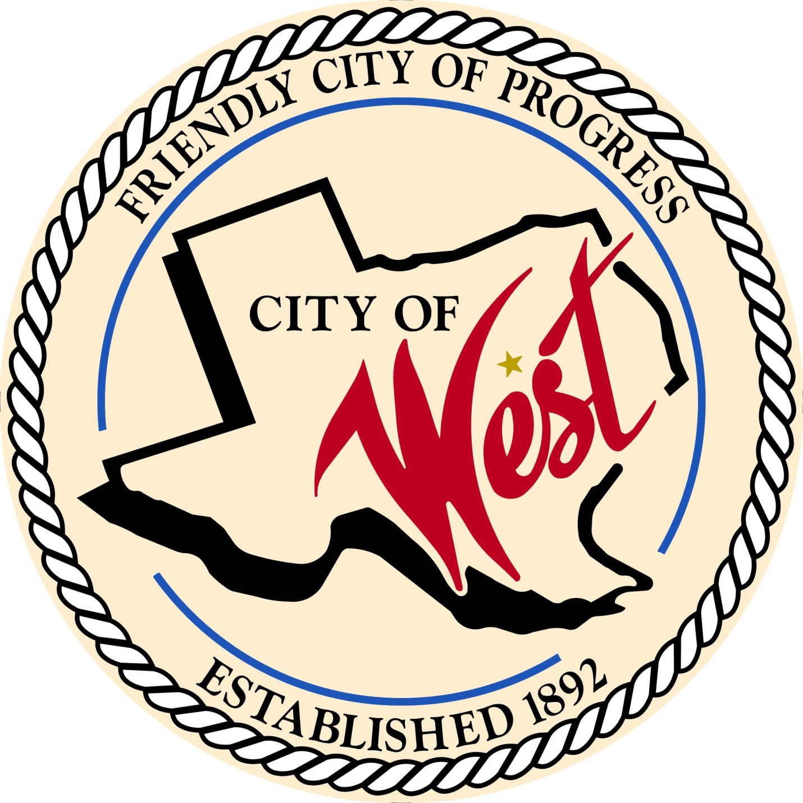

City Council Meeting
MARCH 1, 2022

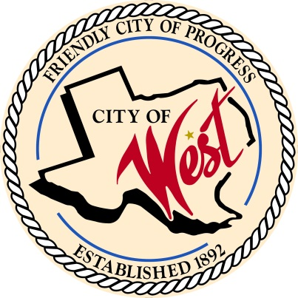
City of West
110 N. Reagan, West, Texas 76691
Phone (254) 826-5351 Fax (254) 826-5969

THE WEST CITY COUNCIL WILL MEET ON TUESDAY, MARCH 1, 2022, AT 5:30 PM IN WORKSHOP LOCATED AT THE WEST FIRE STATION AT 111 S. REAGAN TO DISCUSS ITEMS ON THE AGENDA.

THE REGULAR COUNCIL MEETING WILL START AT 6:00 PM.

- Call to Order

- Invocation and Pledge

- Roll Call

- Approve Minutes: February 1, 2022.

- Approve Bills: February 2022.

- Discussion, consideration, action, if any, re: Monthly Departmental Reports
Finance Report
Police Department Report
Public Works Report
Fire Marshal Report
Engineer Report

- Citizen Comments: Citizens may be heard on any subject, but no discussion by or with Council will be held on any matter not listed on an official agenda as required by law.

- Discussion, consideration, action, if any, re: Approval of 2020 – 2021 financial audit.

- Discussion, consideration, action, if any, re: Approval of Economic Development Corporation bylaws.

- Discussion, consideration, action, if any, re: Little League funding for bathrooms.

- Discussion, consideration, action, if any, re: Grady Calvery Estates zoning – Leslie Long.

- Discussion, consideration, action, if any, re: Opening up of abandoned portion of College Street – Cody Harris.

- Discussion, consideration, action, if any, re: Leslie Long agreement regarding waiver of lift station and subdivision ordinance review – Charles Buenger.

- Discussion, consideration, action, if any, re: Whistleblower policy.

- Executive Session: Under the provisions of Government Code 551, the Council will meet in Executive Session to discuss:

1). Executive Session: A closed meeting will be held pursuant to Section 551.074 of the Government Code (V.C.T.A.) to address procedures for how to handle inclement weather/City Hall closures/hazard pay for employees.

- Discussion, consideration, action, if any, re: Procedures for Inclement weather/City Hall closures/hazard pay for employees.

- Council member comments and requests for items to be placed on future agendas.

- Adjourn
CERTIFICATION
I certify that the above notice of meeting was posted on the bulletin board of the West City Hall in the City of West, Texas on the 25th day of February 2022 at 9:30 o’clock a.m.

____________________________
City Secretary Shelly Nors

