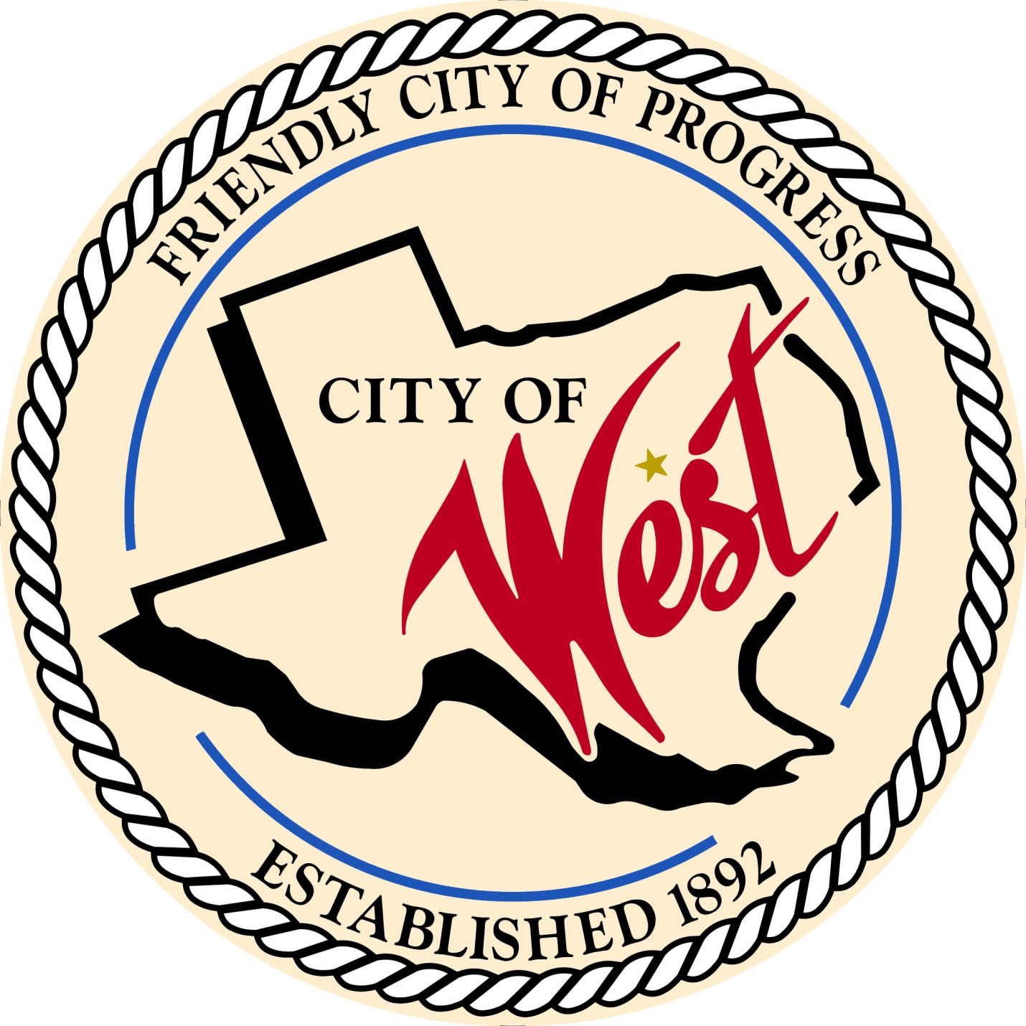

City Council Meeting
JUNE 7, 2022

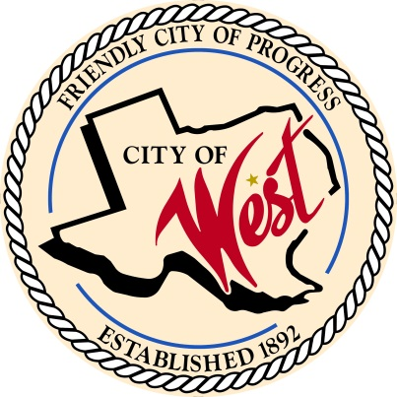
City of West
110 N. Reagan, West, Texas 76691
Phone (254) 826-5351 Fax (254) 826-5969

THE WEST CITY COUNCIL WILL MEET ON TUESDAY, JUNE 7, 2022, AT 5:30 PM IN WORKSHOP LOCATED AT THE WEST COMMUNITY CENTER AT 200 TOKIO ROAD TO DISCUSS ITEMS ON THE AGENDA.

THE REGULAR COUNCIL MEETING WILL START AT 6:00 PM.

- Call to Order

- Invocation and Pledge

- Roll Call

- Approve Minutes: May 3, 2022 and May 7, 2022.

- Approve Bills: May 2022.

- Discussion, consideration, action, if any, re: Monthly Departmental Reports
Finance Report
Police Department Report
Public Works Report
Fire Marshal Report
Code/Permitting Report
Engineer Report

- Citizen Comments: Citizens may be heard on any subject, but no discussion by or with Council will be held on any matter not listed on an official agenda as required by law.

- Discussion, consideration, action, if any, re: West Fair and Rodeo requesting hotel tax funds for advertising – Pat Cammack.

- Discussion, consideration, action, if any, re: West EMS fuel allotment.

- Discussion, consideration, action, if any, re: County wide mutual aid agreement between The City of West and West Fire Department.

- Discussion, consideration, action, if any, re: Increase the 2022 police building construction budget by $154,000 making the total cost $555,519.

- Discussion, consideration, action, if any, re: Approval of new police building construction bid/contract with JCM Builders of Texas, LLC for $555,519 and allowing Mayor to sign contract.

- Discussion, consideration, action, if any, re: Awarding of administrative services contract for the preparation of the City’s 2022 Texas Community Development Block Grant (TxCDBG) FAST application and subsequent administrative services contract if funded.

- Council member comments and requests for items to be placed on future agendas.

- Adjourn
CERTIFICATION
I certify that the above notice of meeting was posted on the bulletin board of the West City Hall in the City of West, Texas on the 2nd day of June 2022 at 9:00 o’clock a.m.
____________________________
City Secretary Shelly Nors

