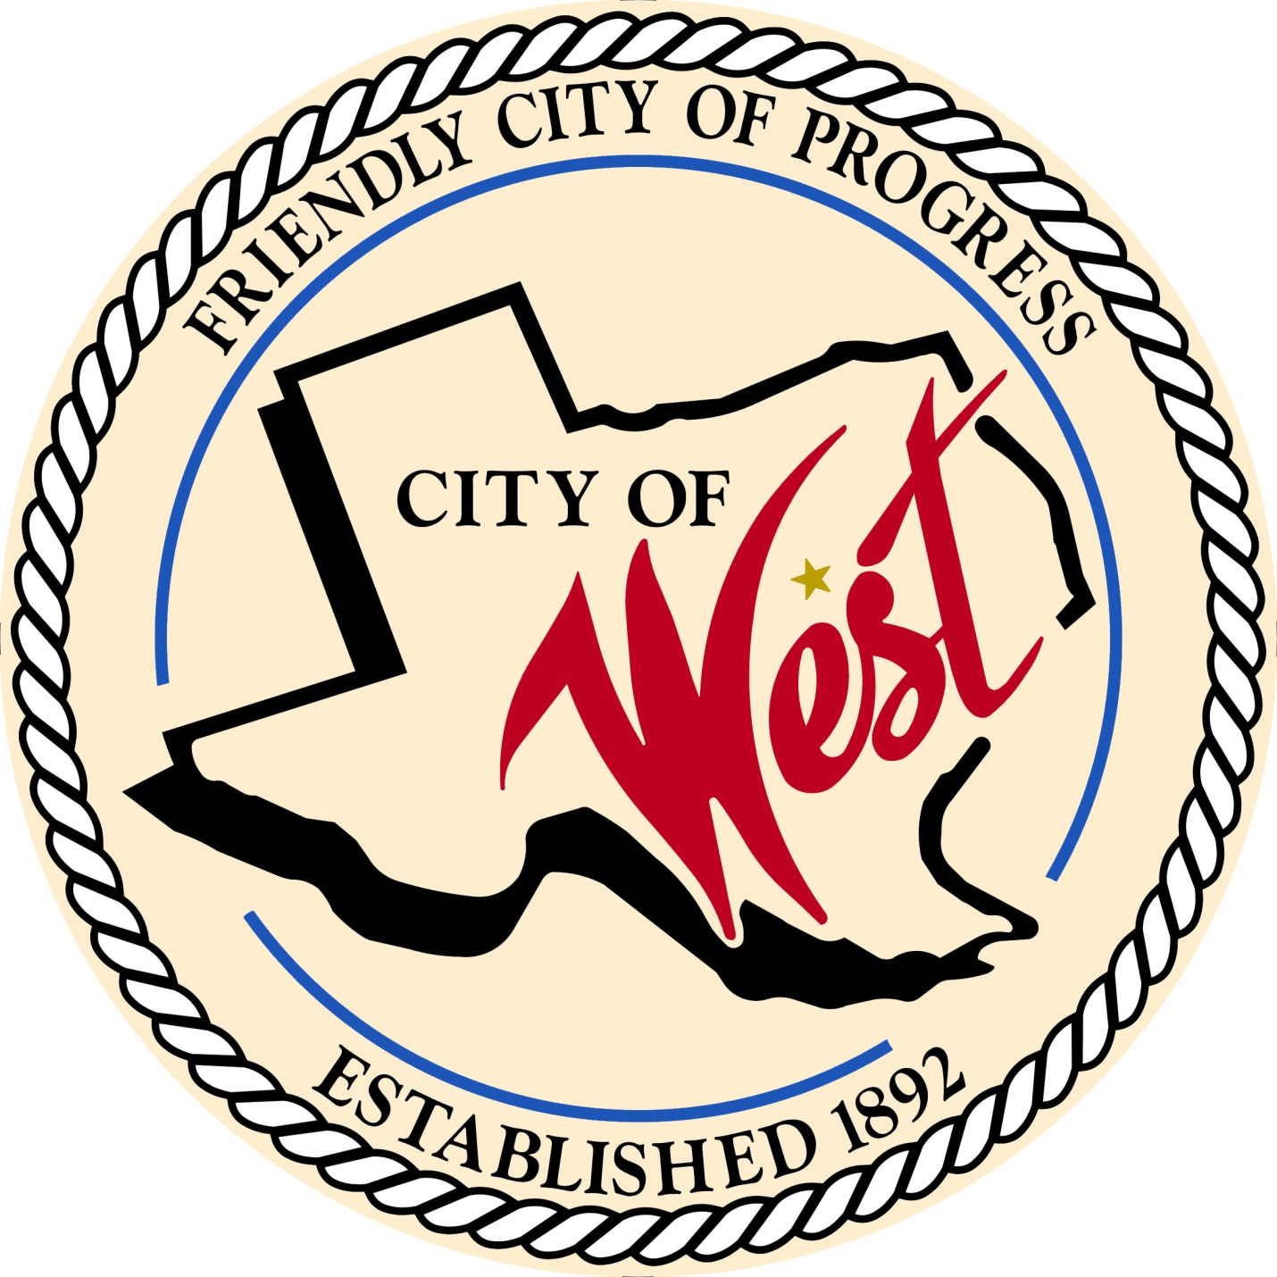

City Council Meeting
JULY 26, 2022

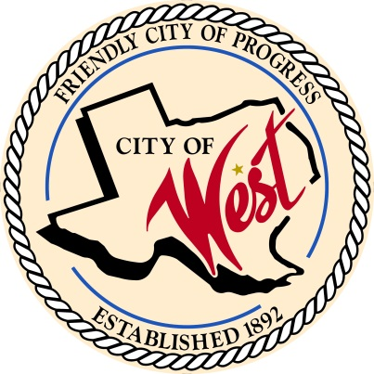
City of West
110 N. Reagan, West, Texas 76691
Phone (254) 826-5351 Fax (254) 826-5969

THE WEST CITY COUNCIL WILL MEET ON TUESDAY, JULY 26, 2022, AT 5:30 PM AT WEST CITY HALL AT 110 NORTH REAGAN TO DISCUSS ITEMS ON THE AGENDA.

- Call to Order

- Roll Call

- Discussion, consideration, action, if any, re: Approve Police Chief job description.

- Discussion, consideration, action, if any, re: City of West 2022 – 2023 fiscal year budget.

- Adjourn
CERTIFICATION
I certify that the above notice of meeting was posted on the bulletin board of the West City Hall in the City of West, Texas on the 22nd day of July 2022 at 9:00 o’clock a.m.
____________________________
City Secretary Shelly Nors

