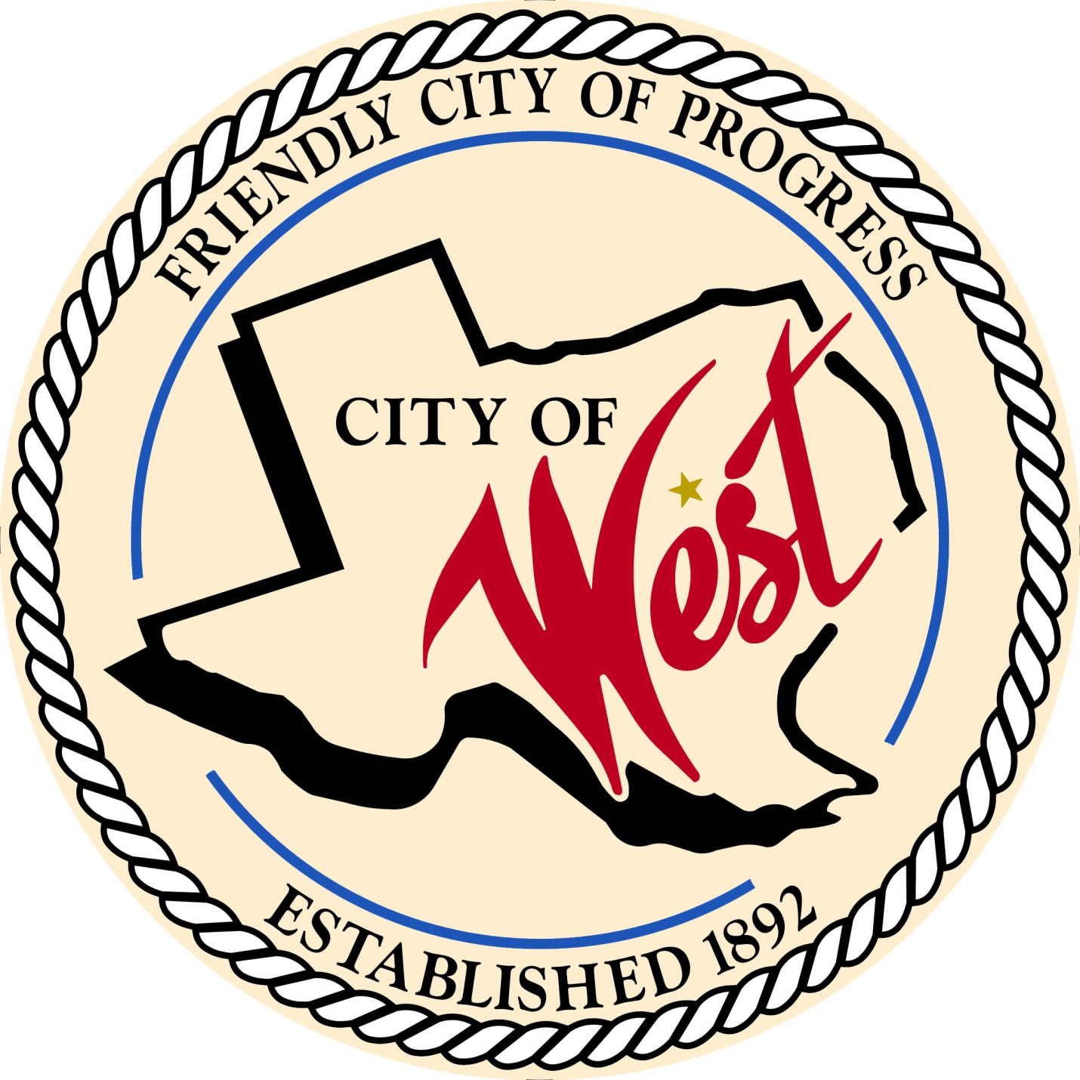

City Council Meeting
FEBRUARY 1, 2022

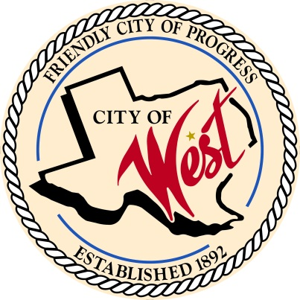
City of West
110 N. Reagan, West, Texas 76691
Phone (254) 826-5351 Fax (254) 826-5969

THE WEST CITY COUNCIL WILL MEET ON TUESDAY, FEBRUARY 1, 2022, AT 5:30 PM IN WORKSHOP LOCATED AT THE WEST COMMUNITY CENTER AT 200 TOKIO ROAD TO DISCUSS ITEMS ON THE AGENDA.

THE REGULAR COUNCIL MEETING WILL START AT 6:00 PM.

- Call to Order

- Invocation and Pledge

- Roll Call

- Approve Minutes: January 4, 2022.

- Approve Bills: January 2022.

- Discussion, consideration, action, if any, re: Monthly Departmental Reports
Finance Report
Police Department Report
Public Works Report
Fire Marshal Report
Engineer Report

- Citizen Comments: Citizens may be heard on any subject, but no discussion by or with Council will be held on any matter not listed on an official agenda as required by law.

- Discussion, consideration, action, if any, re: Approval of 2020 – 2021 financial audit.

- Discussion, consideration, action, if any, re: Joel Jacobson – installation of wastewater service on his lots located on North College Street.

- Discussion, consideration, action, if any, re: Wolf’s Bar – fundraiser for memorial scholarship in honor of Cole Simmons on Sunday, April 24, 2022 - street dance, cornhole, and closing of street.

- Discussion, consideration, action, if any, re: Appoint West Hospital Authority Board of Directors to place 6 and place 10 – Marsha Croll and Emmanuel Mitchell.

- Discussion, consideration, action, if any, re: Reagan and Spruce streets drainage.

- Discussion, consideration, action, if any, re: Drought contingency plan - renew and resolution.

- Discussion, consideration, action, if any, re: Proceed with CDBG grant and ARPA funds for infrastructure, Playdium Drive and Pecan Street project.

- Discussion, consideration, action, if any, re: Opening up of abandoned portion of College Street – Cody Harris.

- Discussion, consideration, action, if any, re: Speed bumps on South Harrison Street – Steve Vanek

- Discussion, consideration, action, if any, re: Appointment of Economic Development Committee board members: Brian Muska, Amanda Niemeyer, and Tim Payne.

- Discussion, consideration, action, if any, re: Research subdivision ordinance regarding septic systems.

- Council member comments and requests for items to be placed on future agendas.

- Adjourn
CERTIFICATION
I certify that the above notice of meeting was posted on the bulletin board of the West City Hall in the City of West, Texas on the 28th day of January 2022 at 11:30 o’clock a.m.

____________________________
City Secretary Shelly Nors

