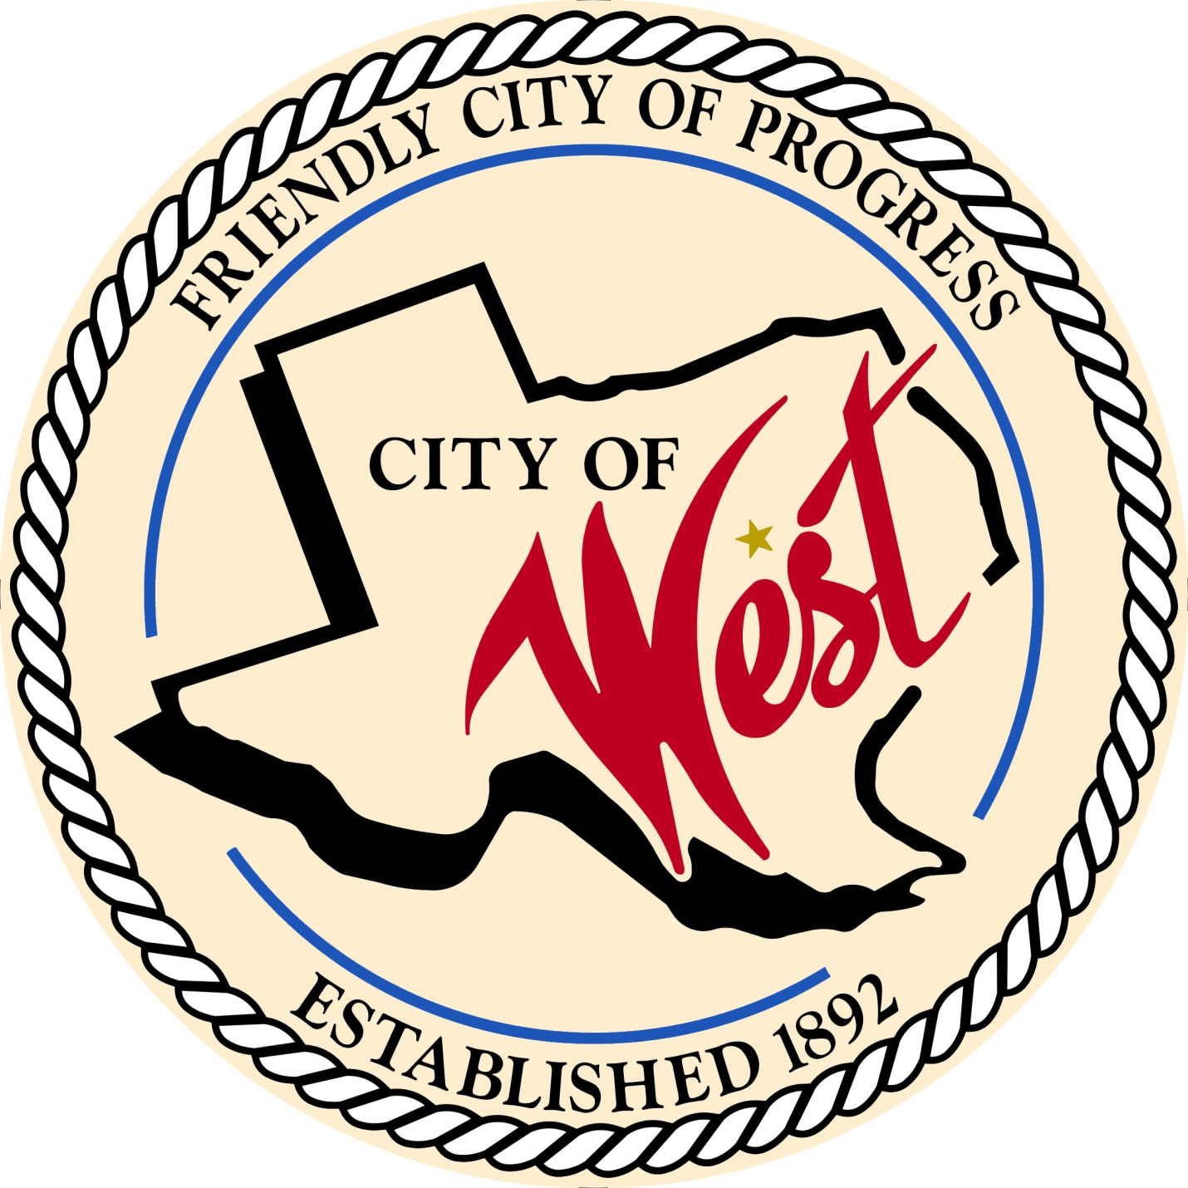

City Council Meeting
August 22, 2022

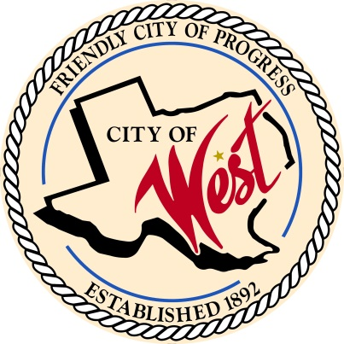
City of West
110 N. Reagan, West, Texas 76691
Phone (254) 826-5351 Fax (254) 826-5969

EMERGENCY MEETING REGARDING HEALTH AND SAFETY. THE WEST CITY COUNCIL WILL MEET ON MONDAY, AUGUST 22, 2022, AT 5:30 PM AT WEST CITY HALL LOCATED AT 110 N. REAGAN TO CONSIDER AND ACT ON THE ITEMS ON THE FOLLOWING AGENDA.

- Call to Order
- Roll Call
- Discussion, consideration, action, if any, re: City of West 2022 – 2023 fiscal year budget regarding ambulance subsidy.
- Adjourn

CERTIFICATION
I certify that the above notice of meeting was posted on the bulletin board of the West City Hall in the City of West, Texas on the 22nd day of August 2022 a 8:30 o’clock a.m.

____________________________
City Secretary Shelly Nors

