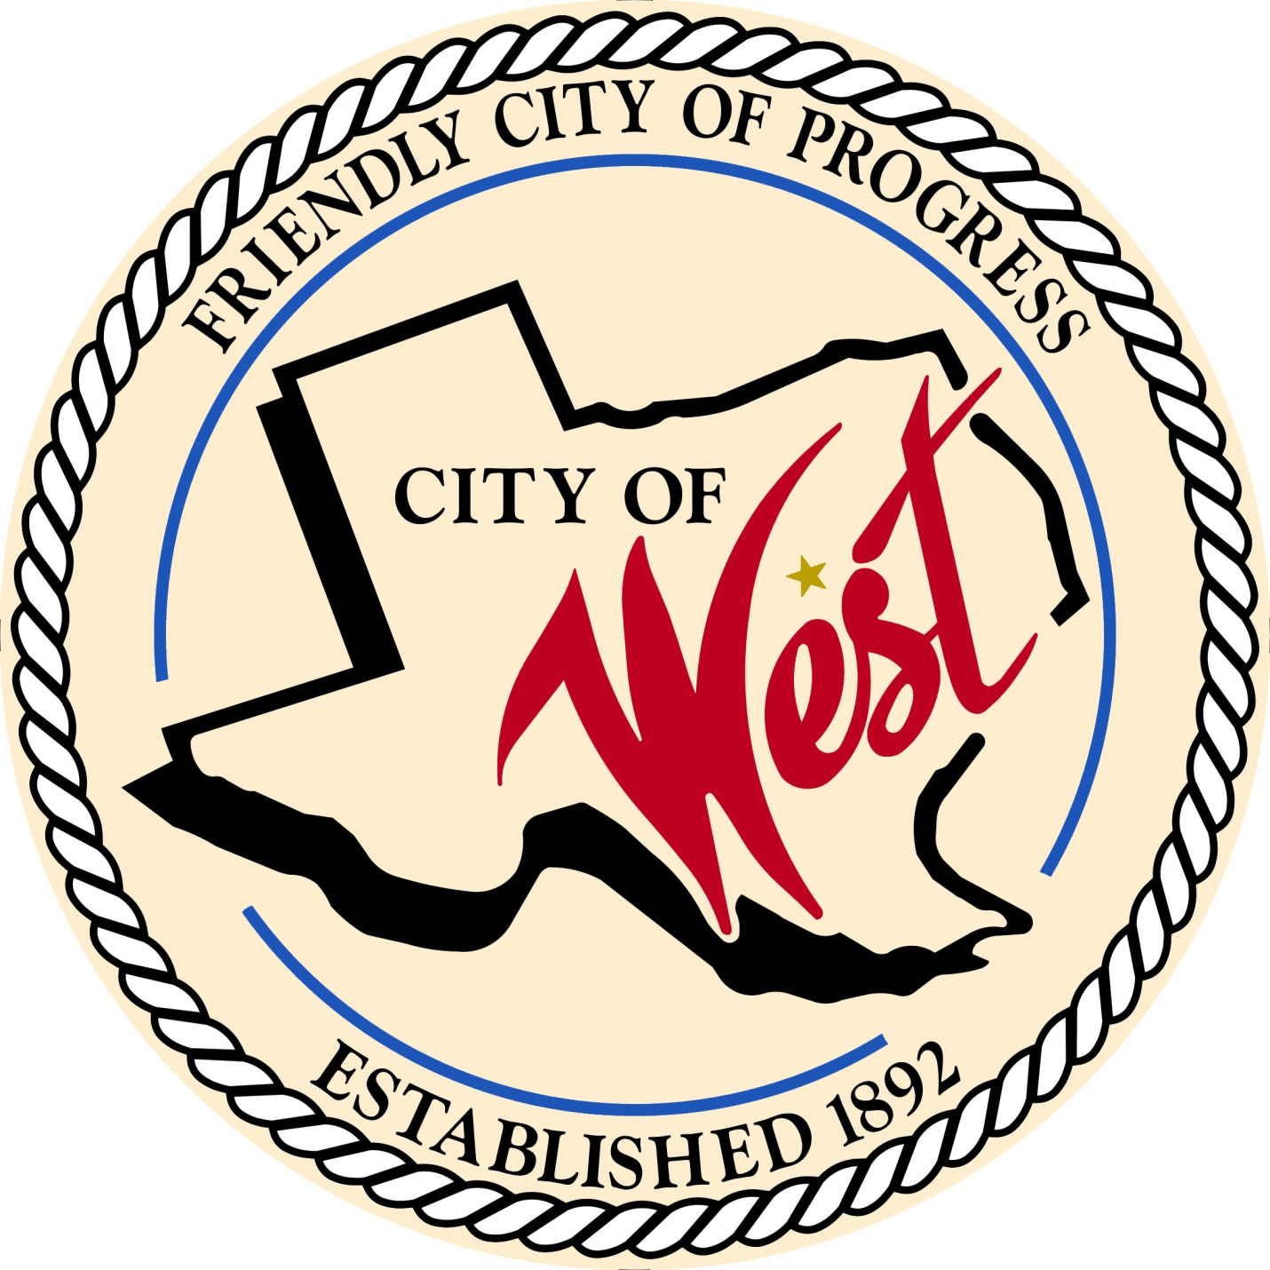

City Council Meeting
AUGUST 2, 2022

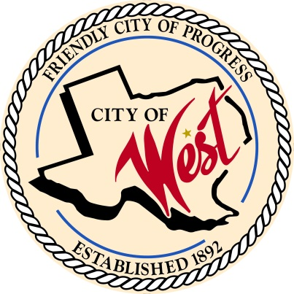
City of West
110 N. Reagan, West, Texas 76691
Phone (254) 826-5351 Fax (254) 826-5969

THE WEST CITY COUNCIL WILL MEET ON TUESDAY, AUGUST 2, 2022, AT 5:30 PM IN WORKSHOP LOCATED AT THE WEST COMMUNITY CENTER AT 200 TOKIO ROAD TO DISCUSS THE 2022 – 2023 FISCAL YEAR BUDGET AND THE ITEMS ON THE AGENDA.

THE REGULAR COUNCIL MEETING WILL START AT 6:00 PM.

- Call to Order

- Invocation and Pledge

- Roll Call

- Approve Minutes: June 7, July 12, July 19, July 21, and July 26, 2022.

- Approve Bills: June and July 2022.

- Discussion, consideration, action, if any, re: Monthly Departmental Reports
Finance Report
Police Department Report
Public Works Report
Fire Marshal Report
Code/Permitting Report
Engineer Report

- Citizen Comments: Citizens may be heard on any subject, but no discussion by or with Council will be held on any matter not listed on an official agenda as required by law.

- Discussion, consideration, action, if any, re: Approve notice of joint general election for November 8, 2022.

- Discussion, consideration, action, if any, re: Approve contract for election services between McLennan County Elections Administration Department and the City of West.

- Discussion, consideration, action, if any, re: Approve Police Chief job description.

- Discussion, consideration, action, if any, re: Releasing land on Shook Street back to West Brethren Church – property legal description Shook Lot B5 TO B7, 8 TO 10, Block 4, Acres .8695.

- Discussion, consideration, action, if any, re: West Little League Restrooms.

- Discussion, consideration, action, if any, re: West ISD requests annexation of land East of school.

- Discussion, consideration, action, if any, re: 405 N. Roberts – Dustin Matus requesting purchase of alley.

- Council member comments and requests for items to be placed on future agendas.

- Adjourn
CERTIFICATION
I certify that the above notice of meeting was posted on the bulletin board of the West City Hall in the City of West, Texas on the 28th day of July 2022 at 9:00 o’clock a.m.
____________________________
City Secretary Shelly Nors

