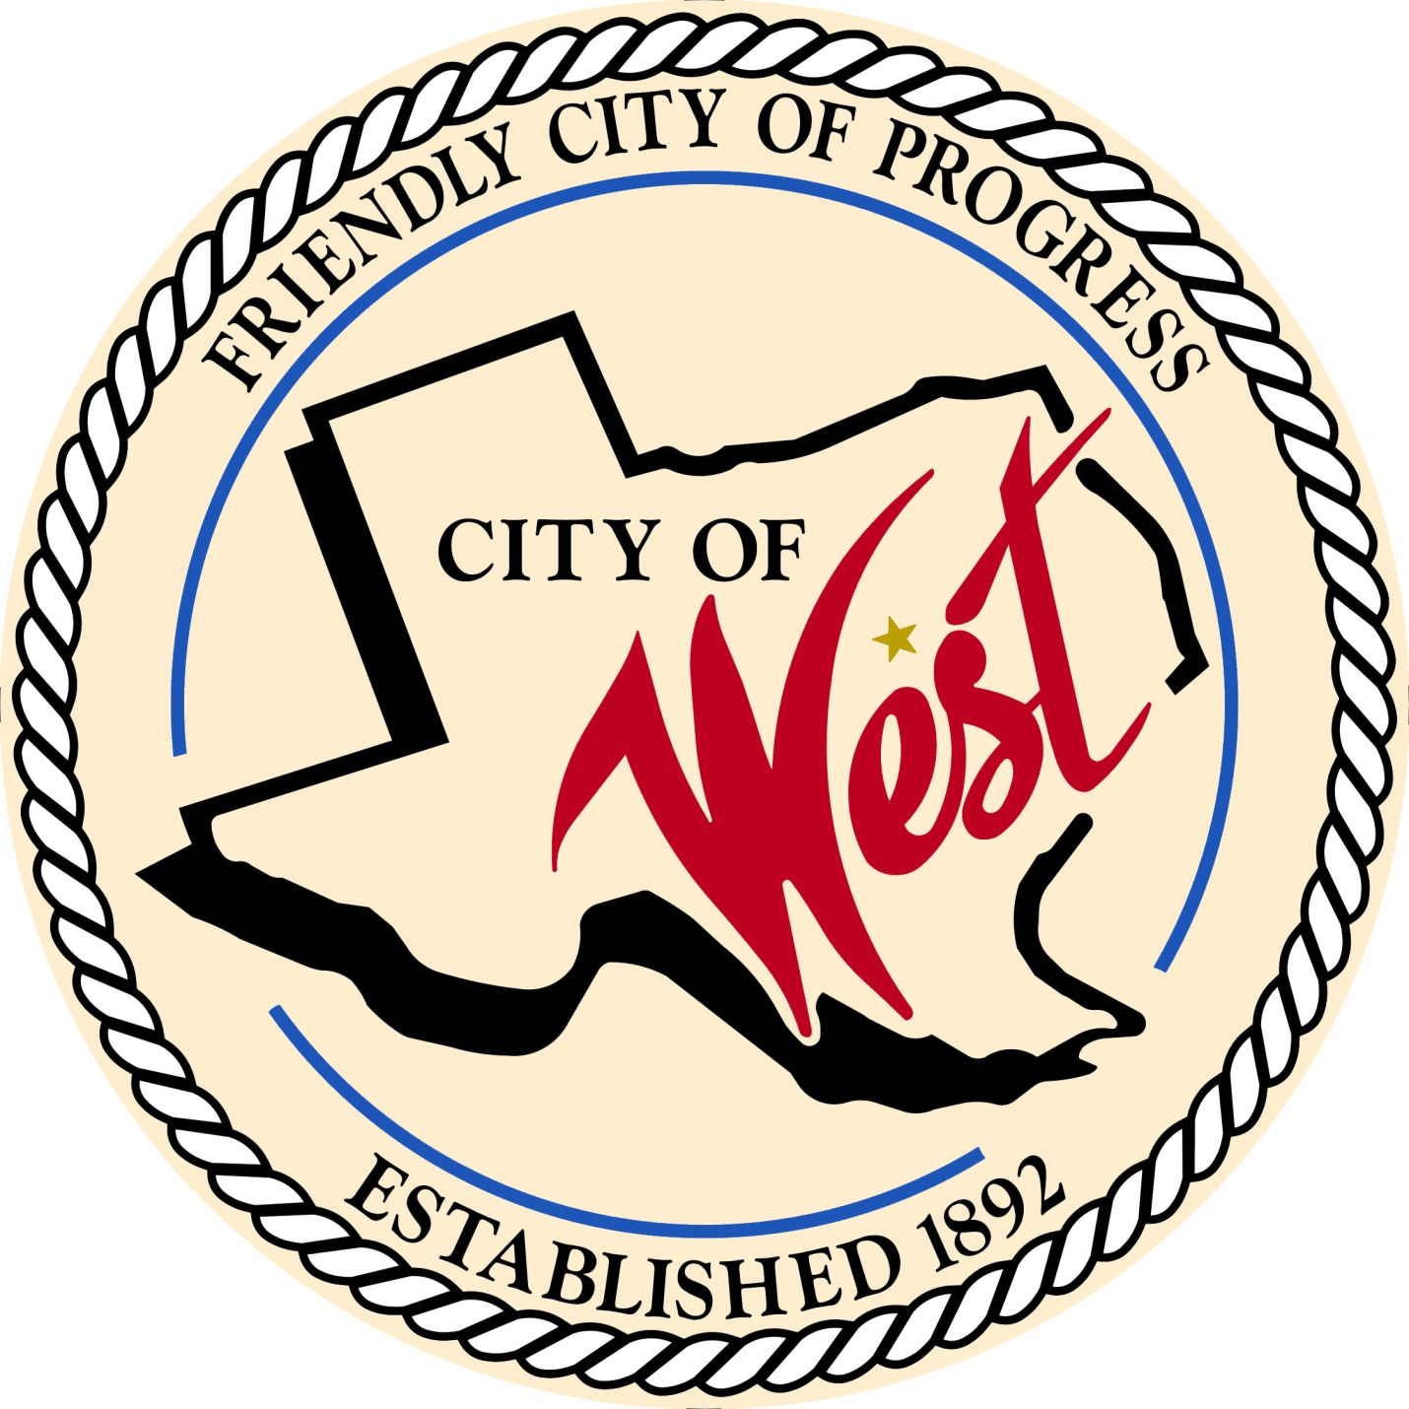

City Council Meeting
August 16, 2022

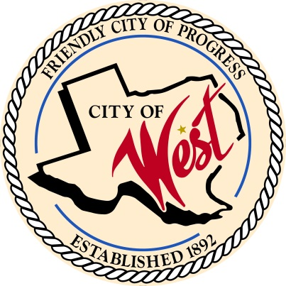
City of West
110 N. Reagan, West, Texas 76691
Phone (254) 826-5351 Fax (254) 826-5969

THE WEST CITY COUNCIL WILL MEET ON TUESDAY, AUGUST 16, 2022, AT 5:00 PM AT WEST CITY HALL LOCATED AT 110 N. REAGAN TO CONSIDER AND ACT ON THE ITEMS ON THE FOLLOWING AGENDA.

- Call to Order
- Roll Call
- Discussion, consideration, action, if any, re: Proposing tax rate of $0.552472 for the 2022 - 2023 fiscal year.
- Adjourn

CERTIFICATION
I certify that the above notice of meeting was posted on the bulletin board of the West City Hall in the City of West, Texas on the 10th day of August 2022 at 3:30 o’clock p.m.

____________________________
City Secretary Shelly Nors

