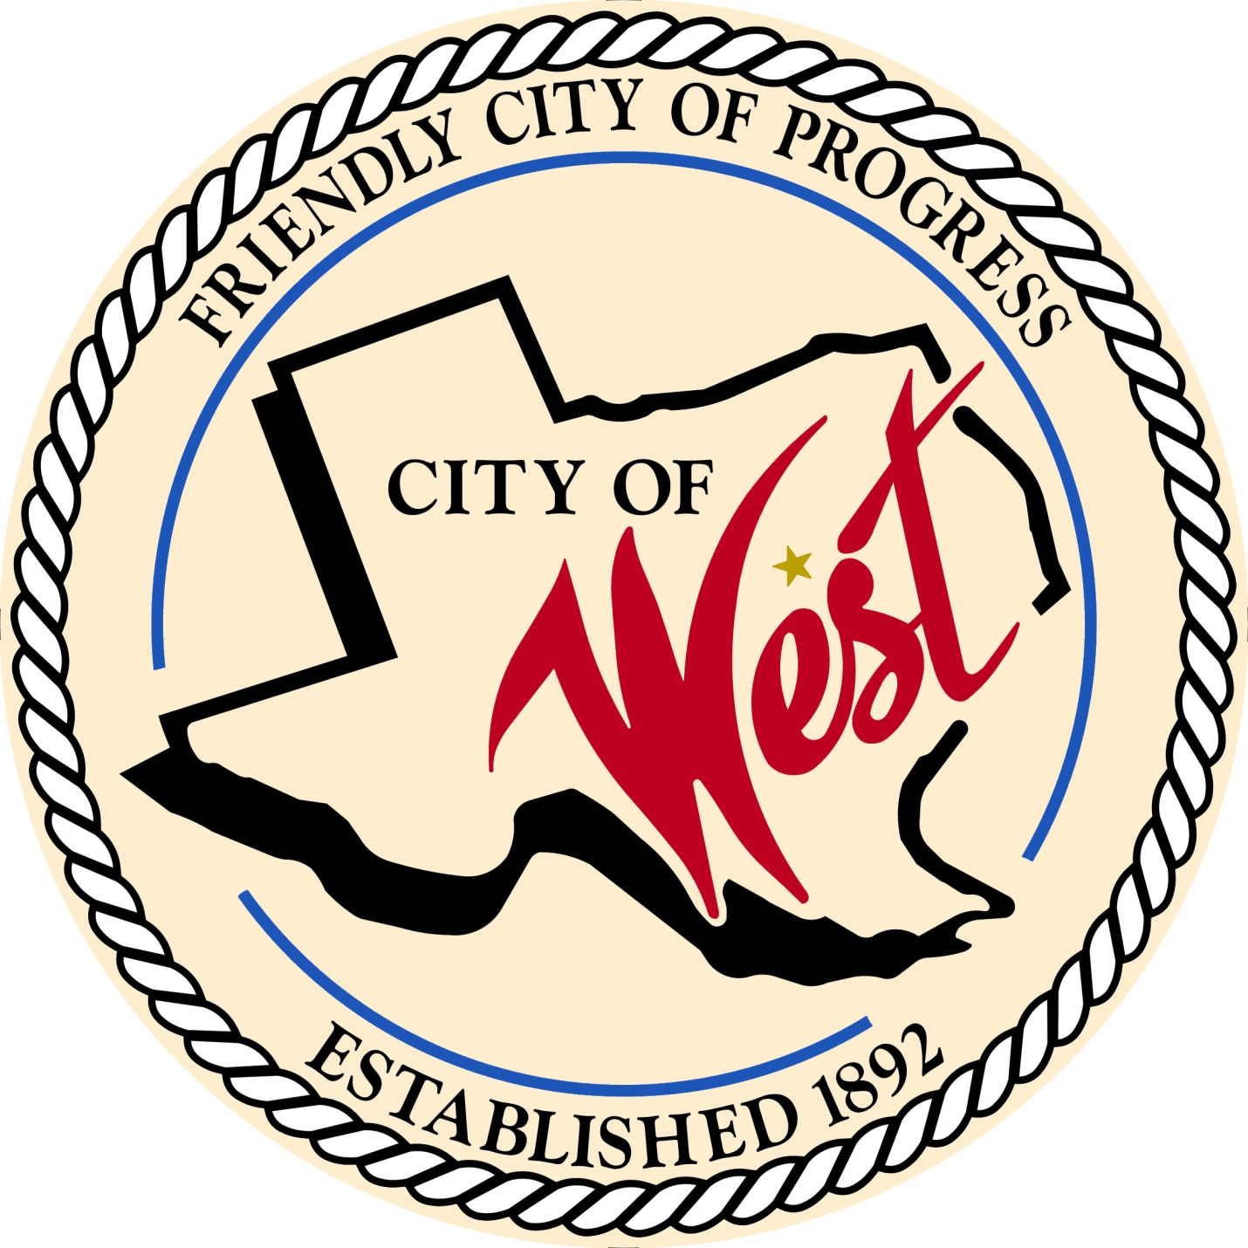

City Council Meeting
APRIL 5, 2022

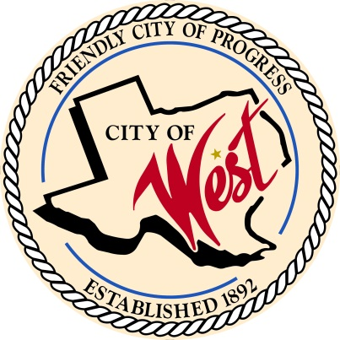
City of West
110 N. Reagan, West, Texas 76691
Phone (254) 826-5351 Fax (254) 826-5969

THE WEST CITY COUNCIL WILL MEET ON TUESDAY, APRIL 5, 2022, AT 5:30 PM IN WORKSHOP LOCATED AT THE WEST COMMUNITY CENTER AT 200 TOKIO ROAD TO DISCUSS ITEMS ON THE AGENDA.

THE REGULAR COUNCIL MEETING WILL START AT 6:00 PM.

- Call to Order

- Invocation and Pledge

- Roll Call

- Approve Minutes: March 1, 2022.

- Approve Bills: March 2022.

- Discussion, consideration, action, if any, re: Monthly Departmental Reports
Finance Report
Police Department Report
Public Works Report
Fire Marshal Report
Engineer Report

- Citizen Comments: Citizens may be heard on any subject, but no discussion by or with Council will be held on any matter not listed on an official agenda as required by law.

- Discussion, consideration, action, if any, re: Street dance on June 11, 2022 – Matt Nemec.

- Discussion, consideration, action, if any, re: Chamber of Commerce farmer’s market on City Hall lawn – John Kocian.

- Discussion, consideration, action, if any, re: Approval of Economic Development Corporation bylaws.

- Discussion, consideration, action, if any, re: Little League funding for bathrooms.

- Discussion, consideration, action, if any, re: Zoning - Grady Calvery Estates annexation of lots 1-8 with lots 1 - 6 being zoned as single family residential, and lots 7 and 8 being zoned M1 with restrictions outlined in proposal, and contingent on approval of final plat.

- Discussion, consideration, action, if any, re: Grady Calvery Estates septic tank contract for Leslie Long.

- Discussion, consideration, action, if any, re: Grady Calvery Estates requesting reimbursement of $49,500.00 to run a new 8” water main from the water tower at Reagan Street down the length of Grady Calvery Dr.

- Discussion, consideration, action, if any, re: Approval of construction plans for Playdium Estates – David Holy.

- Discussion, consideration, action, if any, re: Approve construction plans for West ISD’s wastewater line.

- Discussion, consideration, action, if any, re: Approval of submission of the completed application to Texas Department of Emergency Management (TDEM) for the FEMA HMGP DR 4485 grant funds.

- Discussion, consideration, action, if any, re: Approve resolution to submit the application to Texas Department of Emergency Management (TDEM) for the FEMA HMGP DR 4485 grant funds, appointing the mayor as the authorized official, and committing to the 25% match.

- Discussion, consideration, action, if any, re: Adopt the Civil Rights Resolution and policies for the TxCDBG Grant Agreement CDV21-0430.

- Discussion, consideration, action, if any, re: As a condition of funding for TxCDBG Grant Agreement CDV21-0430, a Section 3 Presentation is required.

- Discussion, consideration, action, if any, re: Award and approve resolution for grant administration and project management services needed to satisfy the requirements under the American Rescue Plan Act (ARP) 2021 Coronavirus Local Fiscal Recovery fund activities and projects to Langford Community Management Services.

- Discussion, consideration, action, if any, re: Closing Reagan Street from Goddard to Lackey for car show on May 28, 2022 – Steve Vanek.

- Discussion, consideration, action, if any, re: Opening up of abandoned portion of College Street – Cody Harris.

- Discussion, consideration, action, if any, re: West ISD sidewalks.

- Discussion, consideration, action, if any, re: Update on police station – Steve Vanek.

- Discussion, consideration, action, if any, re: Resolution selecting elected official of the City as the city’s nominee for service as a member of the Governing Body of the McLennan County Rural Transit District.

- Discussion, consideration, action, if any, re: West EMS budget – Garrett Uptmore.

- Council member comments and requests for items to be placed on future agendas.

- Adjourn
CERTIFICATION
I certify that the above notice of meeting was posted on the bulletin board of the West City Hall in the City of West, Texas on the 31st day of March 2022 at 9:30 o’clock a.m.

____________________________
City Secretary Shelly Nors

